SEAMAN CV

PERSONAL DETAILS

Family name |  | ALIYEV |  |  | 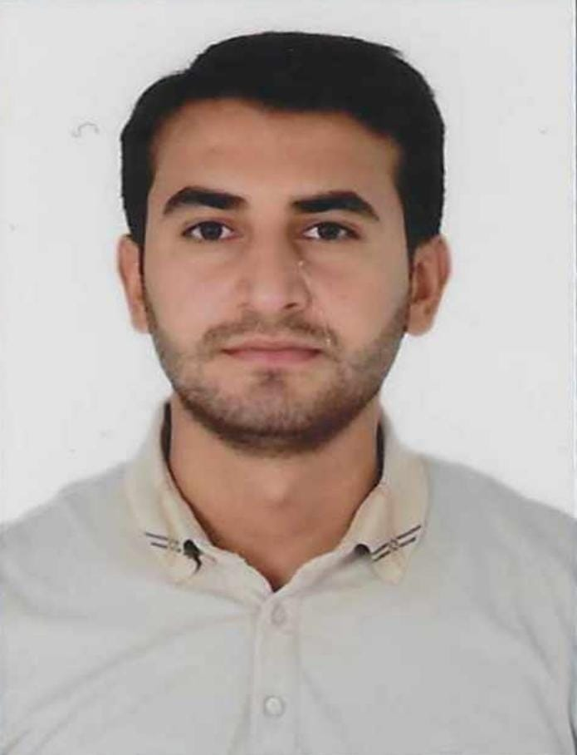
First name |  | VUGAR
Father’s name |  | MUBARIZ
Date and place of birth |  | 23.01.2002  Azerbaijan, MASALLI
Nationality |  | Azerbaijan
Marital status |  | Single
Permanent address |  | Azerbaijan, MASALLI
Nearest airport |  | Heydar Aliyev International Airport Baku, Azerbaijan
Height (cm) | Weight (kg) | Eyes color | Hair color | Size of safety shoes | Size of coveralls
177cm | 73 kg | Brown | BLACK | 42 | M

CONTACT DETAILS

Mobile | Mail address
+994 50 537 98 77 | aliyevvugar444@gmail.com

TRAVEL PASSPORT DEDETAILS.
Document | Number | Place of Issue | Issued | Valid
PASSPORT | C02985152 | Azerbaijan | 20.05.2020 | 19.05.2030

NEXT OF KIN (FOR EMERGENCY)

Next of kin | ALIYEV MUBARIZ | Relationship | FATHER
Mobile | +994 50 634 83 54 | Address | SUMGAYIT, Azerbaijan

MEDICAL INFORMATION

Document | Grade | Place of issue | Date of issue | Date of expiry
MEDICAL CERTIFICATE | A-II/5 | Azerbaijan | 11.09.2024 | 11.09.2026

SEAMAN’S BOOK DETAILS

Document | Number | Place of Issue | Issued | Valid
Seaman book | DGK 029852  AZE 034730 | Azerbaijan ,Baku | 18.09.2024 | 18.09.2029

EDUCATION

Full name of School | Place of Issue | Grade/Class | From | To
Azerbaijan State Marine Academy | Azerbaijan , Baku | SR-0079-23 | 17.02.2023 | 12.01.2028

KNOWLEDGE OF LANGUAGES

Languages | Speaking | Reading | Writing
Azerbaijan | Excellent | Excellent | Excellent
English | Average | Average | Average
Russian | Average | Average | Average
Turkish | Excellent | Excellent | Excellent

COMPUTER SKILLS

Windows | Microsoft Office | Internet
Excellent | Excellent | Excellent

CERTIFICATE OF COMPETENCY

Class/Grade | Issuing country | Certificate No. | Date issued | Expires | Limitations
Rating forming part of an ABLE SEAFARER DECK | Azerbaijan  Marine Administration | 2096/24  RP12134 | 17.09.2024 | -------- | A-II/5

STCW AND OTHER CERTCERTIFICAT.
Name of course/Certificate | Institute | Place | Date of issue | Cert. No | Date of expiry
International  Safety  Management Code | Azerbaijan Marine  Administration | Azerbaijan Baku | 25.06.2021 | SP-0888-21 | 02.06.2026
Proficiency in survival craft and boats other than fast rescue boats | Azerbaijan Marine  Administration | Azerbaijan Baku | 07.10.2022 | SL-3155-22 | 07.10.2027
Basic safety training | Azerbaijan Marine  Administration | Azerbaijan Baku | 17.06.2021 | SO-1219-21 | 31.05.2026
Training for seafarers with designated security duties | Azerbaijan Marine  Administration | Azerbaijan Baku | 14.10.2022 | SH-2081-22 | 12.10.2027
Ship Security-related familiarization security- awareness | Azerbaijan Marine  Administration | Azerbaijan Baku | 18.06.2021 | SI-0509-21 | 04.06.2026
Operational use of electronic chart and ınformatıon systems ECDIS | Azerbaijan Marine  Administration | Azerbaijan Baku | 01.03.2023 | SZ-0162-23 | 16.01.2028
GMDSS GENERAL OPERATOR | Azerbaijan Marine  Administration | Azerbaijan Baku | 24.02.2023 | DQ-0189-23 | 14.06.2027
RADAR Course Certificate | Azerbaijan Marine  Administration | Azerbaijan Baku | 17.02.2023 | SR-0079-23 | 12.01.2028

SEA EXPERIENCE (LAST 5 YEARS – MOST RECENT EXPERIENCE ON TOP LINE)

VESSEL | COMPANY | TYPE OF VESSEL | FLAG | DWT | RANK | SIGN ON | SIGN OFF
MV NAXÇIVAN | ASCO | RO-RO | Azerbaijan | 8547 | CADET | 29.06.2020 | 31.10.2020
MV NAXÇIVAN | ASCO | RO-RO | Azerbaijan | 8547 | CADET | 29.06.2021 | 14.09.2021
MV ISLAY | CMS | AHTS | Azerbaijan | 5275 | CADET | 16.06.2022 | 16.09.2022
MV C.PROVIDER | P&O | PSV | Azerbaijan | 3179 | OS | 01.02.2023 | 16.06.2023
MV C.PROVIDER | P&O | PSV | Azerbaijan | 3179 | AB | 02.10.2023 | 04.05.2024
MV C.PROVIDER | P&O | PSV | Azerbaijan | 3179 | AB | 03.06.2024 | 06.09.2024

