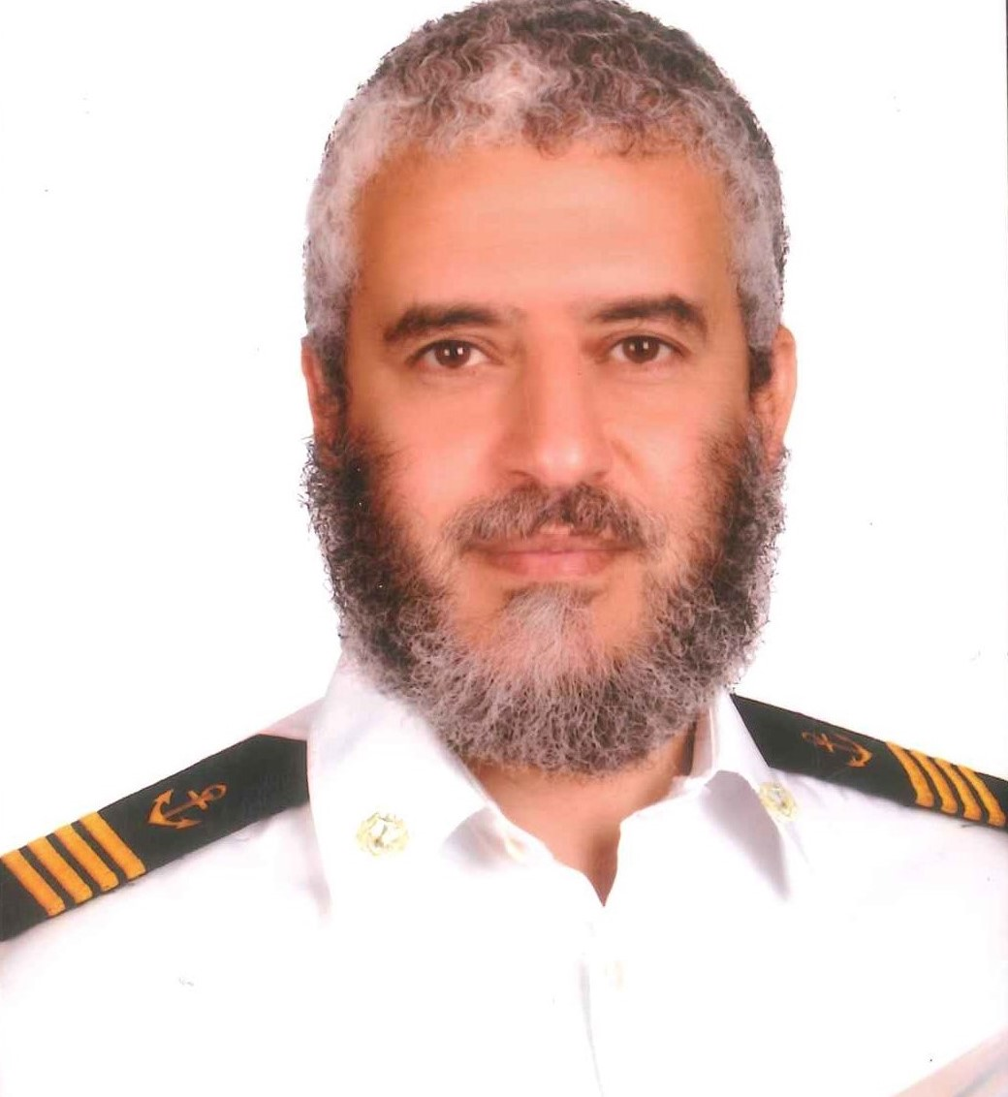
PH 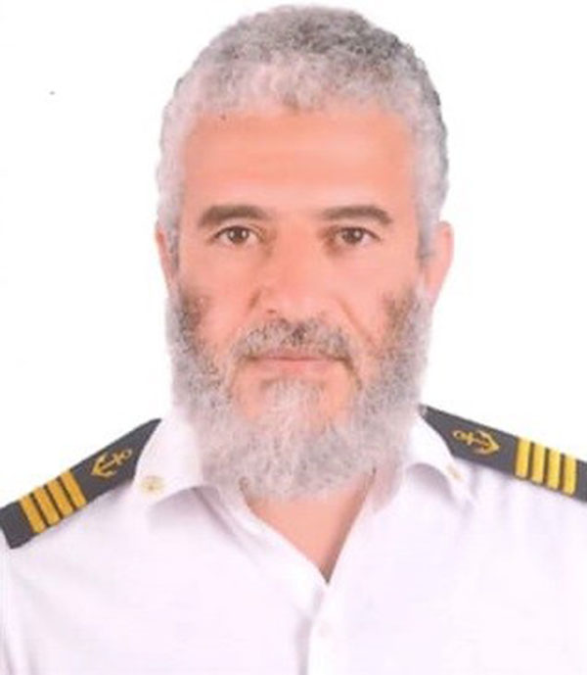 OTO

APPLICATION FORM

1 |  | Position applied for: chief engineer

2 |  | Personal details
 |  | Name: |  | (Surname) EBRAHIM
 |  |  |  | (First Names) ALAA
 |  |  |  | (Middle Name) SOLTAN MEHANA
 |  | Date/Place of Birth: |  | 1/10/1966 |  |  |  | Nationality: |  | EGYPTIAN
 |  | E-Mail address: |  | alaamehana@yahoo.co.uk
 |  |  |  |  |  | Mobil :+201061759188 |  |  |  |  |  | Mobile | +201148858514
3a |  | Educational Background
 |  | Qualification | School / College |  |  |  | From |  |  |  | To |  |  | Percentage/ Grade
 |  | Bachelor of mechanical engineer | Faculty of engineering/Alexandria university |  |  |  | 1985 |  |  |  | 1989 |  |  | V.good

Technical Background

Degree/ Diploma | Institute/ College | From | To | Percentage / Grade
Chief engineer | Arab maritime academy | 1998 | 1999 | Excellent
Welding course | DONBOSCO | 1993 | 1993 | EXCELLENT

4 |  | Identity documents
 |  | DOCUMENT |  | COUNTRY | NUMBER |  |  |  | DATE OF ISSUE |  | PLACE OF ISSUE |  |  | DATE OF EXPIRY
 |  | Passport: |  | Egyptian | A28480304 |  |  |  | 17-7-2021 |  | Egypt |  |  | 16-7-2028
 |  | Seaman Book: |  | National | S00016613 |  |  |  | 25-7-2021 |  | Egypt |  |  | 14-6-2026
 |  |  |  | Cyprus | Cy111999 |  |  |  | 27/8/2007 |  | Limassol |  |  | 26/8/2017
 |  |  |  | Liberian | 1816128 |  |  |  | 10/6/2023 |  | Virginia usa |  |  | 19/6/2028
 |  |  |  | Others | MH 487310 |  |  |  | 19/8/2016 |  | Piraeus Greece |  |  | 16/8/2021
 |  | US Visa ‘C1/D’? |  |  |  |  |  |  | Issue Date: |  | 7/2022 |  | Expiry Date: 7/2027
6 |  | Certificates (Highest certificate of competency held)
 |  | Grade/Class Of COC Country | Issuing Country |  |  | Date of Passing Exam |  | Certificate No. |  | Date Issued |  | Place Issued |  |  | Valid Until
 |  | CHIEF EENGINEER | EGYPT |  |  | 1/1999 |  | 1867 |  | 15-7-2021 |  | Egypt |  |  | 14-6-2026

9  9 |  | Record of previous service

COMPANY | VESSEL NAME | VESSEL TYPE | D.W.T/  GRT | CONTS TEU’S | VSL AGE | TYPE OF ENGINES  (Please give full dtls) | B.H.P | RANK | SIGN ON dd/mm/yy | SIGN OFF dd/mm/yy | DURATION yy/mm/dd | REASONS FOR S/OFF
Genco SH.c | GENCO WEATHERLY | Bulk-GS | 63000 |  | 2014 | MAN B&W  6S50ME | 12000 | CH/ENG | 11/5/2023 | 12/10/2023 |  | End of contract
Genco sh.co | Genco weatherly | Bulk-GS | 63000 |  | 2014 | MAN B&W 6S50ME | 12000 | CH/ENG | 7/11/2020 | 26/05/2021 |  | End of contract
Ocean recruitment sh.co | STPNOT | Bulk-GS | 57000 |  | 2013 | MAN B&W 6S60M | 11000 | CH/ENG | 9/1/2020 | 14/8/2020 |  | End of contract
national navigation company | EDFU | Bulk-GS | 83000 |  | 1996 | B&W  6S60MC | 13000 | CH/ENG | 8/3/2019 | 26/09/2019 |  | End of contract
OCEAN MARINE | BEAUTYOCEAN | Bulk-GS | 75000 |  | 20113 | MAN B&W 6S60Mc | 11500 | CH/ENG | 13/01/2016 | 15/5/2016 |  | End of contract
INTERORIENT | meraldstrait | Bulk-GS | 57000 |  | 2013 | MAN-B&W-6S50ME | 12500 | CH/ENG | 28/1/2015 | 30/8/2015 |  | End of contract
Ocean recruitment sh.co | COLOMPUS | Bulk-GS | 205000 |  | 2013 | MAN-B&W6S60ME-C | 17500 | CH/ENG | 21/7/2014 | 10/12/2014 |  | End of contract
Ocean recruitment sh.co | BEAUTYOCEAN | Bulk-GS | 75000 |  | 2013 | MAN-B&W6S60Mc | 12000 | CH/ENG | 13/1/2014 | 15/4/2014 |  | End of contract
ADNATCO | BUTTINAH | Bulk-GS | 54000 |  | 2011 | MAN-B&W6S60MC-C | 11500 | CH/ENG | 23/5/2011 | 23/09/2011 |  | End of contract
OCEAN MARINE | EDCOSTAR | Bulk-GS | 102000 |  | 1998 | B&W  6L80GFCA | 14500 | CH/ENG | 22/5/2008 | 8/3/2009 |  | End of contract
nord reederi klaus oldendoreff | nordelebe | Bulk-GS | 115000 |  | 2006 | Hundai B&W  7S60MC | 12000 | CH/ENG | 13/7/2007 | 21/12/2007 |  | End of contract
national navigation company | wadi elnile | Passenger | 8000 |  | 1998 | Wortsilla  16V32LND | 8000 | CH/ENG | 2/6/2006 | 21/11/2006 |  | End of contract
UNITED ARAB SHIPPING COMP | DEIRA | Container | 66000 |  | 1998 | MAN &BW  10L80MC | 46700 | CH/ENG | 25/10/2005 | 3/4/2006 |  | End of contract
UNITED ARAB SHIPPING COMP | AL FOWAIRET | Container | 66000 |  | 1998 | MAN &BW  10L80MC | 46700 | CH/ENG | 13/1/2005 | 24/7/2005 |  | End of contract
UNITED ARAB SHIPPING COMP | AL FARAHIDI | Container | 66000 |  | 1998 | MAN &BW  10L80MC | 46700 | CH/ENG | 5/2/2004 | 11/9/2004 |  | End of contract

5. ATTENDED DETAILS OF COURSES
Course | No of Certificate | Date of issue | Place of issue | Date of expire
PERS. SAFETY & SOC. RESP. | L580275 | 17/6/2021 | EGYPTIAN AUTHORITY FOR MARITIME SAFETY | 16/06/2026
PERSONAL SURVIVAL | L580432 | 17/6/2021 | EGYPTIAN AUTHORITY FOR MARITIME SAFETY | 14/06/2026
Advanced Fire Fighting | L580200 | 17/6/2021 | EGYPTIAN AUTHORITY FOR MARITIME SAFETY | 16/6/2026
Proficiency in Survival Craft & Rescue Boats | L578151 | 9/6/2021 | EGYPTIAN AUTHORITY FOR MARITIME SAFETY | 7/6/2026
Medical First Aid | L578384 | 10/6/2021 | EGYPTIAN AUTHORITY FOR MARITIME SAFETY | 9/6/2026
Proficiency of security awareness training for seafarers with designated security duties | L579246 | 15/6/2021 | EGYPTIAN AUTHORITY FOR MARITIME SAFETY | 13/06/2026
Shipboard High Voltage Application And Safety Training Course | L351637 | 25/4/2017 | EGYPTIAN AUTHORITY FOR MARITIME SAFETY | Forever
prevention and combating of marine pollution | 41971/16/EG | 22/9/2016 | EGYPTIAN AUTHORITY FOR MARITIME SAFETY | Forever
Refresher and updating course for [management level] engineering department | L578844 | 13/6/2021 | EGYPTIAN AUTHORITY FOR MARITIME SAFETY | 10/06/2026

