Anglo-Eastern
3/F LinkHouse 78 Cowcross Street
London, EC1M 6EJ United Kingdom

SEAFARER APPLICATION FORM

Position applied for: ________________

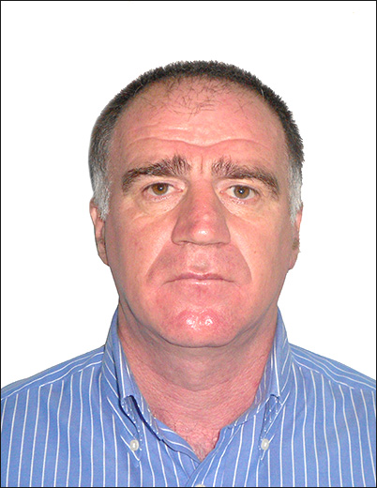

1 Surname : __ANZOR _________ 4 Date of birth : __22.MAY.1965__
2 Name : __KAITAMBA __________ 5 Place of birth : __KHELVACHAURI __
3 Given name : __________________ 6 Citizenship : ____GEORGIA______

7 Address : ___BATUMI V.GORGASALI STR 127 APP9_____________________________
8 Phone No.(home) : _+995 422277349_ 9 Phone No.(contact): _+995555919907___

10 Seaman's ID No. : _S010605_____ 14 InterPassport No.: _17AA13592_____
11 Place of issue : M.T.A. Georgia 15 Place of issue : Ministry of Justice
12 Date of issue : _14.DEC.2023___ 16 Date of issue : __19.FEB.2018___
13 Date of expiry : _14.DEC.2033___ 17 Date of expiry : __19.FEB.2028___

18 Marital status ( Married )
19 Wife’s name : _MAGULI________ 20 Weight/Height : __74_/ 174_______
21 Mother’s name : _GULNARA_______
22 Approved Education: ____________ BATUMI STATE MARITIME ACADEMY _____________________
23 CERTIFICATES
Description | Registration No. | Place of issue | Date of issue
Certificate of Competency | 18G01-01-004480 | Maritime Transport Agency, Georgia | 26.08.2027
Endorsement to the CC | 18G01-01-004480-02 | -------- | 26.08.2027
Ship’s Security Officer | SSO02- 207906 | -------- | 22.12.2028
Basic safety training STCW’ 78/95 | BST02- 207905 | -------- | 20.12.2028
* Medical Care | MFC04- 123740 | -------- | 26.05.2025
* Fire Fighting | AFT02- 207908 | -------- | 12.01.2029
* Survival Craft | FRB02- 207907 | -------- | 30.12.2028
* Medical First Aid | BST02- 207905 | -------- | 20.12.2028
Chemical Tanker | OCG10-093345 | -------- | 25.07.2028
Oil Product Tanker | OCG10-093345 | -------- | 25.07.2028
Electronic Chart Display | ECS04-123739 | -------- | 18.05.2025
Bridge Team Management | BTM02-168715 | -------- | 21.08.2027
HAZMAT / Dangerous Cargoes | CDH02- 207909 | -------- | 21.01.2029
Security Awareness Training | SEC02-207910 | -------- | 24.01.2029
Designated Security Duties | SEC02-207910 | -------- | 24.01.2029
ARPA | RBS02-168723 | -------- | 12.08.2027
GMDSS / GOC | 18G09-23-002377 | -------- | 10.12.2028
Radar Simulator | RBS02-168723 | -------- | 12.08.2027
Sips Safety Officer | 003/24 | -------- | 29.01.2029
Medical Examination
Vaccination Yellow Fever | 5164 | M.H.C.Georgian | 06.05.2030
24 PROFESSIONAL EXPERIENCE DURING LAST 5 YEARS (in backwards order)
RANK | MISSION  STARTED | MISSION  COMPLETED | SHIPOWNER/Nationality  Tel/Fax/e-mail | VESSEL  Name & Type | DWT | ME  Type/BHP
MASTER | 14.03.24 | 25.07.24 | BEK SHIPPING | M.V BOSPORUS QUEEN | 7009 | MAK 3075
MASTER | 14.10.22 | 26.11.23 | T- SHIPPING | M.V AH ERA | 10763 | B&W 5279
MASTER | 15.02.22 | 07.07.22 | ONEXS MARITIME | M.V N.KUZNETSOV | 4020 | SKL 2540
MASTER | 20.05.21 | 14.10.21 | KANAKIS & ENGINEERING S.R.L | M.V ANCHON MICHAEL | 3600 | MAN 2430
MASTER | 04.04.20 | 24.10.20 | GANT TRADING COR | M.V FORESTER | 4902 | MAN 2350
MASTER | 28.06.19 | 08.11.19 | SEA GLORY SHIPPING | M.V SAFE WAY | 4876 | MAK 3280
MASTER | 23.05.18 | 30.10.18 | MIA SHIPPING | M.V AYLIN | 4678 | MAK 3040

Minimum acceptable salary USD __NEGOTIABLE___

I, undersigned, confirm all above information to be true and correct to my best knowledge:
Signature of the Applicant __ANZOR KAITAMBA ___

CREW MANAGER REMARKS | 1 | 2 | 3 | 4 | 5
English: |  |  |  | GOOG

