CURRICULUM VITAE
PERSONAL DETAILS
Family name |  | ASADOV |  |  | 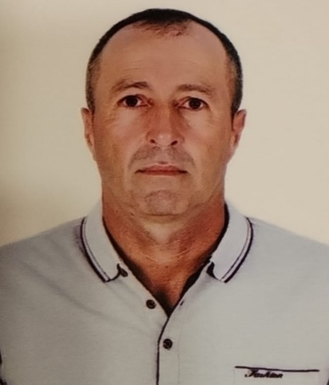
First name |  | AZIZ
Father’s name |  | IZAFADDIN
Date and place of birth |  | 21/06/1973Azerbaijan
Nationality |  | Azerbaijani
Marital status |  | No
Permanent address |  | Azerbaijan, BAKU
Nearest airport |  | Heydar Aliyev International Airport Baku, Azerbaijan
Height (cm) | Weight (kg) | Eyes color | Hair color | Size of safety shoes | Size of coveralls
175 cm | 86 kg | BROWN | BLACK | 42 | 52
CONTACT DETAILS
Mobile | E-mail address
+994553935879
NEXT OF KIN (FOR EMERGENCY)
Next of kin |  | Relationship | Brother
Date of birth |  | Address | Baku,Azerbaijan
Phone |  | Mobile phone
TRAVEL PASSPORT DETAILS
Document | Number | Place of Issue | Issued | Valid
PASSPORT | C03552708 | Azerbaijan | 14.09.2023 | 13.09.2033
SEAMAN’S BOOK DETAILS
Document | Number | Place of Issue | Issued | Valid
Seaman book | DGK025828 | Azerbaijan ,Baku | 22.11.2023 | 22.11.2028
SEAARERS IDENTITY | AZE030700 | Azerbaijan ,Baku | 22.11.2023 | 22.11.2028
EDUCATION
Full name of School | Place of Issue | Grade/Class | From | To
Azerbajan  KAINAT MARITME LLC | Azerbaijan , Baku | COOK 000024 | 09.03.2023
KNOWLEDGE OF LANGUAGES
Languages | Speaking | Reading | Writing
Azerbaijan | Excellent | Excellent | Excellent
Russian | Excellent | Excellent | Excellent
Turkish | Excellent | Excellent | Excellent

COMPUTER SKILLS
Windows | Microsoft Office | Internet
Excellent | Excellent | Excellent
MEDICAL INFORMATION
Document | Grade | Place of issue | Date of issue | Date of expiry
Med.Sertificate | A/B | Azerbaijan | 19.06.2023 | 19.06.2025
CERTIFICATE OF COMPETENCY
Class/Grade | Issuing country | Certificate No. | Date issued | Expires | Details of Limitations
COOK | Azerbaijan Marine Administration | COOK 2461/23 | 14.11.2023 |  | COOK
STCW AND OTHER CERTIFICATES
Name of course/Certificate | Institute | Place | Date of issue | Cert.No | Date of expiry
International Safety Management | Azerbaijan Marine Adminstration | Azerbaijan Baku | 22.09.2023 | SP-3209-23 | 22.09.2028
Proficiency in survival craft and boats other than fast rescue boats | Azerbaijan Marine Adminstration | Azerbaijan Baku | 20.09.2023 | SL-3555-23 | 20.09.2028
Training for seafarers with designated security duties | Azerbaijan Marine Adminstration | Azerbaijan Baku | 28.09.2023 | SH-2614-23 | 25.09.2028
Basic safety trainig | Azerbaijan Marine Adminstration | Azerbaijan Baku | 27.12.2022 | S0-5980-22 | 19.12.2027
Ship Security-related familization security-awareness | Azerbaijan Marine Adminstration | Azerbaijan Baku | 15.09.2023 | SI-2994-23 | 15.09.2028
SEA EXPERIENCE (LAST 5 YEARS – MOST RECENT EXPERIENCE ON TOP LINE)
Vessel | Company | Type of vessel | Flag | DWT | GRT | BHP | Rank | Sign on | Sign off
AMUR 2528 | NR GORUP | GEN CARGO | Russia [RU] | 3332 | 3086 | 116.03 x 13.43 | COOK | 10.05.2022 | 30.01.2023
BAKI 357 | SEMAYE  SHIPPING | Ore/Oil Carrier | AZERBAIJAN | 3280 | 2615 | 119.04 x 13.46 | COOK | 25.07.2023 | 05.02.2024
GAS MİLANO | MACC (Marine Advisors Coparation Center) | LPG Tanker | Marshall Islands | 4500 | 4402 | 99x18 | COOK | 20.03.2024 | 01.09.2024

