Yücel Zeyyat Özbay
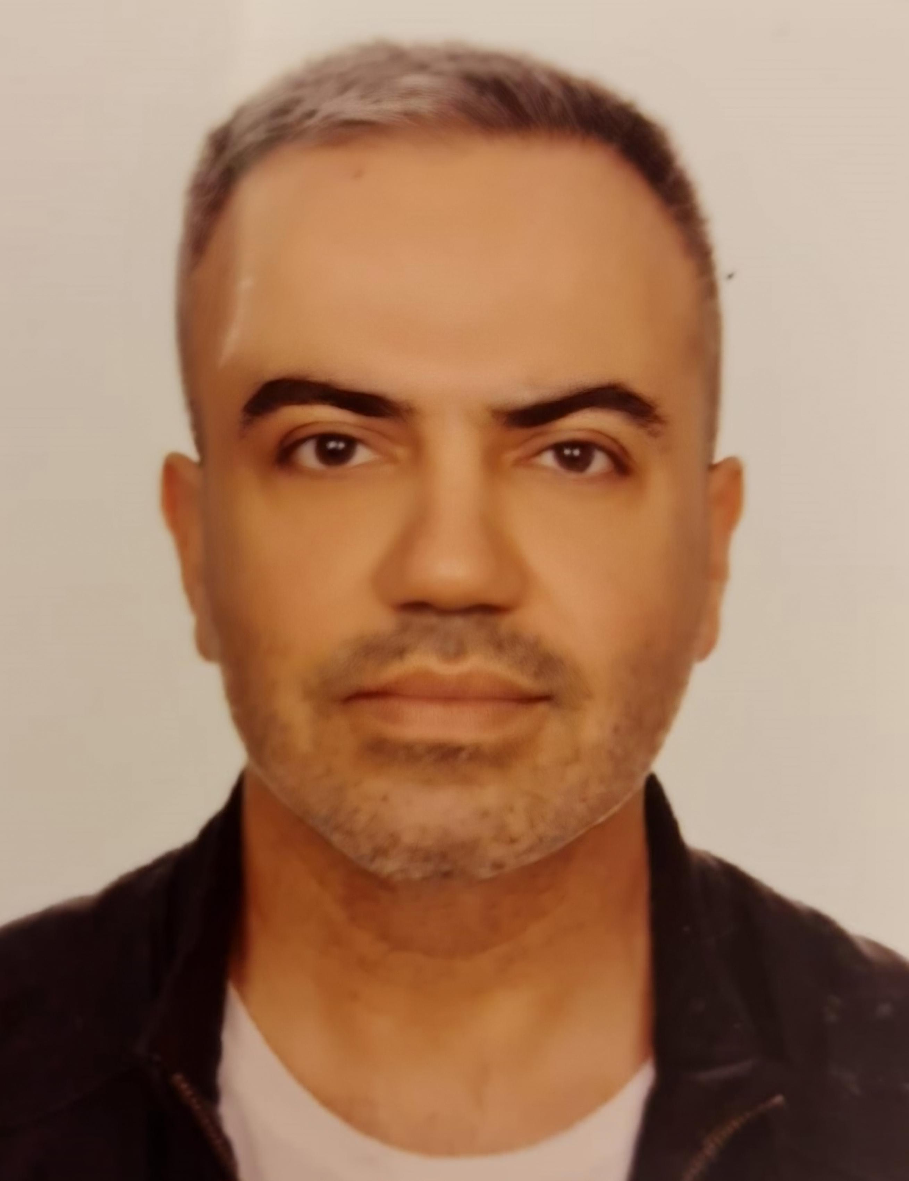 1st. Adress : İstasyon Mah. Vatan Cad. Zirvekent 2 Blokları Tuzla/İst
2nd. Adress : Ivan Shishman 22/7 Varna Bulgaria
Telephone : +90 5325227242 (WP and Viber)

e-mail : yucellion@gmail.com

Date of Birth : 11 August 1982

Nationality : Turkish
Visa : Permanent Residence Permit for All Europe Schengen Terretories from Bulgaria
Education

Sep 2009 – Jul 2014 Varna Technical University – Varna, Bulgaria
Bachelor Degree of Engineering in Marine Transportation and Management Engineering
Sep 2014 – Jun 2015 Varna Technical University – Varna, Bulgaria
Master Degree of Engineering in Marine Transportation and Management Engineering
Work Experience
01th of July 2024 – 30th of September 2024 Oceangoing Master(COC) on LR Tanker Ship ( 72000DWT)
Trinident Trinity Co.
9th of February 2024 – 13th of June 2024 Oceangoing Master(COC) on MR Tanker Ship ( 45000DWT) Trinident Trinity Ship Co.
July 2023 – Oct 2023 Oceangoing Chf. Officer
MT Nikolay , Vlad Shipping
Duty: Ship’s Chf. Officer, Cargo Officer, Ship Security Offıcer
Jun 2021 – Feb 2023 Dynamic Positioning Operator (DPO) – QHSE Supervisor – ISM Supervisor – Marine Manager
Drill Ship / Sondaj Gemisi - Turkish Petroleum

Dec 2019 – Jan 2021 Rig Administrator , Crew Management and Transfer, Helicopter Comms.
Drill Ships / Sondaj Gemisi - V. Ships Istanbul /
Nov 2018 – Jun 2019 Oceangoing Whatchkeeping Officer - Chf. Officer
Oil Tanker, Med Tanker
Duty: Ship’s Chf. Officer, Cargo Officer, Ship Security Offıcer
Sep 2017 – Jun 2018 Oceangoing Watchkeeping Officer – Chf. Officer
General Cargo, Istanbul Shipping
Duty: Ship’s 2nd Officer/3rd Officer, Medical Officer, Radio Officer, Deputy
Security and Safety Officer
Dec 2016 – Jun 2017 Oceangoing Watchkeeping Officer - Chf. Officer
Oil/Chemical Tanker, Vlad Shipping
Duty: Ship’s 2nd Officer/3rd Officer, Medical Officer, Radio Officer, Deputy
Security and Safety Officer

Other Qualifications
- Member of Nautical Institute London since 2022
- Dec 2019 – Dec 2023 BOSEIT
Certifications and Licenses
- Bulgaria Maritime Oceangoing Master License

- Undersecretariant of Maritime Affairs of Bulgaria -issued Oceangoing Master Licence
• Offshore Unlimited Dynamic Positioning Operator License ( Nautical Institute London – UK )
• Chemical Tanker Familiarization Certification
• Advanced Training Programme on Chemical Tanker Operations Certificate
• Personal Survival Techniques Training Certificate
• Proficiency in Survival and Rescue boats (Other than Fast Rescue boat) Certificate
• Elementary First Aid Training Certificate
• Medical Care Training Certificate
• Medical First Aid Training Certificate
• Fire Prevention and Fire Fighting Training Certificate
• Advanced Fire Fighting Training Certificate
• Personal Safety and Responsibility Training Certificate
• Oil Tanker Familiarization Certificate
• Advanced Training Programme on Oil Tanker Operations Certificate
• Navigational Watchkeeping Certificate
• RADAR Observation and Plotting Training Certificate
• The Operational Use of Automatic Radar Plotting Aids (ARPA) Training Certificate
• ECDIS Certificate
• Bridge Resources Management Certificate
• Ship Security Officer Certificate
• Security-Related Familiarization Certificate
• Designated Security Duties Certificate
• Security Awareness Certificate
• GMDSS General Radio Operator Certificate (GOC)
Software

- Advance knowledge of Microsoft Office and related programs
- Ship specific programs; SOLAS approved ECDIS ( Transas, JRC, Furuno), NS5, EDMAR, Danaos, Shipnet, ISF Watchkeeper, ChartCo, Ship Manager, Electronic Digital Publications and Nautical Publications
Language

- Turkish/ Native language
- English/ Advance (Fluent)
- Bulgarian/ Beginner
- Russian/ Beginner

References
- Cpt. Nikolay Bedzhev
Teı : +359888479003
- Efe Sipahi
V SHIPS Istanbul – General Manager
Tel : +90 545 8285449

