Application Form Deck & Engineering Officers

Personal Information |  | 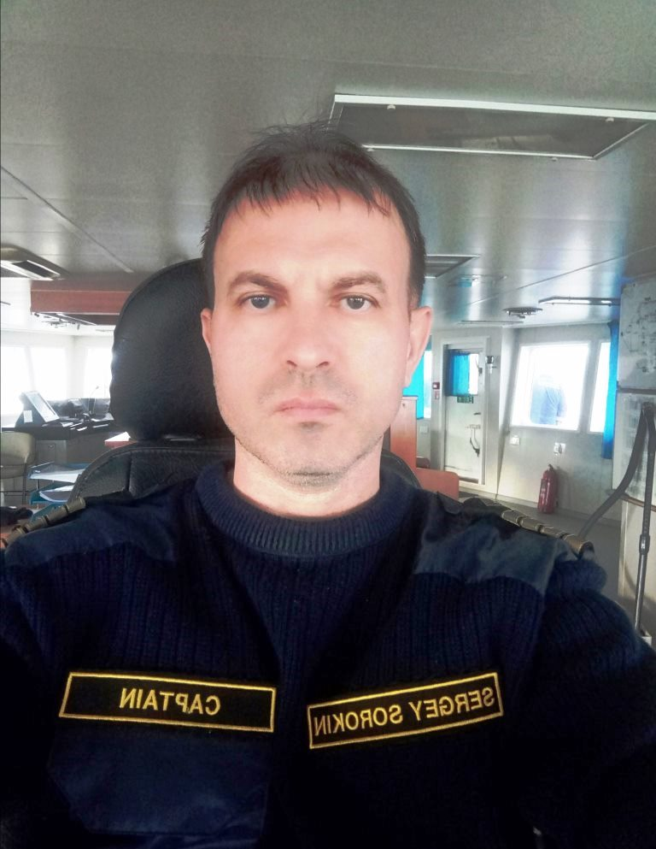
Given Name | SERGEY
Surname Name | SOROKIN
Citizenship | Russian
Date of Birth | Astrakhan, Russia
Place of Birth | 03.07.1974
Sex | Male
Religion | Christian
Marital Status | married
No of Children | 2
Rank Applied For | MASTER

Contact Information
Address | Airport | Babaevskogo Street 3-/33, Astrakhan, Russia
Home Phone | +7 927 284 61 42 | Mobil phone | +7 927 284 61 42
Skype | sergeymaster41 | E-mail | sergey.master@mail.ru  sergeysorokin.aqua@gmail.com

Passport Information
Date Of Issue | 12.01.2024 | Passport No | 77 220847
Date of Expiry | 12.01.2034 | I/C No (Malaysians Only) | Russia
Place of issue | Russia

Next Of Kin Information
Name of Next of Kin | Svetlana Sorokina | Relationship | Wife
Home Phone | N/A | Mobile phone | +7 962 751 31 11
Address | General Gerasimenko str. 4-/2, Astrakhan, Russia, box 414032

EPF & SOSCO Information (Malaysian Citizens/ Malaysian PR)
EPF # |  | SOSCO #
Tax # | N/A
Do you have Tax exemption Letter

 | Certificates
 |  | Cert No | Cert. Class (I ; II ; III ; IV) | Date Of Issue | Date Of Expiry | Place of Issue
Seaman Book |  | MK 0267880 |  | 28.02.2011 | Permanent | Russia
Certificate of Competency (Master) |  | ASF 204283372 | II/2 | 17.09.2020 | 18.08.2025 | Russia
Basic Safety Training |  | 1464209 |  | 03.09.2020 | 03.09.2025 | Astrakhan, Russia
Medical First Aid |  | 1551397 |  | 12.08.2020 | 12.08.2025 | Astrakhan, Russia
Proficiency in Survival Craft |  | 1550548 |  | 04.09.2020 | 04.09.2025 | Astrakhan, Russia
Training of seafarers with designated security duties |  | 13118756 |  | 01.09.2020 | 01.09.2025 | Russia
GMDSS + Endorsement |  | 144-G/20 |  | 19.08.2020 | 19.08.2025 | Astrakhan, Russia
ARPA |  | 1465034 |  | 26.08.2020 | 26.08.2025 | Astrakhan, Russia
Radar Simulator |  | 1465204 |  | 29.08.2020 | 29.08.2025 | Astrakhan, Russia
Advance Fire Fighting |  | 1551162 |  | 05.09.2020 | 05.09.2025 | Astrakhan, Russia
Ship Security Officer |  | 1160270 |  | 27.08.2018 | 27.08.2023 | Astrakhan, Russia
Operational use of electronic chart display and information system - ECDIS |  | 1465489 |  | 22.08.2020 | 22.08.2025 | Russia
Medical Certificate of Fitness |  | 582 |  | 29.02.2024 | 01.03.2025 | Medical Centre “KOMMED”
Proficiency in fast rescue boats
Bridge Team and Resources Management |  | 20180420 BRM0046 |  | 20.04.2018 | 20.04.2023 | ALMA-ATA
Medical Care |  | 00000018 |  | 28.10.2015 | 28.10.2020 | Russia. State Marine Academy
Training of seafarers with designated security duties |  | 1160270 |  | 27.08.2020 | 27.08.2025 | Russia
Marlins Test |  | BBC196C53937547F |  | 17.01.2016 | 17.01.2021 | Russia

PREVIOUS SEA SERVICE
VESSEL | OWNERS | FLAG | VSL TYPE | GRT | ENG Type | HP/KW | RANK | SIGN-ON | SIGN-OFF | Area of Operations | Length of Service
NEFTERUDOVOZ 37 | VOLGOTANKER VOLZHSKI OIL SHPG | RUS | ORE/OIL CARRIER | 2615 | SKL | 888 | MASTER | 28.08.2004 | 10.12.2004 | World wide | 3mon,12days
NEFTERUDOVOZ 33 | VOLGOTANKER VOLZHSKI OIL SHPG | RUS | ORE/OIL CARRIER | 2615 | SKL | 888 | MASTER | 29.06.2005 | 19.12.2005 | World wide | 5 mon,21days
VOLGODON-5021 | VASSILEV MARITIME NAKLIYAT | RUS | GCGO | 3958 | SKL | 1480 | MASTER | 20.06.2006 | 15.10.2006 | World wide | 3 mon,25d
PALLADIY | VASSILEV MARITIME NAKLIYAT | RUS | GCGO | 3994 | SKL | 1480 | MASTER | 03.02.2007 | 10.04.2007 | World wide | 2m,7d
VOLGODON-5041 | VASSILEV MARITIME NAKLIYAT | RUS | GCGO | 3958 | SKL | 1480 | MASTER | 04.05.2007 | 05.07.2007 | World wide | 2m
SARA MAATJE IX | ACTA MARINE BV | KAZ | AHTS | 528 | CATERPILLAR | 2*814 | MASTER | 27.09.2007 | 01.02.2008 | Caspian sea | 3m,4d
SARA MAATJE IX | ACTA MARINE BV | KAZ | AHTS | 528 | CATERPILLAR | 2*814 | MASTER | 02.04.2008 | 10.07.2008 | Caspian sea | 3m,8d
SARA MAATJE XV | CASPIAN SERVICES GROUP LTD | PAN | SEISMIC VESSEL | 419 | CATERPILLAR | 1850 | MASTER | 10.09.2008 | 20.12.2008 | Caspian sea | 3m,10d
P-1 | CASPIAN OCEAN LLP | KAZ | ACCOMODATION BARGE | 2850 | CATERPILLAR |  | MASTER | 12.03.2009 | 12.05.2009 | Caspian sea | 2 m
P-1 | CASPIAN OCEAN LLP | KAZ | ACCOMODATION BARGE | 2850 | CATERPILLAR |  | MASTER | 05.06.2009 | 10.08.2009 | Caspian sea | 2m,5d
UNION | CASPIAN OCEAN LLP | KAZ | OSV | 850 | MITSUBISHI | 1110 | MASTER | 02.09.2009 | 10.10.2009 | Caspian sea | 1m,8d
SOMERI | RIVER SEA SHIPPING CO LTD | BLZ | TUG single screw | 270 | DAEWOO | 2590 | MASTER | 15.10.2009 | 14.03.2010 | Black sea | 5m
IEVOLI SHUTTLE | CASPIAN OCEAN LLP | KAZ | OFFSHORE SUPPLY VSL | 523 | CATERPILLAR | 2*1332 | MASTER | 20.03.2010 | 29.07.2010 | Caspian sea | 4m,9d
IEVOLI SHUTTLE | CASPIAN OCEAN LLP | KAZ | OFFSHORE SUPPLY VSL | 523 | CATERPILLAR | 2*1332 | MASTER | 07.09.2010 | 01.01.2011 | Caspian sea | 3m,25d
IEVOLI SHUTTLE | CASPIAN OCEAN LLP | KAZ | OFFSHORE SUPPLY VSL | 523 | CATERPILLAR | 2*1332 | MASTER | 07.03.2011 | 01.05.2011 | Caspian sea | 1m,24d
IEVOLI SHUTTLE | CASPIAN OCEAN LLP | KAZ | OFFSHORE SUPPLY VSL | 523 | CATERPILLAR | 2*1332 | MASTER | 29.05.2011 | 29.06.2011 | Caspian sea | 1m
OT-2431 | ARK SHIPPING CO LTD | RUS | TUG boat | 824 | 64PH 36/45 | 1776 | MASTER | 12.07.2011 | 12.08.2011 | Caspian sea | 1m
HOSHI | Thong Yong Marine PTE LTD | SGP | TUG boat | 296 | CATERPILLAR | 1776 | MASTER | 05.10.2011 | 18.12.2011 | Persian gulf | 2m,13d
KIDA | Thong Yong Marine PTE LTD | INDONESIA | TUG boat | 294 | CATERPILLAR | 1554 | MASTER | 11.01.2012 | 04.02.2012 | Persian gulf | 24d
HALLIBURTON-301 | TIMES MARINE SURVEY | PAN | OSV | 1048 | CATERPILLAR | 2*1361 | MASTER | 10.06.2012 | 01.09.2012 | Persian gulf | 2m,21d
LAMNALCO CHOUGH | SMIT LAMNALCO LTD | CYP | AHTS | 981 | CATERPILLAR | 5149 | MASTER | 27.11.2012 | 29.01.2013 | Persian gulf | 2m,2d
GULF HORIZON | Horizon Survey | PAN | Supply 4 point mooring | 1356 | DEUTZ | 2*1349 | MASTER | 13.06.2013 | 28.07.2013 | Persian gulf | 1m,15d
LIGER | Blank Top Invest | SVS | Tug Boat ASD | 352 | CATERPILAR 3516C HD | 5200 | MASTER | 18.10.2013 | 05.12.2013 | Baltic sea | 1 m,22d

Dulam Responder | Integrated Marine Services | PAN | DSV | 1190 | CATERPILLAR | 3400 | MASTER | 26.12.2013 | 30.01.2014 | Persia gulf | 1 m.4d
Aqua Diver II | Aqua Diving Service | UAE | DSV | 510 | CATERPILAR | 3100 | Master | 17.08.2014 | 27.11.2014 | Persian Gulf | 3 m.10 d.
Aqua Lift-II | Aqua Diving Service | UAE | JACK UP | 1037 | COMINS | 3500 | CHIEF MATE | 11.02.2015 | 20.05.2015 | Persian Gulf | 3 m.9 d.
Glomar Avior | Glomar Marine | PAN | ERRV | 620 | Mitsubishi | 1200 | Master | 10.10.2015 | 29.10.2015 | Baltic Sea | 20 d.
Ocean Fortune | Marine Core Charter | PAN | AHTS. | 427 | CATERPILAR | 1500 | Master | 07.08.2016 | 07.10.2016 | Persian Gulf | 2m.8 d.
ORION | GIDROMECHANIK CO. | RUS | TUG boat | 485 | 6NVD | 1720 | MASTER | 28.03.2017 | 01.06.2017 | Baltic Sea | 2m.4 d.
ORION | GIDROMECHANIK CO. | RUS | TUG boat | 485 | 6NVD | 1720 | MASTER | 01.08.2017 | 01.10.2017 | Baltic Sea | 2m.
ORION | GIDROMECHANIK CO. | RUS | TUG boat | 485 | 6NVD | 1720 | MASTER | 28.12.2017 | 01.04.2018 | Baltic Sea | 3m.5 d
TOPAZ DON | TOPAZ MARINE | RUS | MPSV / ASD | 3183 | CAT | 2100 | CHIEF OFFICER | 10.05.2018 | 13.07.2018 | Baltic Sea | 2m.3d
REYD - 9 | EMCO | RUS | MPSV / ASD | 3704 | CAT | 1800 | MASTER | 09.05.2019 | 10.06.2019 | Japan sea | 1m.4d
DS Provider | Daniel Survey | Saint-Vinsent | 4 point mooring | 877 | Cat | 1937 | MASTER | 05.10.2019 | 08.12.2019 | Persian gulf | 2 m
DS Provider | Daniel Survey | Saint-Vinsent | 4 point mooring | 877 | Cat | 1937 | MASTER | 12.03.2020 | 15.06.2020 | Persian gulf | 3 m,3 d
Beluga Rotterdam | Beluga Project | Russia | AHTS | 294 | cat | 2386 | MASTER | 02.07.2020 | 03.08.2020 | Polar ring | 1m
MB-1204 | NORTH-WEST CO. | Russia | Tug boat | 520 | COMINS | 720 | MASTER | 04.11.2020 | 31.03.2021 | Caspian sea | 4 m, 20
MB-1204 | NORTH-WEST CO. | Russia | Tug boat | 520 | COMINS | 720 | MASTER | 01.04.2021 | 07.07.2021 | River-Sea | 3 m, 7
BLENDA | GAC MARINE | Panama | Tug boat | 396 | CAT3512 | 2X1250 | MASTER | 05.09.2021 | 25.10.2021 | Persian gulf | 1m,20 d
MARZHAN | GAC MARINE | Panama | AHTS | 1678 | CAT3516b | 2X1920kW | MASTER | 26.10.2021 | 27.12.2021 | Persian gulf | 2m,1d
MIMI | GAC MARINE | Panama | AHTS | 678 | Wartsila6L26 | 5350HP | MASTER | 05.02.2022 | 14.04.2022 | Persian gulf | 2m,9d
ULRIKA | GAC MARINE | Panama | Tug boat | 499 | Mitsubisi | 4000HP | MASTER | 15.04.2022 | 09.06.2022 | Persian gulf | 1m,26d
ANN SOFIE | GAC MARINE | Panama | AHTS | 678 | CAT3516b | 5350HP | MASTER | 25.09.2022 | 08.03.2023 | Arabian gulf | 5m.11d
BLENDA | GAC MARINE | Panama | Tug boat | 396 | CAT3512 | 2X1250 | MASTER | 12.06.2023 | 16.12.2023 | Persian gulf | 6m.4d
YAUZA | JSC Marine chartering Co. | Russia | Cable layer | 10000 | Mitsubishi | 1x3200 hp | MASTER | 11.06.2024 | 15.07.2024 | Barents sea
РOmskiy 14 | BKS Shipping | Russia | General cargo | 2700 | 6 NVD | 2x515 kwt | Master | 04.08.2024 | 22.08.2024 | Black sea | 18 d.

