APPLICATION FORM

 |  |  |  |  |  |  | 6 | 6 | 1 | 9 | 1 | 2 | D
 |  | Personal ID Number
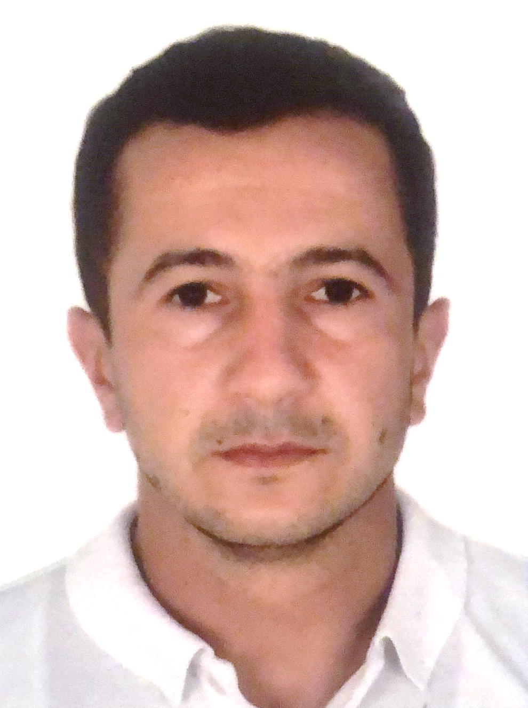

Position Applied for: Electrician (III/6) | Date Available from: ANY TIME

1. Personal Data +
Family Name:  Garakhanov | First Name:  Mubariz | Middle Name:  Zohrab
Date of Birth:  12.04.1996 | Place of Birth:  Azerbaijan/ Guba | Citizenship:  Azerbaijani
Permanent Address:  Azerbaijan/ Guba |  | Phone (Home): +99450 362 22 18  Whatshapp +99450 362 22 18  E-mail: Mubariz.qaraxanli@mail.ru

2. Maritime Education +
Name of school | Town | Country | From | To | Type of degree or diploma
Azerbaijan State Marine Academy | Baku | Azerbaijan | 2013 | 2017 | Bachelor

3. Professional Test +
EnglishTest Date | Nameof Test | Score
Professional TestDate | Nameof Test | Score
Professional Interview Date | Result

4. FamilyDetails -
Civil Status (Single, Married, Separated, Divorced, Widowed):
Single
Next of Kin (the first emergency contact) :  Garakhanov Aykhan | Relationship:  Brother
Address of Residence:  Azerbaijan/Guba | +99455 248 22 13

5. IdentityDocuments +
Document | Country | Number | PlaceofIssue | IssueDate | Expiry Date
Seaman's Book | Azerbaijan | DQK 024960 | State Maritime Adminstration | 08.09.2023 | 08.09.2028
Travel Passport | Azerbaijan | C02813895 | Ministry of Internal Affairs | 13.12.2019 | 12.12.2029

6. ValidVisa
CountryorUnion | Type | ValidUntil

7. Courses Attended and Certificates Obtained
Document | Number | Dates |  | Place
Document | Number | Issue | Expiry | Place

CertificateofCompetency | RP-13375 | 22.08.2023 | N/A | State Maritime Administration
MalteseEndorsementof COC
OilTankerEndorsement
ChemicalTankerEndorsement
GasTankerEndorsement
OilTankerFamiliarizationTraining
ChemicalTankerFamiliarizationTraining
GasTankerFamiliarizationTraining
OilTankersSpecializedTraining
ChemicalTankerSpecializedTraining
GasTankerSpecializedTraining
BasicTrainings | SO-3655-23 | 27.07.2023 | 20.07.2028 | State Maritime Administration
Proficiency in Survival Craft and Rescue Boats | SL-2795-23 | 04.08.2023 | 31.07.2028 | State Maritime Administration
AdvancedFireFighting
MedicalFirstAidTraining
Medical First Aid Training and Medical Care
GMDSS
GMDSS Endorsement
RadarObservation&Plotting
Automatic Radar Plotting Aids Simulator (ARPA)
BridgeTeamManagement
Shiphandling&Maneuvering
Ship Security-related familiarization security-awareness training | SI-2236-23 | 13.07.2023 | 13.07.2028 | State Maritime Administration
MalteseEndorsementof SSO
ISM Code | SP-2469-23 | 26.07.2023 | 26.07.2028 | State Maritime Administration
SafetyOfficer
ECDISTrainingCourse
RiskAssessmentCourse
C.O.W./ I.G.S
FirePracticeonTankers
VapourRecoverySystem
UnmannedMachinerySpace
FRAMO FamiliarizationCourse
Cargo Ballast Operations on Oil/Chemical Tankers
HazardousMaterials
Welder
Turner
Risk Management And Incident Investigation
Training of seafarers with designated security duties
Dangerous hazardous and harmfull cargoes | SH-1799-23 | 27.07.2023 | 27.07.2028 | State Maritime Administration
BasicTraining and qualifications on oil and chemical tanker cargo operations | SA-0946-23 | 17.11.2023 | 17.11.2028 | State Maritime Administration
Crowd management training

8. PhysicalData
Height | 168 sm
Weight | 64 kg
Colourof Hair | Black
Colourof Eyes | Brown
BoilersuitSize | M
ShoesSize | 40

9. MedicalHistory | Yes | No
Have you ever signed off a ship due to medical reasons? |  | No
Did you undergo any medical operation in the past? |  | No
Have you consulted a doctor during the last 12 months for an illness/accident? |  | No
Do you have any health or disability problems now? |  | No

If yes, please give full details:

 | Passed: | Valid till:
International Medical Examination | 18.07.23 | 18.07.25
Vaccination Against YellowFiver
Vaccination Against Diphtheria

10. References (please give name and address of your current or past employer) | Officeremarks

NameofCompany
Name of person to contact
Address
Phone

NameofCompany
Name of person to contact
Address
Phone

11. Bank address forallotments
Beneficiary
AccountNo.
NameofBank
BankAddress

12. Knowledgeandexperience | Yes | No
OCIMF vetting experience:
ISGOT knowledge:

13. I hereby declare that the above, including Medical History, is true
Place

14. ForOfficeuseonly

15. Seagoing Experience

Nameofvessel | Flag | Vessel’sType | DWT | EngType | HP | Manageror Owner | Rank | From d/m/y | Tod/m/y | Total  m/d
Nizami | Azerbaijan | Drei cargo | 3950 | Diesel |  | Azerbaijan Caspian Shipping Closed Joint-Stock Company | practitioner | 18.06.2014 | 28.09.2014 | 3 m, 10 d.
Aura | Azerbaijan | Offshore | 1393 | Diesel |  | Azerbaijan Caspian Shipping Closed Joint Company | practitioner | 01.06.2015 | 28.09.2015 | 3 m, 28 d.
Şirvan | Azerbaijan | Crane | 11159 | Diesel |  | Azerbaijan Caspian Shipping Closed Joint Company | electrician | 01.06.2016 | 01.01.2016 | 6 m, 4 d
Sabit Orujlov | Azerbaijan | Passenger ship | 19813 | Diesel |  | Azerbaijan Caspian Shipping Closed Joint Company | electrician | 02.02.2017 | 22.08.2017 | 6 m, 20 d
Total |  |  |  |  |  |  |  |  |  | 1 y, 7 m.

Total rank sea service: Total type of vessel sea service:
Rank | Years |  | Typeofvessel | Years
Electrican |  |  | OIL TANKER
 |  |  | LPG
 |  |  | DRY CARGO
 |  |  | TANKER ICE
 |  |  | OIL /CHEMICAL TANKER
 |  |  | FERRY
Total |  |  | Total:

