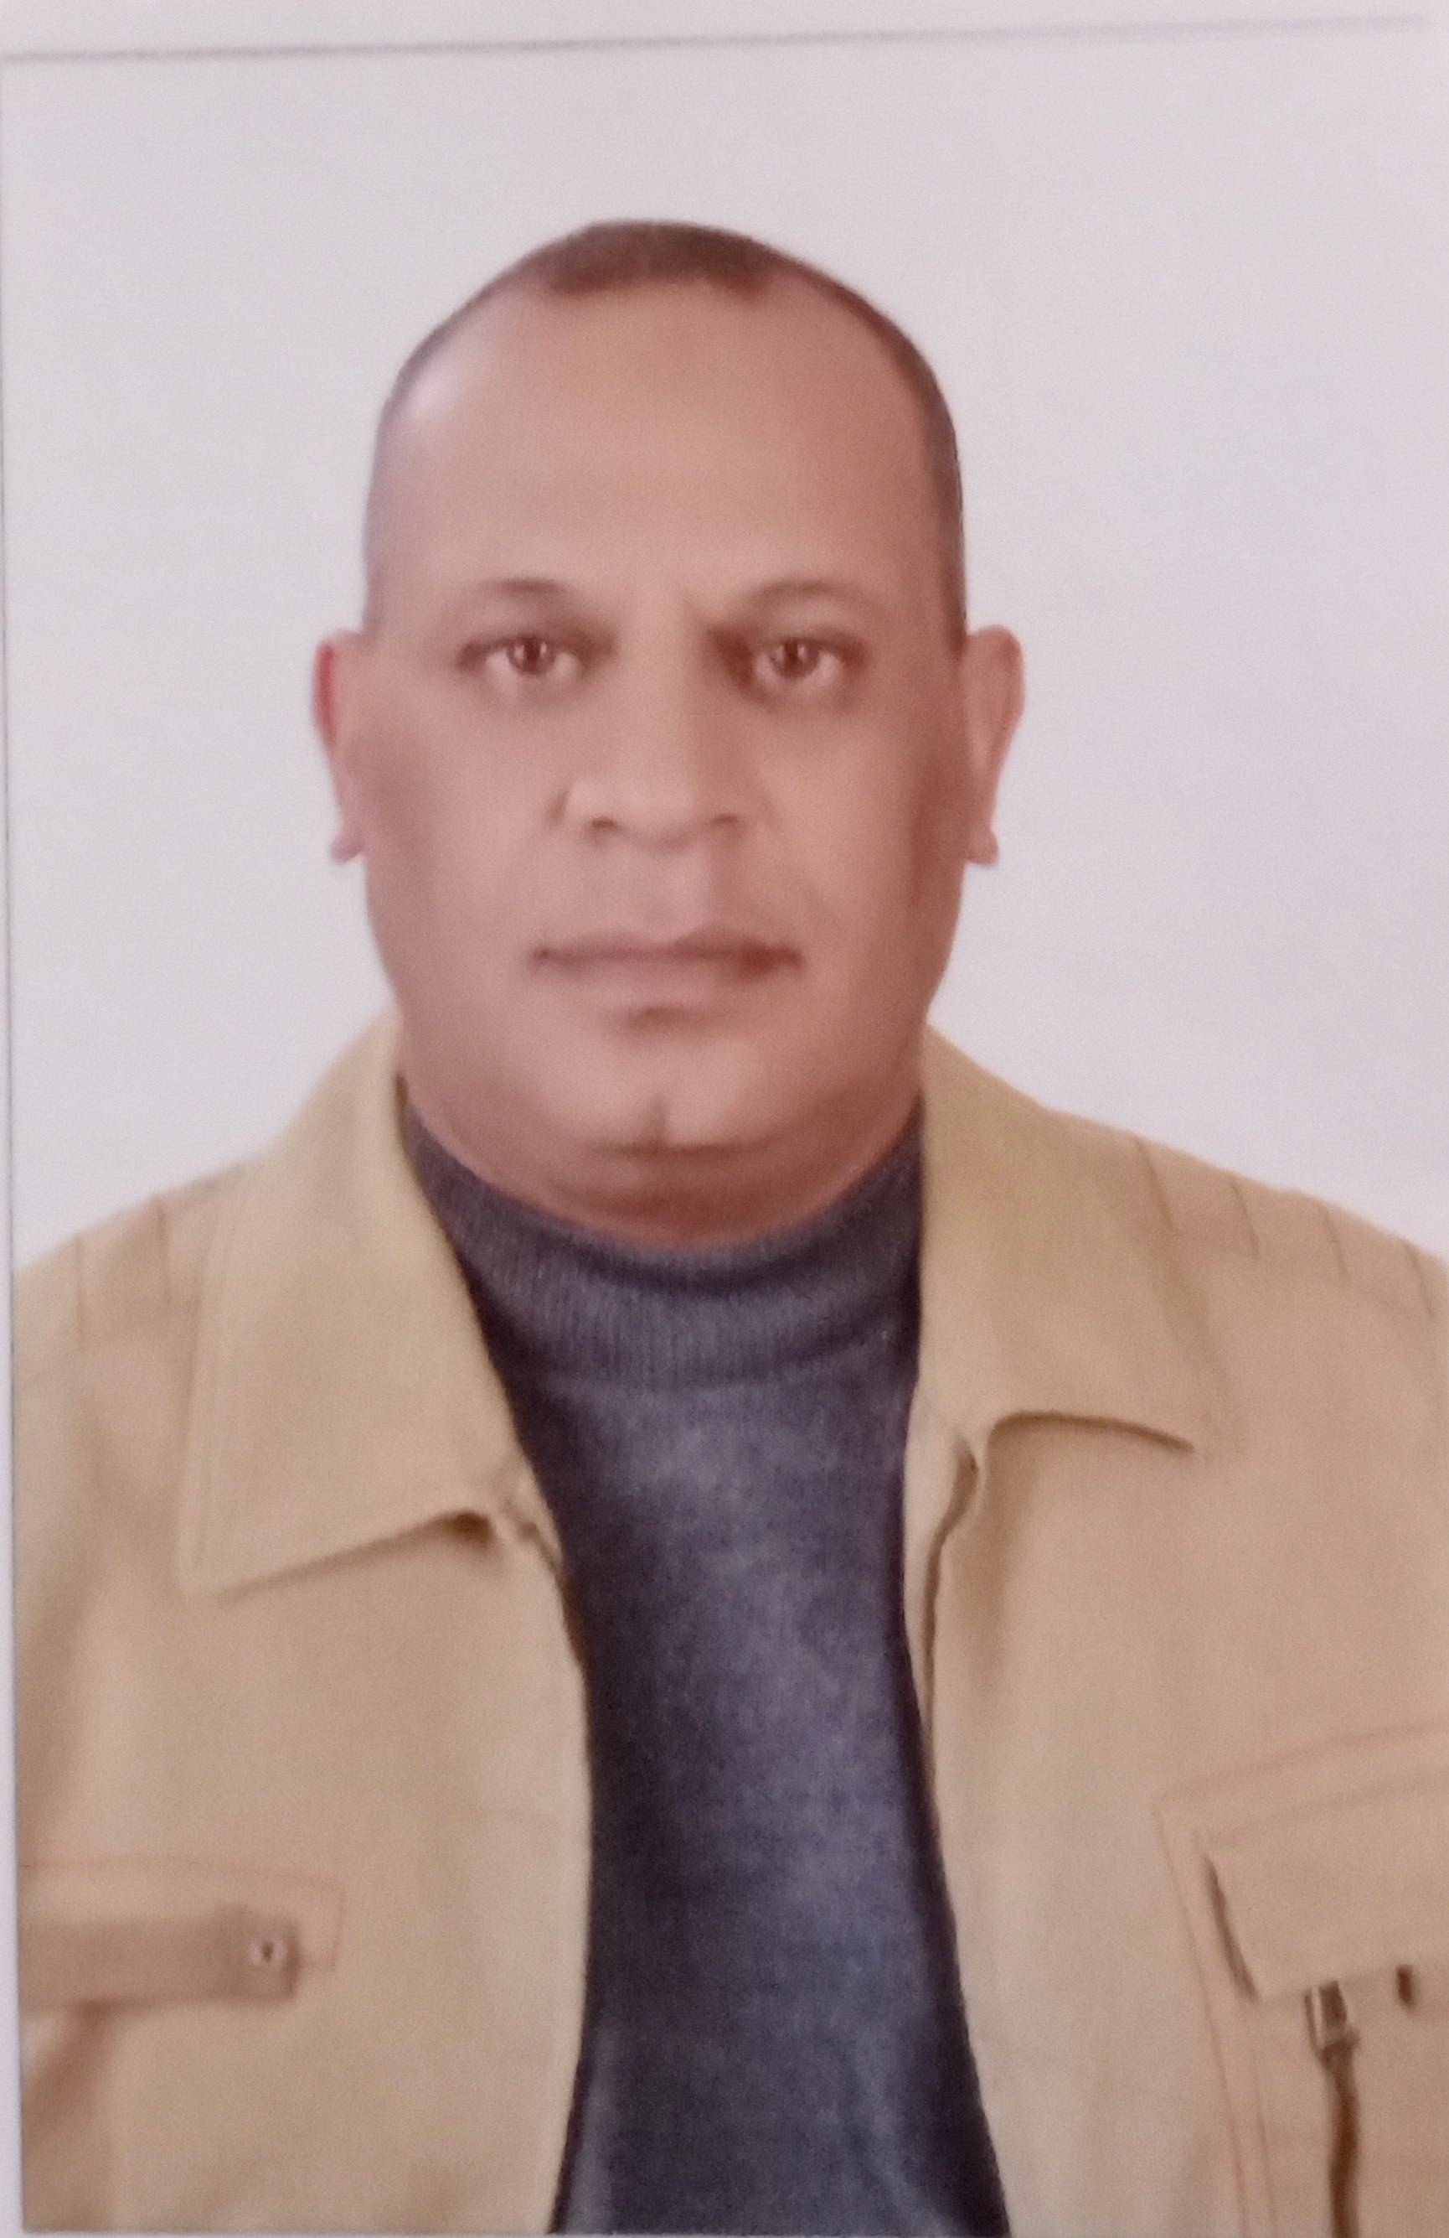
CV

:Rank : Cheif Cook
:First Name. : Salah
:Middel Name. : Bastawy
:Last name : Radwan
:Date of Birth : 25/01/1970
:Military Service : Completed
:Marital Status : Married
:Nationality : Egyptian
:Address : Shams aldawla Street No 9, Alexandria – Egypt.
:Home No. : +2034942010
:Mobile No : 00201002771472
:E-mail : basta_salah@yahoo.com
:Next kin name. : Nader Salah Bastawy
:Tel No. : +201014164643
^{Identity Documents} | ^{Number} | ^{Issuance Date} | ^{Expiration Date}
^{Seaman Book} | ^{S00023791} | ^{04/07/2022} | ^{28/06/2027}
^{Passport} | ^{A30840501} | ^{28/06/02022} | ^{27/06/2029}

Certificates | ^{Issuance Date} | ^{Expiration Date}
Hotels marine catering Diploma (Art of cooking)from (1991)(1993)AASTMT | _{25/9/1993} | _{XXXXXXX}
^{PERSONAL SURVIVAL TECHNIQUES} | _{12/10/2020} | _{11/10/2025}
^{FIRE PREVENTION &FIRE FIGHTING} | _{12/10/2020} | _{11/10/2025}
PERSONAL SAFETY & SOCIAL RESPONSIBILITIES | _{28\10\2021} | _{25/10\2026}
^{ELEMENTARY FIRST AID} | _{12/10/2020} | _{11/10/2025}
PROFICIENCY IN SURVIVAL CRAFTS & RESCUE BOATS | _{02\11\2021} | _{27\10\2026}
PROFICIENCY OR SECURITY AWARENESS TRAINING  SEAFARERS WITH DESIGNATED SECURITY DUTIES | _{28/03/2023} | _{22/03/2028}
^{BASIC H2S TRAINING} | _{06/06/2023} | _{04/06/2025}
^{BOSIET} | _{11/11/2021} | _{08/11/2024}
^{FOOD HANDLING} | _{04/06/2023} | _{02/06/2025}
PERSONAL HYGIENE ENVIRONMENTAL PROTECTION | _{30/07/2022} | _{26/07/2027}
^{FOOD STORAGE&INVENTORY CONTROL} | _{30/07/2022} | _{26/07/2027}
PRACTICAL ABILITY TO PREPARE MEALS AND FOOD | _{30/07/2022} | _{26/07/2027}
SAFETY&HEALTH IN THE PROVISION OF MEALS | _{30/072022} | _{26//07/2027}
^{CERTIFICATE COOK ON SHIP} | _{24/08/2022} | _{25/07/2027}
INTERNATIONAL MEDICAL CERTIFICATE FOR SEAFARERS | _{18/07/2022} | _{17/07/2024}
^{YELLOW FAVER} | _{10/01/2012} | _{XXXXX}
^{OGUK} | _{09.01.2024} | _{09.01.2026}
ASTRAZENECA VACCINE OF COVID19 (3 Dose) | _{19/05/2021} | _{21/09/2022}

^{Previous sea service}
^{From} | ^{To} | ^{Name of Vessel} | ^{Rank} | ^{Flag} | ^{Ship type} | ^{Company Name}
^{02/07/2004} | ^{27/01/2005} | ^{Fast Arrow} | ^{CH Cook} | ^{Malta} | ^{Ro r o} | ^{Dem line Egypt}
^{20/06/2005} | ^{02/06/2006} | ^{Fast Independence} | ^{CH Cook} | ^{Malta} | ^{Ro R o} | ^{Dem line Egypt}
^{31/08/2006} | ^{09/02/2007} | ^{Fast Independence} | ^{CH Cook} | ^{Malta} | ^{Ro R o} | ^{Dem line Egypt}
^{13/02/2007} | ^{04/09/2007} | ^{Al Horeya 1} | ^{CH Cook} | ^{Egypt} | ^{Ro R o} | ^{Egyptian Shipyard}
^{23/10/2007} | ^{21/01/2008} | ^{Fast Challenger} | ^{CH Cook} | ^{Egypt} | ^{Ro R o} | ^{Dem line Egypt}
^{14/02/2008} | ^{04/06/2008} | ^{Fast Arrow} | ^{CH Cook} | ^{Malta} | ^{Ro R o} | ^{Dem line Egypt}
^{28/07/2008} | ^{12/03/2009} | ^{Fast Challenger} | ^{CH Cook} | ^{Egypt} | ^{Ro R o} | ^{Dem line Egypt}
^{14/05/2009} | ^{23/08/2009} | ^{Fast Independence} | ^{CH Cook} | ^{Malta} | ^{Ro R o} | ^{Dem line Egypt}
^{06/09/2009} | ^{11/12/2009} | ^{Fast Independence} | ^{CH Cook} | ^{Malta} | ^{Ro R o} | ^{Dem line Egypt}
^{11/12/2009} | ^{06/07/2010} | ^{Fast Arrow} | ^{CH Cook} | ^{Malta} | ^{Ro R o} | ^{Dem line Egypt}
^{12/08/2010} | ^{06/09/2010} | ^{Fast sea Runner} | ^{CH Cook} | ^{Malta} | ^{Ro R o} | ^{Dem line Egypt}
^{14/10/2010} | ^{03/02/2011} | ^{Fast Challenger} | ^{CH Cook} | ^{Egypt} | ^{Ro R o} | ^{Dem line Egypt}
^{13/04/2011} | ^{14/11/2011} | ^{CMA CGM QUETZAL} | ^{CH Cook} | ^{CYPRUS} | ^{Container} | ^{DIORYX shipping}
^{24/05/2012} | ^{28/01/2013} | ^{Fast Challenger} | ^{CH Cook} | ^{Egypt.} | ^{Ro R o.} | ^{Dem line Egypt}
^{14/04/2013} | ^{07/09/2013} | ^{Fast Challenger} | ^{CH Cook} | ^{Egypt} | ^{Ro R o} | ^{Dem line Egypt}
^{26/11/2013} | ^{24/6/2014} | ^{Jabal Ali 1} | ^{CH Cook} | ^{Panama} | ^{Ro R o} | ^{Naif Marine Serv}
^{09/09/2014} | ^{31/05/2015} | ^{Jabal Ali 1} | ^{CH Cook} | ^{Panama} | ^{RORO} | ^{Naif Marine Serv}
^{31/05/2015} | ^{05/06/2015} | ^{Jabal Ali 4} | ^{Ch Cook} | ^{Aqaba} | ^{RORO} | ^{Naif Marine Serv}
^{09/09/2015} | ^{01/02/2016} | ^{Leen Almelahia} | ^{CH Cook} | ^{KSA} | ^{L/C} | ^{MACNA}
^{15/03/2016} | ^{19/06/2016} | ^{Dana Almelahia} | ^{CH Cook} | ^{KSA} | ^{L/C} | ^{MACNA}
^{01/08/2016} | ^{21/04/2016} | ^{Reema Almelahia} | ^{CH Cook} | ^{KSA} | ^{L/C} | ^{MACNA}
^{08/02/2017} | ^{28/04/2017} | ^{Bourbonevalution80} | ^{CH Cook} | ^{VCT} | ^{D p3} | ^{Aramark catering}
^{08/05/2017} | ^{20/06/2017} | ^{SESV SHAMAL} | ^{CH cook} |  | ^{Barge} | ^{Aramark catering}
^{11/01/2018} | ^{11/4/2018} | ^{Vega egypt1} | ^{CH cook} | ^{Marchal} | ^{DP2} | ^{Thome offshore}
^{17/05/2018} | ^{03/07/2018} | ^{Belait barakah} | ^{Ch cook} |  | ^{Supply} | ^{Makamin ofshore}
^{03/07/201} | ^{09/04/2018} | ^{Makamin camp} | ^{Ch cook} |  | ^{Ac Camp} | ^{Makamin offsore}
^{09/05/2019} | ^{13/09/2019} | ^{Belait barakah} | ^{Ch Cook} |  | ^{Suplly} | ^{Makamin offshore}
^{21/10/2019} | ^{17/09/2020} | ^{MKN204} | ^{Ch cook} | ^{San ven} | ^{DP} | ^{Makamin offshore}
^{06/12/2020} | ^{19/02/2021} | ^{Pan GG} | ^{Ch.cook} | ^{Egypt} | ^{Container V} | ^{Pan marine serv}
^{32/03/2021} | ^{25/06/2021} | ^{Albatros} | ^{Ch.cook} | ^{Bahama} | ^{Cruises ship} | ^{Pan marine serv}
^{09/12/2021} | ^{13/06/2022} | ^{Posh endivour} | ^{Ch cook} | ^{Sigapou} | ^{supply ship} | ^{Posh}
27.09.2022 | 27.04.2023 | Jolly express | Ch.cook | Portugal | Roro | MSC
27.07.2023 | 30.11.2023 | Sleipnir | Ch cook | Panama | Heavy left | Heerema contractors
20.03.2024 | 20.10.2024 | ARO 56 | Ch cook | Marshal | Oil rig | Conntrak catering

