- RESUME
POST APPLIED FOR : CHEEF. COOK
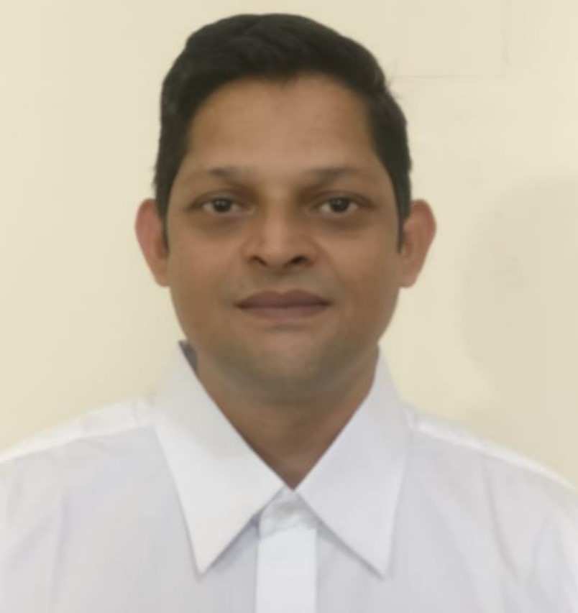
NAME : RAMESH SANWAL
FATHER’S NAME : NARAYAN DATT SANWAL
GENDER/MARITAL STATUS : MALE/MARRIED
DATE OF BIRTH : 15/07/85
NATIONALITY/RELIGION : INDIAN
LANGUARGE KNOWN : HINDI, ENGLISH, MARATHI,KUMAONI ।
CONTACT NO. :6395069220/ +917830530624
QUALIFICATION : 10thPASS
EMIL ID sanwalramesh89@gmail.com

PRESENT ADDRESS: | PERMANENT ADDRESS
SHIVALIK VIHAR BISHTDHARA BITHORIA NO 1 HALDWANI, NAINITAL PIN. 263139, UTTARKHAND, INDIA | SHIVALIK VIHAR BISHTDHARA BITHORIA NO 1 HALDWANI, NAINITAL PIN. 263139, UTTARKHAND, INDIA

DOCUMENT DETAILS:
DOCUMENT | NUMBER | DATE OFISSUE | DATE OF EXP. | PALCE OF ISSUE
PASSPORT | Z5407605 | 11/11/2019 | 10/11/2029 | DEHRADUN
CDC | MUM 502678 | 23/03/2023 | 22/03/2033 | MUMBAI
Sid | M338488220 | 25/07/2023 | 24/07/2033 | MUMBAI
YELLOW FEVER
Indos | 00ZL1047 | 16/06/2008 | NA | MIMBAI
COVID,19 | Z5407605 | 25/01/2021 | 15/02/2021 | 25/10/2021
NUSI CARD
Coc | CC/MUM/2024/E008 | 11-OCT-2024 | NA | MUMBAI

COURSES DETAILS:
COURSE | CERTIFICATE NO | DATE OF ISSUE | DARE OF EXP. | PLACE OF ISSUE
EFA | 10501666212300814 | 17/02/2023 | N.A | DEHRADUN
PST | 10501666212300814 | 17/02/2023 | N.A | DEHRADUN
FPFF | 10501666212300814 | 17/02/2023 | N.A | DEHRADUN
PSSR | 10501666212300814 | 17/02/2023 | N.A | DEHRADUN
STSDSD | 10501661012300414 | 17/02/2023 | N.A | DEHRADUN
OPITO | 52515858090323504820 | 09/03/2023 | 15/02/2027 | ABU.DHABI

COMPANY | VESSEL | TYPE |  | RANK | SIGN ON | SIGN OFF
SODEXO | PUNJ LORD | BARGE |  | COOK | 16/08/2009 | 25/2/2010
SODEXO | ENSCO 104 | JACK UP RIG |  | COOK | 05/4/2010 | 28/11/2012
SODEXO | DISCOCER  INDIA | DIRLL SHIP |  | COOK | 15/01/2013 | 29/04/2013
A.K.SARAF | ONGC | PLATEFORM |  | COOK | 15/06/2013 | 08/11/2013
KELVIN SODEXO | ABAN | RIG DD2 |  | CHIEF  COOK | 15/01/2014 | 22/11/2015
KELVIN SODEXO | ABAN | RIG DD4 |  | CHIEF  COOK | 28/01/2015 | 10/01/2017
KELVIN SODEXO | SHILF DRILLING | RIG |  | CHIEF  COOK | 15/02/2017 | 12/05/2019
KELVIN  SODEXO | SHILF DRILLING | RIG |  | CHIEF  COOK | 25/03/2019 | 10/01/2023
SEAFOX | TRIDENT ONE | JACKUP  BARGE |  | CHIEF  COOK | 20/04/2023 | 30/06/2023
CCTC | JOPETWIL 300 | JACKUP BARGE |  | CHEF COOK | 02/07/2023 | 07/10/2024

PLACE:
DATE :

RAMESH SANWAL

