NOMINATION FOR EMPLOYMENT |  |  |  |  |  | 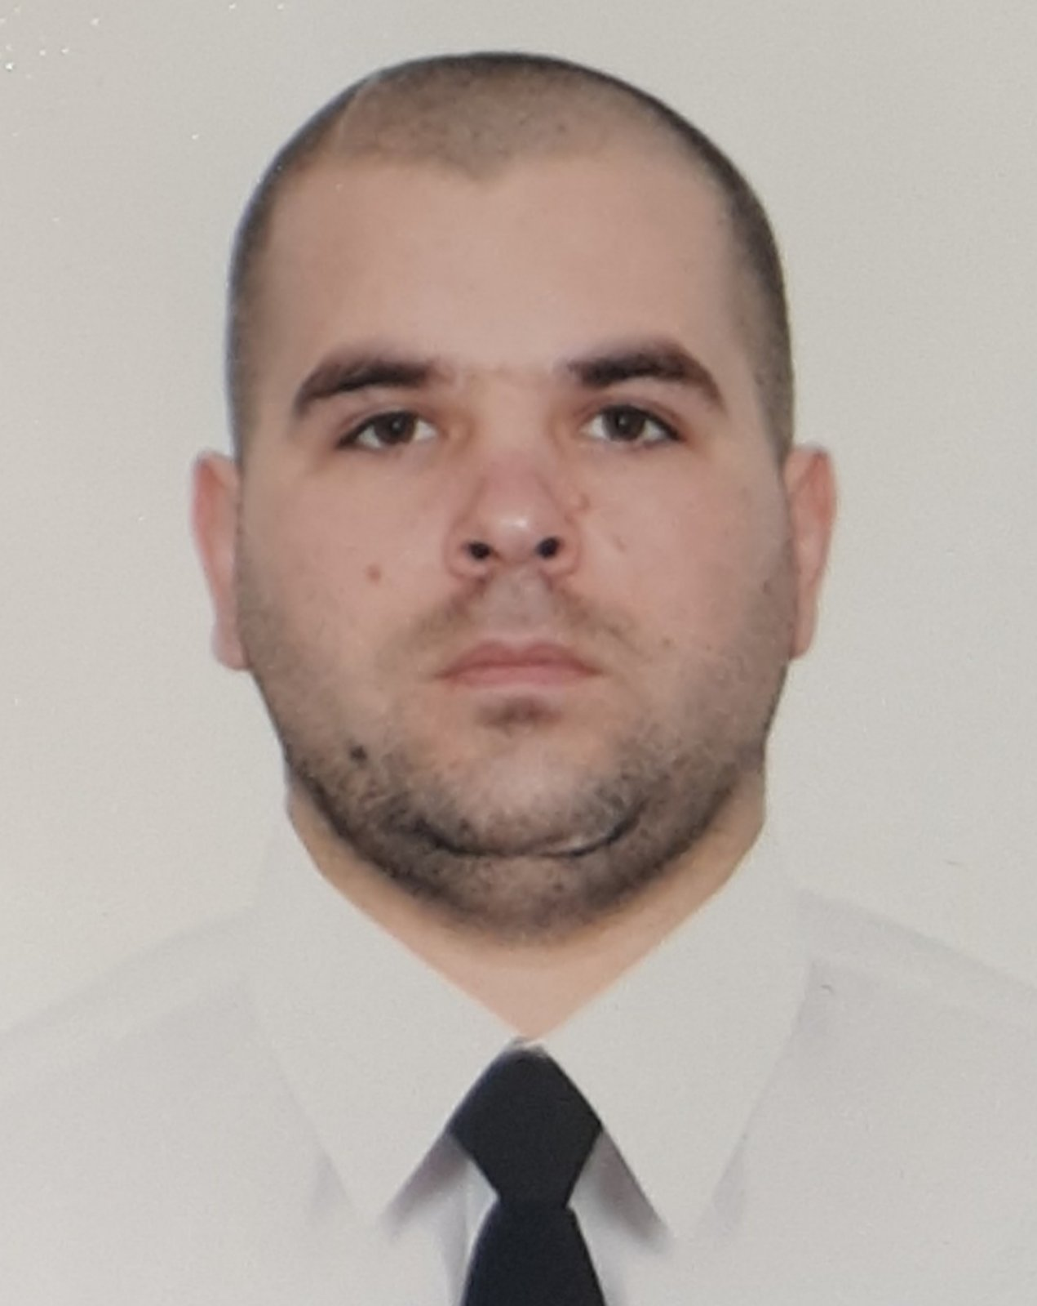
Position applied for:
4th Engineer
Surname: Babenko |  |  | First name : Oleksandr
 |  |  | Father's name : Volodimirovich
Date of birth : 13.10.1991 |  |  | Place of birth: Ukraine,Odessa reg
Nationality: Ukrainian |  |  | Departure airport:International Chisinau
Home address : Ukraine,Odessa ,Kiliysk.reg reg..,vil..Shevchenko
Email : babenkosacha91@gmail.com |  |  | Mob phone: +38 099 306 85 83
Number of children under the age of 18: Yes |  |  |  | status: married
Next of kin /relationship / Wife - Olga |  |  |  | +38 066 69 31 692
 | Height  176 | Weight  95 | Shoes  44 |  | Overall size  54-56
 | Required Salary min 3400USD |  | Last Salary 3500USD

STCW 95 CERTIFICATES:
Description |  | Grade | Number |  | Place | Issue | Expiry
Certificate of Competency |  | Third-class Engineer | 31345/2024 |  | Ukraine | 24.07.2024 | ------
Endorsement |  | Third-class Engineer | 31345/2024 |  | Ukraine | 24.07.2024 | 12.12.2027
Certificate of Competency |  | Motorman  1nd class | 02347/2018/08 |  | Ukraine | 05.07.2018 | ------
Seaman's Book |  |  | AB 570187 |  | Ukraine | 05.04.2016 | 10.12.2025
Foreign passport |  |  | FA 880237 |  | Ukraine | 09.10.2015 | 09.10.2025
Foreign passport _biometric .jpg |  |  | FK 893816 |  | Ukraine | 15.01.2018 | 15.01.2028
Yellow Fever |  |  |  |  | Ukraine | 26.01.2016 | ------
Certificate of Proficiency on Advanced Training on Liquified gas Tankers |  |  | 23716/2024 |  | Ukraine | 22.10.2024 | 15.10.2029
Certificate of Proficiency On Basic Training on Liquified Gas Tankers |  |  | 23314/2024 |  | Ukraine | 22.08.2024 | 15.08.2029
Certificate of proficiency on advanced training on liquified gas tankers |  |  | 14/03241/2024 |  | Ukraine | 20.06.2024 | 20.06.2029
Certificate of Proficiency on Basic Training on Liquified Gas Tankers |  |  | 11/05135/2024 |  | Ukraine | 02.08.2024 | 02.08.2029
Certificate of proficiency in basic safety training |  |  | 26/03240/2024 |  | Ukraine | 20.06.2024 | 20.06.2029
Certificate of proficiency in familiarization training on ship security issues |  |  | 00880/2024 |  | Ukraine | 18.03.2024 | ------
Proficiency in Survival Craft and Rescue Boats other than Fast Rescue Boats |  |  | 1491847 |  | Ukraine | 06.09.2022 | 06.09.2027
Designated Security Duties of Shipboard Personnel |  |  | 1490038 |  | Ukraine | 01.09.2022 | 01.09.2027
Medical first aid on board ship |  |  | 1525320 | Ukraine |  | 05.12.2022 | 05.12.2027
Advanced fire fighting |  |  | 1525319 | Ukraine |  | 05.12.2022 | 05.12.2027
Engine-Room Team & Resource Management (management level) |  |  | 00288/2024 | Ukraine |  | 22.02.2024 | ------

From | To | Rank | Vessel's Name | Type | GRT | BHP | FLAG | Company
02.03.2024 | 26.09.2024 | 4th Engineer | m/v Gladiator | Bullk Carrier | 57000 | MAN B&W 6S50MC-C | Bahamas | Starline Marine-Enterprises Shipping & Trading S.A.
15.04.2023 | 01.12.2023 | 4th Engineer | m/vDiamond Sea | Bullk Carrier | 55437 | Wartsila 6RT-flex50 | Malta | IHB Shipping Co EAD-Oskar
19.01.2022 | 31.08.2022 | Oiler | m/vWhite Purl | L P G | 12058 | Sulzer | Panama | Fleet Grant-Taboga Marine
22.02.2021 | 10.11.2021 | Oiler | m/vEcho Star | L P G | 49651 | Mitsubishi | Belize | Fleet Grant-Dede Maritime S.A
08.06.2020 | 26.10.2020 | Oiler | m/vTorpo | General Cargo | 4262 | MaK | Barbados | Wilson Ship Management AS-Same
03.06.2019 | 03.01.2020 | Oiler | m/v Atlas Wave | General Cargo | 7563 | MaK | Saint Vincent and the Grenadine | Atlas Marine S.A.-Key West Marine
07.11.2018 | 14.03.2019 | Oiler | m/v Netburg | General Cargo | 9302 | MaK | Panama | Azburg Shipping co. LTD-Marine job service
23.07.2017 | 09.03.2018 | Oiler | m/v EFA | General Cargo | 3907 | Skoda | Vanuatu [VU] | Izida
09.04.2016 | 29.09.2016 | Oiler | m/v Almuhieddine | Bulk Carrier | 22137 | Man – 138w6s50mc-c | Belize | Abou Merhi Co
18.06.2015 | 20.08.2015 | Motorman-  trainee | СЛВ-400 | Collection of flax water | 235 |  | Ukraine | "Black Sea Ship  Repair Factory"

Languages: | English | Fluent | Good | Satisfactory | Poor
Other: |  |  | Operational experience in the mixed crew

