CURRICULUM VITAE
PERSONAL DETAILS
Family name |  | OSMANOV |  |  | 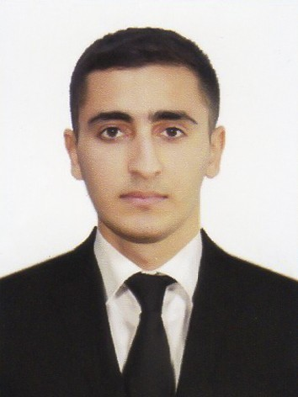
First name |  | MURAD
Father’s name |  | MAYIS
Date and place of birth |  | 15.12.2002
Nationality |  | Azerbaijan
Marital status |  | UNMARRIED
Permanent address |  | Azerbaijan, AGDASH
Nearest airport |  | Heydar Aliyev International Airport Baku, Azerbaijan
Height (cm) | Weight (kg) | Eyes color | Hair color | Size of safety shoes | Size of coveralls
1  .  7  2 | 67 | GREY | BLACK | 40 | M
CONTACT DETAILS
Mobile | E-mail address
+994 55 316 40 73  WhatsApp | muradosmanov588@gmail.com
NEXT OF KIN (FOR EMERGENCY)
Next of kin | Osmanov Mayis | Relationship | FATHER
Phone | +994 50 367 91 82 | Address | AZERBAIJAN , BAKU
TRAVEL PASSPORT DETAILS
Document | Number | Place of Issue | Issued | Valid
PASSPORT | C-03856496 | Azerbaijan | 09.09.2022 | 08.09.2032
SEAMAN’S BOOK DETAILS
Document | Number | Place of Issue | Issued | Valid
Seaman book | DGK017130 | Azerbaijan ,Baku | 17.02.2021 | 17.02.2026
SEAARERS IDENTITY | AZE022056 | Azerbaijan ,Baku | 17.02.2021 | 17.02.2026
EDUCATION
Full name of School | Place of Issue | Grade/Class | From | To
Kainat Traning Center | Azerbaijan , Baku | Group – 21 /A | 01.10.2020 | 22.04.2021
KNOWLEDGE OF LANGUAGE
Languages | Speaking | Reading | Writing
Azerbaijan | Excellent | Excellent | Excellent
Turkish | Excellent | Excellent | Excellent
Russia | Medium | Medium | Medium
COMPUTER SKILLS
Windows |  |  | Microsoft Office |  | Internet
Excellent |  |  | Excellent |  | Excellent
MEDICAL INFORMATION
Document | Grade |  | Place of issue |  | Date of issue | Date of expiry
Medical Sertificate | Engineroom watch |  | Azerbaijan |  | 11.10.2022 | 11.10.2024
CERTIFICATE OF COMPETENCY

Class/Grade
Issuing
country

Certifikate

No-2111/22
Date
issued
Expires
Details of Limitations
RATING FORMING

State Maritime
and Port Agency

RP-11810

28.09.2022

unlimited

A-3/4

PART OF
AN ENGINE-ROOM
WATCH
STCW AND OTHER CERTIFICATES
Name of course/Certificate | Institute | Place | Date of issue | Cert.No | Date of expiry
International  Sadety  Managemt | State Maritime  And  Port Agency | Azerbaijan Baku | 07.09.2022 | SP-2693-  22 | 22.08.2027
Proficiency in survival craft and boats other than fast rescue boats | State Maritime  And  Port Agency | Azerbaijan Baku | 09.09.2022 | SL-2667-  22 | 18.08.2027
Training for seafarers with  designated security  duties | State Maritime  And  Port Agency | Azerbaijan Baku | 06.09.2022 | SH-177422 | 02.08.2027
Personal Safety and  Social  Responsibilities | State Maritime  And  Port Agency | Azerbaijan Baku | 12.09.2022 | S0-4136-  22 | 25. 08.2027
Ship Securityrelated  familization security-awareness | State Maritime  And  Port Agency | Azerbaijan Baku | 08.09.2022 | SI-2169-  22 | 01.08.2027
Basic trainig and qualifications on oil and chemical tanker cargo operation | State Maritime  And  Port Agency | Azerbaijan Baku | 14.09.2022 | SA-070522 | 16.08.2027
SEA EXPERIENCE (LAST 5 YEARS – MOST RECENT EXPERIENCE ON TOP LINE)

Vessel | Company | Type of  vessel | Flag | DWT | GRT | Rank | Sign on | Sign off
AMUR | Caspian Sea | Dry Cargo  Ship | AZERBAIJAN | 2528 | 3086 | MOTOR  MAN | 15.07.2022 | 16.01.2023
DELFIN-1 | PARVIZ IKF | Dry Cargo  Ship | AZERBAIJAN | 2235 | 3000 | MOTOR  MAN | 14.03.2024 | 04.06.2024

