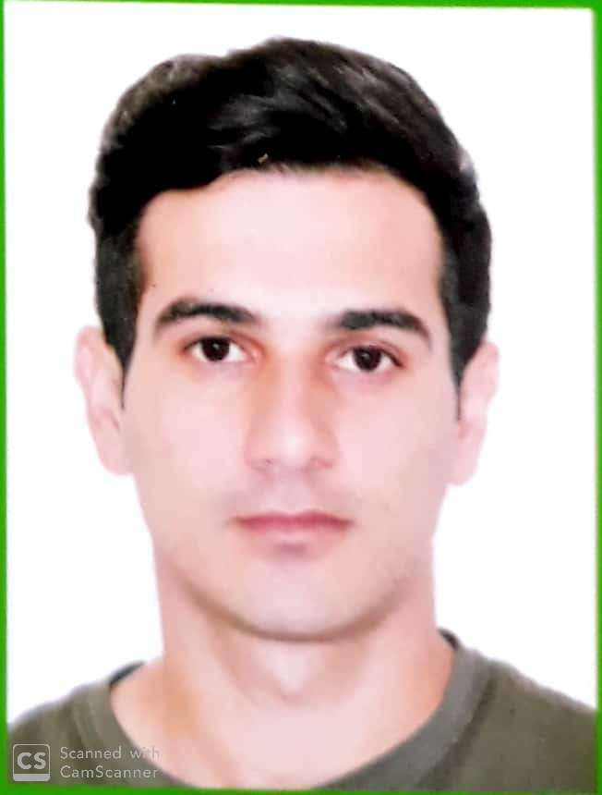

APPLICATION FORM

0 | 0 | 0 | 6 | 7 | 9 | 1
Personal ID Number

Position Applied for | Date Available from:

1. Personal Data
Family Name: mehdiyev | First Name: Mehemmed | Middle Name: SALEH
Date of Birth: 31.05.1994 | Place of Birth (City and Country):  AZERBAIJAN,SALYAN | Citizenship: AZERBAIJANI
Permanent Address  AZERAIJAN/SALYAN |  | Phone : +905352731351  Phone (Mobile)+994505477357 (24 hrs)  E-mail:Mehdiyevm@mail.ru

2. Maritime Education
Name of school | Town | Country | From | To | Type of degree or diploma
AZERBAIJAN STATE MARITIME ACADEMY | BAKU | AZERBAIJAN | 2011 | 2015 | BACHELOR

3. Professional Test
English Test Date | Name of Test | Score
Professional Test Date | Name of Test | Score
Professional Interview Date | Result

4. Family Details
Civil Status(Single, Married, Separated, Divorced, Widowed) : SINGLE

Next of Kin (the first emergency contact) MEHDIYEV SALEH | Relationship FATHER
Address of Residence  BAKU CITY AZERBAIJAN | Phone : +99450 447 31 93

 | Daughter | Son
Family Name
First Name
Date of Birth
City of living
Phone Numbers

5. Identity Documents
Document | Country | Number | Place of Issue | Issue Date | Expiry Date
Seaman's Book | Azerbaijan | DQK 022689 | AZERBAIJAN, BAKU | 11.02.23 | 11.02.28
Travel Passport | Azerbaijan | C01011457 | AZERBAIJAN, BAKU | 21.08.16 | 20.08. 26

6. Valid Visa
Country or Union | Type | Valid Until
N/A | N/A | N/A
N/A | N/A | N/A

7. Courses Attended and Certificates Obtained
Document | Number | Dates |  | Place
Document | Number | Issue | Expiry | Place

Chief Mate on ships of 3000 gross tonnage or more | 000636/21 | 08.10.2021 | 08.10.2026 | ASMA(AZERBAIJAN STATE MARTIME ADMINISTRATION
Certificate of Competency(OFFICER IN CHARGE OF A NAVIGATIONAL WATCH) | 0006791 | 05.06.18 | 05.06.23 | ASMA(AZERBAIJAN STATE MARTIME ADMINISTRATION)
Basic training and qualifications on oil and chemical tanker Cargo operations | SA-0238-20 | 20.10.20 | 20.10.2025 | ASMA
Basic Trainings | SO-1093-20 | 15.09.2020 | 11.09.2025 | ASMA
Proficiency in Survival Craft and Rescue Boats | SL-6258-23 | 26.01.23 | 26.01.28 | ASMA
Advanced Fire Fighting | SJ-0388-20 | 17.09. 20 | 17.09. 25 | ASMA
Medical First Aid Training | SN-0355-20 | 21.09.20 | 21.09. 25 | ASMA
Medical Care on Board | SM-0198-21 | 20.08.21 | 20.08.26 | ASMA
GMDSS GENERAL OPERATOR | DQ-0149-20 | 16.09.20 | 02.09.25 | ASMA
LEADERSHIP AND TEAMWORK | DL-5876-23 | 26.01.23 | 26.01.28 | ASMA
Automatic Radar Plotting Aids Simulator (ARPA) | SQ-0195-20 | 04.09.20 | 31.08.25 | ASMA
Bridge Team Management | SW-0209-20 | 15.09.20 | 27.08.25 | ASMA
SHIP SECURITY – RELATED TRAINING AND INSTRUCTION | SI-0559-20 | 16.09.20 | 16.09. 25 | ASMA
TRAINING FOR SEAFARERS WITH DESIGNATED SECURITY DUTIES | SH-0474-20 | 18.09.20 | 18.09.25 | ASMA
ISM Code | SP-5535-23 | 29.01.23 | 29.01.28 | ASMA
ECDISTraining Course | SZ-0262-20 | 19.09.20 | 19.09.25 | ASMA
Ship Security Officer | SG-0207-21 | 13.08.21 | 13.08.26 | ASMA
Handling and Manoeuvring | SV-0277-21 | 20.08.21 | 20.08.26 | ASMA
Dangerous Hazardous and harmful cargoes | SK-0263-20 | 21.09.20 | 21.09.25 | ASMA
Advance training for oil tanker Cargo operations | SB-1214-19 | 09.12.2019 | 09.12.2024 | ASMA

8. Physical Data
Height | 172
Weight | 68
Colour of Hair | BLACK
Colour of Eyes | BLACK
Boilersuit Size | S
Shoes Size | 41

9. Medical History | Yes | No
Have you ever signed off a ship due to medical reasons? |  | No
Did you undergo any medical operation in the past? |  | No
Have you consulted a doctor during the last 12 months for an illness/accident? |  | No
Do you have any health or disability problems now? |  | No

If yes, please give full details:

 | Passed: | Valid till:
International Medical Examination | 29.11.24 | 29.11.2026
Vaccination Against Yellow Fiver | 31.08.2018 | Unlimited
Vaccination Against Diphtheria | N/A | N/A

10. References (please give name and address of your current or past employer) | Office remarks

Name of Company | ACM PETROL
Name of person to contact
Address | ISTANBUL/TURKEY
Phone

Name of Company | ADMR SHIPPING AND TRADER LTD
Name of person to contact | BEGUM
Address | ISTANBUL/TURKEY
Phone | +90549 544 44 67

11. Bank address for allotments
Beneficiary
Account No.
Name of Bank
Bank Address

12. Knowledge and experience | Yes | No
OCIMF vetting experience:
7ISGOT knowledge:

13. I hereby declare that the above, including Medical History, is true
Place : BAKU | Date : 23..05.2018 | Signature

14. For Office use only

15. Seagoing Experience

Name of vessel | Flag | Vessel’s Type | GT | Eng Type | HP | Manager or Owner | Rank | From d/m/y | To  d/m/y | Total  m/d
BALAKEN | Azerbaijan | Rail Vehicles Carrier | 8045 |  |  | Azerbaijan Caspian Shipping Co. | Probationer | 15.06.2012 | 28.09.2012 | 3m  13d
SHOLLAR | Azerbaijan | WATER TANKER | 1876 |  | 2 x 1820 | Azerbaijan Caspian Shipping Co. | Probationer | 15.06.2013 | 28.09.2013 | 3m  13d
GYULTAKIN ASKEROVA | Azerbaijan | AHTSV | 2737 | SULZER | 2 x5294 | Caspian Marine Services ltd. | Probationer | 15.06.2014 | 28.09.2014 | 3m  13d
RESUL RZA | Azerbaijan | General  Cargo | 3048 |  | 2 x 640 | Azerbaijan Caspian Shipping Co. | Probationer | 26.01.2015 | 27.02.2015 | 1m
M/T ALFA KAARDENIZ | TURKEY | TYPE 2 – CHEMICAL/OIL TANKER | 4319 | Mak 6 M 551 AK | Mak 6 M 551 AK 2500 KW | ACM PETROL | Deck cadet | 02.09.2016 | 15.07.2017 | 10m13d
M/T ALFA KAARDENIZ | TURKEY | TYPE 2 – CHEMICAL/OIL TANKER | 4319 | Mak 6 M 551 AK | Mak 6 M 551 AK 2500 KW | ACM PETROL | 2nd officer | 13.10.2017 | 30.04.2018 | 6m  17d
M/V FORTIUS | VANUATU | GENERAL CARGO | 1291 | MAN B&V 7L20/27 | MAN B&V 7L20/27 | CUNDA SHIPPING | 2nd offıcer | 29.09.2018 | 10.04.2019 | 6m  11d
M/V NEVA | VANUATU | GENERAL CARGO | 1545 | DEUTS | 541 KW | EFE SHIPPING | 2ND OFFICER | 13.09.2019 | 23.08.2020 | 11m 10d
M/V UNI TRADER | PANAMA | TANKER | 4606 | MAK6M25 | 1800KW | ADMR SHIPPING | 2ND OFFICER | 17.12.2020 | 31.05.2021 | 5m  13d
M/V FG LEVENT | PANAMA | GENERAL CARGO | 4982 | MAN B&W DIESEL 12V28/32 | 2940 KW | FG SHIPPING | CHF.OFF | 25.12.2021 | 31.12.2022 | 12m  5d
M/V DOA GLORY | PANAM | GENERAL CARGO | 5026 | DETUZ MVM DISEL TBD-645L8 | 3446 Kw | Doa Shipping | Chf.off | 07.05.2023 | 17.05.2024 | 12m10d
M/V DOA GLORY | PANAM | GENERAL CARGO | 5026 | DETUZ MVM DISEL TBD-645L8 | 3446 Kw | Doa Shipping | Chf.off | 11.07.2024 | 25.11.2025 | 4m 14d

Total rank sea service: Total type of vessel sea service:
Rank | Years |  | Type of vessel | Years
AB SEAMAN | 11MONTH |  | WATER TANKER | 3MONTHS
DECK CADET | 10 MONTH |  | OIL /CHEMICAL TANKER | 1 YEAR 10 MONTHS
2ND OFFİCER | 28 MONTH |  | AHTSV | 3 MONTHS
CHF.OFF | 29 MONTH |  | GENERAL CARGO | 4 Year
 |  |  | FERRY | 2MONTH
 |  |  | Total: | 6 YEARS 6 MONTHS

