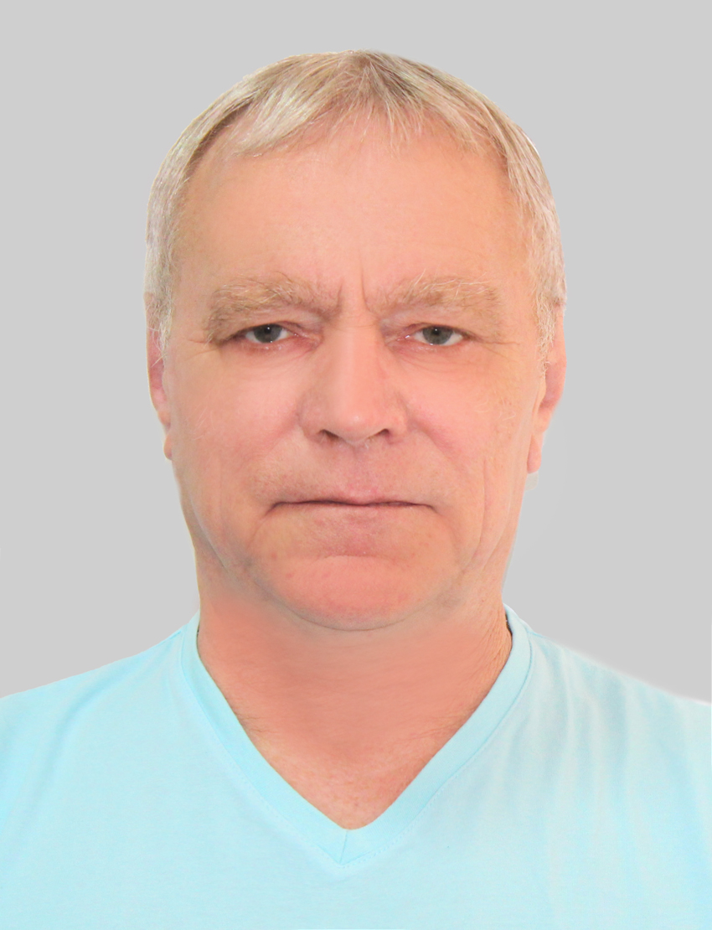

PERSONAL APPLICATION FORM

1 | Position
 | Position applied for: |  | Master
 | Ready to contract:
 | Minimum salary $: |  | 6000
 | Desired Vessel Type: |  | Over 5000 dwt gen cargo, bulker, cont. e.c.

2 | Personal details
 | Surname and Name: |  | Lomtev Aleksandr
 | Date and place of birth: |  |  |  |  |  |  | Citizenship: | Russia
 | Permanent address: |  | Petrozavodsk Drevlanka st. 4/3 fl.8
 | Phones: |  | +7 911 406 3609 |  |  |  |  | English level: |  |  | excelent
 | e-mail : |  | lanmaster7@inbox.ru |  |  |  |  | USA visa valid up:
 | Skype: |  | lizir2002 |  |  |  |  | SCHENGEN visa valid up: |  |  | 16.09.2025
 | Hear color: blond |  |  |  | Height: 174 |  |  | Overall size: L
 | Eyes color: blue |  |  |  | Weight: 78 |  |  | Shoe size: 41
 | DOB 09.07.1954
3 | Education
 | School / College |  |  | From |  | To | Highest Qualification Attained
 | Marine academy |  |  | 1976 |  | 1982 | Master

4 | Identity documents
 | DOCUMENT | COUNTRY | NUMBER | ISSUED | PLACE | EXPIRY
 | National passport | Russia | 8603547188 | 09.07.2003  Hilh; | Petrozavodsk | permanent
 | Int’nal Passport: | Russia | 76 3256209 | 03.08.2020 | Petrozavodsk | 03.08.2030
 | Seaman book:  ллллллл | Russia | MK0112364 | 26.09.2022 | Petrozavodsk | 25.09.2027
 |  | A&B | 105656 | 18.11.2016 | St.Johns | 05.07.2021
 | Visas | Schenghen | Fin 300352877 | 17.09.2020 | Petroskoi | 16.09.2025

5 | NEXT OF KIN
 | Relationship: wife
 | Surname and Name: | Lomteva Irina
 | Address: | same |  |  | Post code:
 | Contact telephone numbers: | +7 911 4056026
 | Names of Children |  | Sex | Date of Birth
 | Lomteva Elizaveta |  | female | 18.06.2002

6 | Certificates of Competency
Grade |  | Country | Certificate No. | Date Issued | Place | Valid Until
Master |  | Russia | LED205201456 | 21.10.2021 | St Petersburg | 31.07.2025
GMDSS jjoperator |  | Russia | LED205201462 | 21.10.2021 | St Petersburg | 31.07.2025

7
 | Model | Course | Place |  | Cert. No. | Valid Until
 |  | Basic Safety Training | Russia |  | AB 1780820 | 04.08.2026
 |  | Proficiency In Survival Craft | Russia |  | AB 1671735 | 05.08.2026
 |  | Fast Rescue Boats
 |  | Advance Fire Fighting | Russia |  | AB 1671790 | 09.08.2026
 |  | Medical First Aid | Russia |  | AB 1781230 | 11.08.2026
 |  | Medical Care | Russia |  | 00130 | 15.08.2026
 |  | Security Awareness Training
 |  | Designated security duties
 |  | HAZMAT (DangerouCargoes) | Russia |  | C3 0758/2021 | 02.11.2026
 |  | Dangerous goods USA | Russia |  | C3 0328/2021 | 03.11.2024
 |  | ARPA | Rissia |  | AB 0774843 | 19.08.2026
 |  | Radar Observer | Russia |  | AB 1514239 | 17.08.2026
 |  | GMDSS | St Petersburg |  | LED205201462 | 31.07.2025
 |  | ECDIS | Russia |  | AB 1514372 | 24.08.2026
 |  | Ship Security Officer A-V!/6 | Russia |  | AB 1781421 | 02.08.2026
 |  | Ship Security Officer A-V!/5 | Russia |  | AB 1288498 | 31.07.2025
 |  | Bridge Resources Management
 |  | Shipp Handling Arrangements
 |  | Ship Handling Stimulator
 |  | Engine-Room Resource Management
 |  | Electrical & electronic equipment
 |  | Tanker Familiarization
 |  | Oil Tanker Advanced
 |  | Chem. Tanker Advanced
 |  | Gas Tanker Advanced
 |  | YELLOW FEVER | Petrozavodsk |  |  | 09.09.2030
 |  | DP basic course
 |  | DP advanced course
 |  | DP Full
 |  | DP maintenance
 |  | ARAMCO Approve

8 | Record of previous service

VESSEL | COMPANY# | VESSEL TYPE /  DP CLASS | FLAG | DWT | YEAR BUILT | MAIN ENGINE |  | B.H.P. | RANK | SIGN ON DATE  dd.mm.yy | SIGN OFF  DATE  dd.mm.yy
 |  |  |  |  |  | MAKE | TYPE
Elektra | Unimars | Cont | SV | 8000 |  |  |  |  | Master | 30.12.09 | 11.06.10
Gooteborg | ESM | Cont/gc | A&B | 5461 |  |  |  |  | Master | 08.11.10 | 08.06.11
Gooteborg | ESM | Cont/gc | A&B | 5461 |  |  |  |  | Master | 18.08.11 | 08.01.12
Lauren.C | Carisbrook | GC | UK | 5200 |  |  |  |  | Master | 27.06.12 | 27.09.12
Emre Kose | Platin | GC | Malta | 6600 |  |  |  |  | Master | 26.06.13 | 25.10.13
Gulf Express | Pacific Shipping | MPP | A&B | 4500 |  |  |  |  | Master | 28.01.14 | 25.07.14
Gulf Express | Pacific Shipping | MPP | A&B | 4500 |  |  |  |  | Master | 20.10.14 | 27.04.15
Gulf | Pacific Shipping | GC | A&B | 4300 |  |  |  |  | Master | 01.10.15 | 18.06.16
Gulf | Pacific Shipping | GC | A&B | 4300 |  |  |  |  | Master | 14.11.16 | 14.04.17
Galan | Shipmar | GC | Russia | 3200 |  |  |  |  | Master | 24.05.18 | 23.08.18
YORK | Shipmar | GC | Russia | 3300 |  |  |  |  | Master | 24.11.18 | 30.06.19
Galan | Shipmar | GC | Russia | 3200 |  |  |  |  | Master | 10.10.19 | 07.07.20
Navis-1 | B&T Shipping | GC | Russia | 6200 |  |  |  |  | Master | 15.11.20 | 21.02.21
Runo | OOO “Aliance” | Tug | Russia | 486 |  |  |  |  | Master | 01.05.21 | 30.07.21
A.Tvardovskiy | CoronCargo | GC | Russia | 3200 |  |  |  |  | Master | 10.03.22 | 07.07.22
Bassel | Maz shipping | GC | Panama | 3200 |  |  |  |  | Master | 13.12.22 | 12.07.23

REMARKS:
1. Multicrew experience: Poland, Indian, Paraguay, Uruguay, Cape-Verde, Filipino

A.LOMTEV
Date:
Signature

