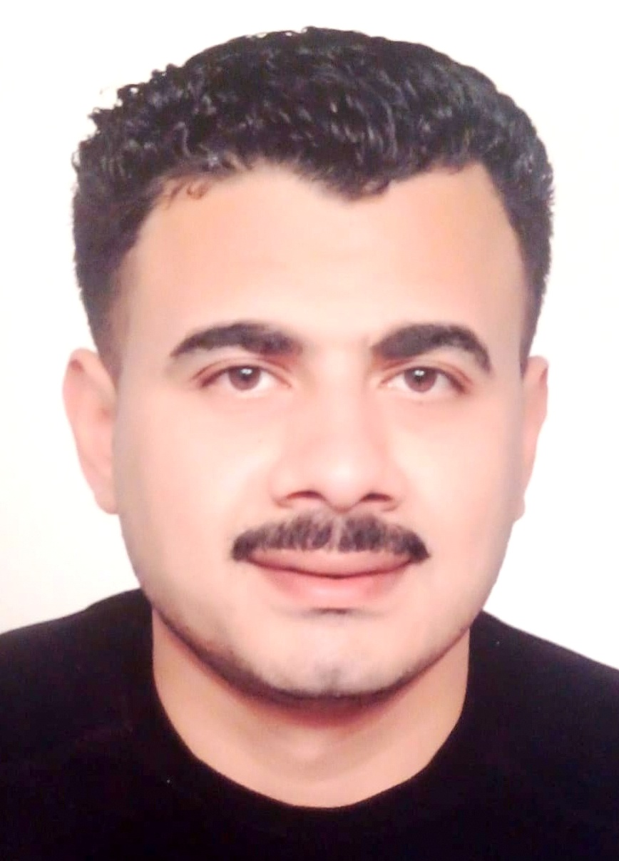

c.v

1. PERSONAL DETAILS
Full Name |  | MOHAMED GAMAL EZZAT ELSHERBINY
Date Of Birth |  | 20 /10 /1989 |  |  |  |  |  | Place Of Birth |  |  |  |  |  |  |  | Damietta
Nationality |  | Egyptian |  |  |  |  |  | Marital Status |  |  |  |  |  |  |  | Single |  |  |  |  |  |  | - Married
Height (Cm) |  | 179 |  |  |  |  |  | Overall Size |  |  |  |  |  |  |  | 60 |  |  |  | Shirt Size |  |  |  |  | 2x
Weight (Kg) |  | 98 |  |  |  |  |  | Trouser Size |  |  |  |  |  |  |  | 2x |  |  |  | Shoes Size |  |  |  |  | 46
2. EDUCATION
College / School |  | Damietta navy academy
Marline Test |  | Issued Date |  |  |  | Result % |  |  |  | Issued By (Authority) |  |  |  |  |  |  |  |  | Issued At
English Language |  | Fluent |  |  |  |  | - Good |  |  |  |  | Average |  |  |  |  |  |  | Poor
Italy Language  ( ) |  | Fluent |  |  |  |  | Good |  |  |  |  | - Average |  |  |  |  |  |  | Poor
3. CONTACT DETAILS
Home Address / City |  |  | Damietta - 101RAS ELBAR
E-Mail |  |  | Mezat3000@gami.com |  |  |  |  |  | Mobile / Tel |  |  |  |  |  | 00201090854397

4. TRAVEL DOCUMENTS
Type |  | Document No. |  |  | ISS. Date |  |  | Exp. Date |  |  |  |  | ISS. By (Authority) |  |  |  |  |  |  |  |  | Place of Issue
Passport |  | A20409675 |  |  | 29/04/2024 |  |  | 29/04/2031 |  |  |  |  | Egyptian Authority |  |  |  |  |  |  |  |  | Damietta
Seaman Book |  | S00029883 |  |  | 190/3/2023 |  |  | 140/3/2028 |  |  |  |  | EAMS |  |  |  |  |  |  |  |  | Alex.
Other Seaman Book |  | PA0436208 |  |  | 21/06/2023 |  |  | 20/06/2028 |  |  |  |  | PAN |  |  |  |  |  |  |  |  | PANAMA
5. NEXT OF KIN
Full Name | Gamal Ezzat ELsherbiny |  |  |  |  |  |  |  |  |  |  |  |  | Relationship |  |  |  | Father
Address | Damietta - RAS ELBAR- 101 st
Tel. No. |  |  |  |  |  |  |  |  | Mobile |  |  | +2:0101271533
6. HEALTH CERTIFICATES & VACCINATIONS
Flag State |  |  |  | Number |  | Issue Date |  |  |  |  | Expiry Date |  |  |  |  |  | Issued By |  |  |  |  |  |  | Issued At
International Medical |  |  |  | 39672 |  | 27/01/2025 |  |  |  |  | 26/01/2027 |  |  |  |  |  | EAMS |  |  |  |  |  |  | Alex.
Yellow Fever |  |  |  | H5313-2 |  | 8/4/2013 |  |  |  |  |  |  |  |  |  |  | Ministry of Health |  |  |  |  |  |  | Alex
Cholera |  |  |  | 122 |  | 8/4/2013 |  |  |  |  |  |  |  |  |  |  | Ministry of Health |  |  |  |  |  |  | Alex
Covid-19 |  |  |  | Vaccination Name |  | First Dose |  |  |  |  | Second Dose |  |  |  |  |  | (Other Does or Remarks)
 |  |  |  | JOHNSON and johnson |  | 6/4/2022

Rank:Able seafarers Deak

7. MARINE COURSES
Course Name | Number | Issue Date | Expiry Date | Issued By / At
Personal Survival Techniques | Xbst 626 | 6/3/2023 | 12/3/2028 | Alex
Fire Prevention and Fire Fighting | Xbst626 | 6/3/2023 | 12/3/2028 | Alex
Elementary First Aid | Xbst626 | 6/3/2023 | 12/3/2028 | Alex
Personal Safety and Social Responsibilities | Xbst626 | 6/3/2023 | 12/3/2028 | Alex
Proficiency Of Security Awareness Training Seafarers | Na 232 | 4/2/2019 | 30/1/2024 | Alex
Proficiency In Survival Craft & Rescue Boats | Xnc1439 | 14/3/2023 | 8/3/2028 | Alex
Proficiency in survival craft and Rescue Boats (v l/2) | 04576 | 5/4/2023 | 8/3/2028 | EAMS / Alex.
Passenger Safety Cargo Safety and Hull integrity | Nxd55 | 26/2/2019 | 18/2/2024 | Alex
Crowd Management Training | Nxa55 | 26/2/2019 | 18/2/2024 | Alex
Crisis Management and Human Behavior Training | Nxb55 | 26/2/2019 | 18/2/2024 | Alex
Safety training for Personal Prov. Direct Passengers | Nxc55 | 26/2/2019 | 18/2/2024 | Alex
Abel Seafarer Deck | 13857/22/eg | 8/5/2022 |  | Alex
Proficiency for Abel Seafarer Deck ( II/5 ) | 00661 | 5/4/2023 |  | EAMS / Alex.
Proficiency in Fast Rescue Craft ( Boats ) | 10029/19/EG | 12/3/2019 | 11/3/2024 | Alex

Name: | MOHAMED GAMAL ELSHERBINY |  |  |  |  |  | Rank: |  | A/B | SEA SERVICE
Company Name |  | Rank | Vessel Name | Flag |  | Signed On |  | Signed Off |  | Period | Vessel Type | D.W.T. | Engine Type |  | KW
UME |  | A.B | Poseidon express | ANTIGUA BARBUDA |  | 26/07/2015 |  | 30/01/2016 |  | 7 M | RORo passenger | 10996  TONS | 2*WARTSIL |  | 14000
TRABEH LIEN CO |  | A.B | HAJ SAYED1 | ZANZIBAR |  | 20/07/2018 |  | 27/01/2019 |  | 6 M | G.CARGO | 3135 | 1.MAN |  | 1500
ZMEG.CO |  | A.B | ALBATROSS | TOGO |  | 02/08/2017 |  | 19/02/2018 |  | 7 M | G. Cargo | 5840 | 1.mak |  | 2000
GNV ITALY |  | A.B | SPLENDID | PALERMO |  | 07/07/2019 |  | 29/12/2019 |  | 6 M | RORo passenger | 39139 | 4 MAN |  | 23000
A SHIPS MANAGEMENT |  | A.B | GOLDEN BRIDGE | LIMASSOL |  | 09/06/2021 |  | 31/01/2022 |  | 8 M | RORo passnger | 6090 | 2 DU PIELSTICK |  | 11915
A SHIPS MANAGEMENT |  | A.B | GALAXE | LIMASSOL |  | 21/05/2022 |  | 08/02/2023 |  | 9 M | RORo passenger | 1571 | 4 SHULZER-ZGODA |  | 4200
SOLYMR MARITIME  S.A. |  | A.B | VENTUS | PANAMA |  | 29/06/2023 |  | 25/01/2024 |  | 7M | G.CARGO | 6063 | 8320CD-6 |  | 2060
ZODIAC SHIPTRDE S.A |  | A.B | IC PROGRESS | PANAMA |  | 19/07/2024 |  | 28/11/2024 |  | 4M | BUIK  CARRIER | 32526 | STX_MAN  _B&W |  | 6480
Availability
I am able to start work after 0 weeks .

As : full time

Job location : Egypt – Arab countries – foreign countries
This was a brief of my experience . which I hope it may satisfy part of your needs .
With my great thank yours

MOHAMED GAMAL EZZAT ELSHRBINY
e-mail address : mezat3000@gmail.com

