Personal Data

GÖREV: FİTER

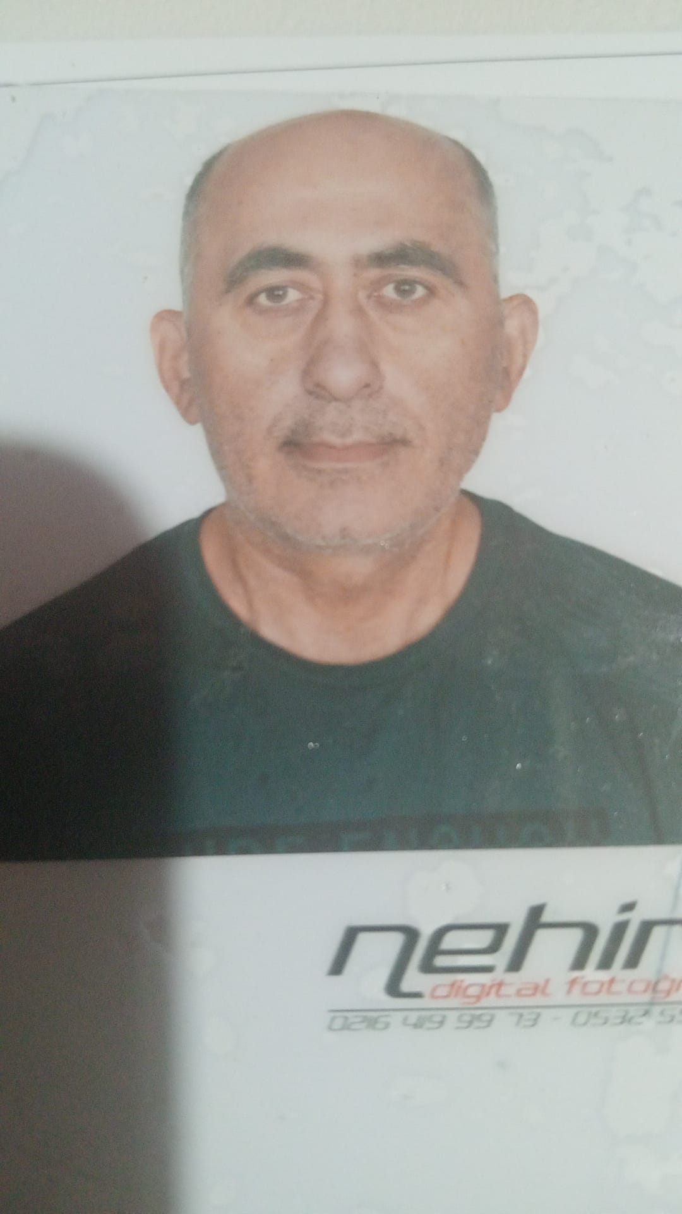

Surname: | KABADAYI
Given Name(s): | MAHMUT
Nationality / Citizenship: | TURKEY
Date of Birth: | 20.02.1970
Personal Id: | 4343021140
Gender: | M
Marital status: | MARRIED
Nearest airport: | SAW
Address:
Phone: | 0535 264 03 20

Travel documents (Passports, SB, Visas)
Name | Country | Document No | Date of Issue | Issuer/Place of Issue | Expires
PASSPORT | TURKEY | U 32120118 | 21.08.2023 | GIRESUN EGM. | 21.08.2033
SEAMAN BOOKS | TURKEY | S 00343749 | 22.10.2021 | TUZLA LIMAN BSK. | 22.10.2026

Medical documents
Name | Country | Document No | Date of Issue | Issuer/Place of Issue | Expires
MEDICAL EXAMINATION CERTIFICATE FOR SEAFARERS | TURKEY | 289730 | 14.01.2025 | TUZLA LIMAN BSK | 14.01.2027

Measurements
Eyes: | BROWN | Safety shoes: | 42
Hair: | - | Boiler suit: | M
Height: | 172 CM | Weight: | 75KG

ÇALIŞMA HAYATIM

1993-2000 KAPTANOGLU DENIZCILIK

2000-2008 DENAK DENIZCILIK

2008-2020 TURKON DENIZCILIK

2020-2023 KARPOWER ENERJI

2023-2024 SEALIFE DENICILIK

YUKARIDAKI TARIHLERDE BIRCOK GEMI TIPI VE MAKINA TIPINDE AKTIF OLARAK FITER OLARAK CALISTIM. BILGILERINIZE SUNARIM.

Name | Country | Date of Issue | Expires
BELIRLENMIS GUVENLIK GOREVLERI EGITIM BELGESI | TURKEY | 27.12.2013
GUVENLIK FARKINDALIK BELGESI | TURKEY | 27.12.2013
GUVENLIKLE ILGILI TANITIM BELGESI | TURKEY | 27.12.2013
MAKINA VARDIYASI TUTMA BELGESI | TURKEY | 15.09.2014
CANKURTARMA ARACLARINI KULLANMA YETERLIGI EGITIM BELGESI | TURKEY | 22.10.2021 | 22.10.2026
DENIZDE KISISEL CAN KURTARMA TEKNIKLERI EGITIM BELGESI | TURKEY | 22.10.2021 | 22.10.2026
PERSONEL GUVENLIGI VE SOSYAL SORUMLULUK EGITIM BELGESI | TURKEY | 22.10.2021 | 22.10.2026
TEMEL ILKYARDIM EGITIMI BELGESI | TURKEY | 22.10.2021 | 22.10.2026
YANGIN ONLEME VE YANGINLA MUCADELE EGITIM BELGESI | TURKEY | 22.10.2021 | 22.10.2026
PETROL VE KIMYASAL TANKERLERDE YUK ISLEMLERI ICIN TEMEL EGITIM BELGESI | TURKEY | 22.10.2021 | 22.10.2026
SERTIFIKALAR

