SEAFARER APPLICATION FORM

SURNAME | Rudnevskii |  |  | RANK: |  | 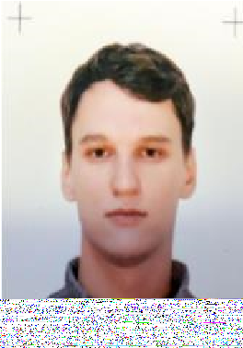  3rd/2nd Engin
FIRST NAME | Artem |  |  | Second Language: |  | English intermediate
Date of Birth | 11.04.95 | Place of Birth |  | Russia | Nationality | Russian
Height | 187 | Weight | 93 | Size of Shoes | 46 | Size of Working Clothes | L
Phone home | 89284258266
Phone mobile | 89284258266
E-mail | Artemrad843@gmail.com
Skype | live:.cid.fc527160b5737524
Permanent Address | Russia, Saint-Petersburg

Document | Number | Date and Place of Issue | Date of Expiry
Seaman’s Book/MK | MK0154598 | Harbour master of Novorossiysk Seaport 14.07.2014
SID/УЛМ | RUS 0636279 | BOLSHOY PORT OF  ST PETERBOROUGH | 12.11.2028
Travel Passport | 77 1552937 | МВД 26002 | 06.10.2033
Medical certificate | 3865 | 000 "MC Eco-safety" 15.12.24

Type of Certificate | Number | Date and Place of Issue | Date of Expiry
Basic safety/survival at sea | BST-08194/24 | 19.11.2024 | 19.11.2029
Advanced fire-fighting | AFF-06113/24 | 23.11.2024 | 23.11.2029
Proficiency in survival craft | PSC-06989/24 | 21.11.2024 | 21.11.2029
Medical care / First aid | MFA-06184/24 | 13.11.2024 | 13.11.2029
Security officer | ISPS-D-06114/24 | 15.11.2024 | 15.11.2029

Rank | Vessel’s Name | Type/DWT | Engine Type/BHP | Flag | Ownens | From | Till
3rd Eng. | Elos | Bulk carrier/176505 | B&W 6S70MC/16860 | Panama | Esin maritime  service group | 27.04.24 | 20.09.24
3rd Eng. | Platos | Bulk carrier/171314 | B&W 6S70MC/16860 | Panama | Kisamos  Shipping  DMCC | 27.04.23 | 19.09.23
3rd Eng. | Bogdan | Bulk carrier/13898 | Man-B&W 7S35MC-MK  /4900 | Belize | Aurora  Shipping  L.T.D | 7.07.22 | 25.10.22
3rd Eng. | Ermak | General Cargo/7049 | Man-B&W 7L45GBE/4690 | Russia | HTMC | 26.06.21 | 28.10.21
3rd Eng. | Kapitan  Danilkin | Bulk carrier/22910 | Sulzer 14V40/48/8692 | Russia | MSC | 16.10.20 | 26.01.21
3rd Eng. | Grumant | Bulk carrier/23278 | Man K8Z 70/120 DE/8238 | Russia | MSC | 13.12.19 | 22.03.20

