
APPLICATION FORM
AP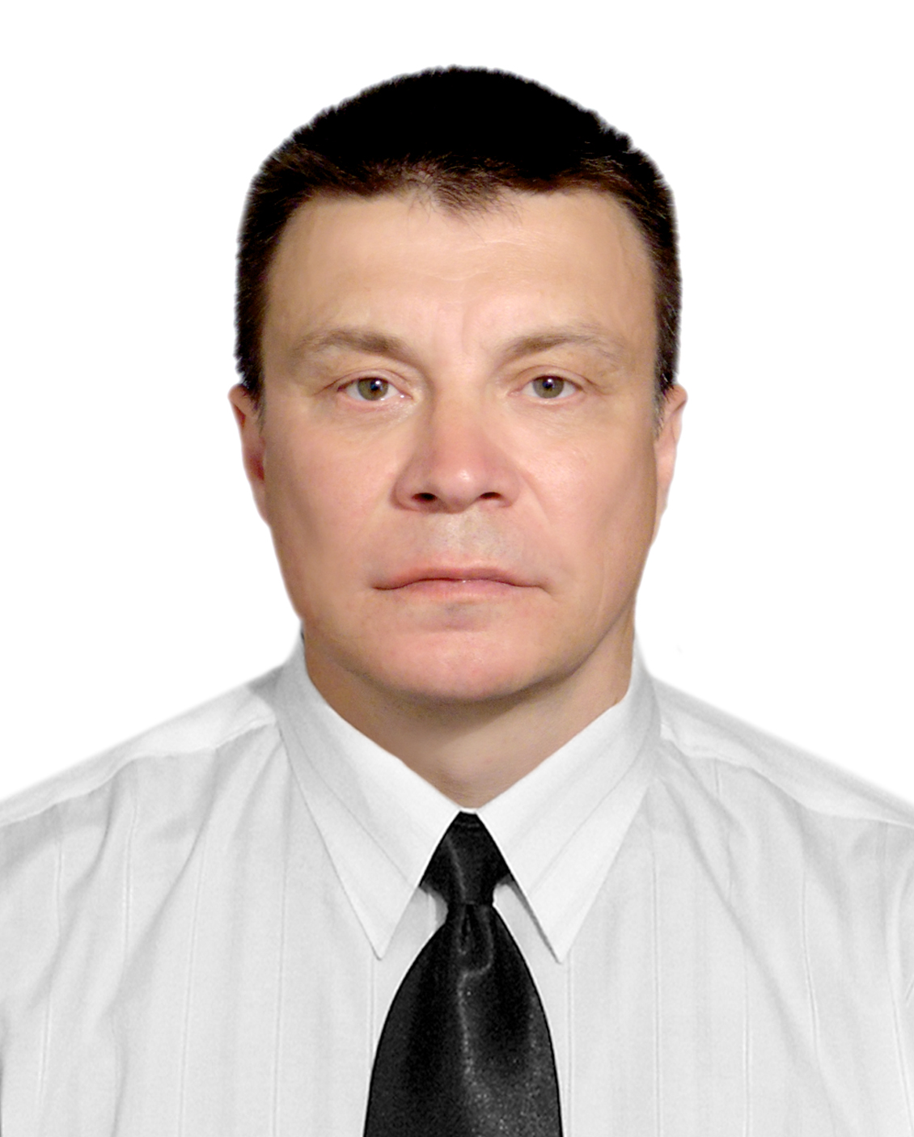PLICANT’S PHOTO

EASTAWAY (INDIA) PRIVATE LIMITED
B/C-915, Atrium 215, Andheri Kurla Road
Andheri (East), Mumbai 400093
BOARD: +91 22 6802 0000
EMAIL: seajobs@eastaway.com

RPSL / MUM /

SECTION I
Applicant Name | Seklyutskiy German
Rank Applied | Chief Engineer
Date of Availability | 06.02.2025
SECTION II | Personal Details
Family Name/Surname  (As per Passport) | Seklyutskiy
First Name/Given Name (As per Passport) | German
Date of Birth  (less than 18 yrs not eligible to apply) | 22.08.1970 Place of Birth: USSR/Krasnodar
Nationality | Russian
Marital / Civil Status | Single v Married Divorced Separated
INDOS No(for Indians)
Permanent Address | 353915, Russia, Novorossiysk, Fizkulturnaya 9
Present Address
(if different from permanent add)
Home Principal Airport | Sochi/Krasnodar
Contact Number
Mobile (Self) | (995)189 75 61, (953)081-81-31
Mobile (NOK)
Email (Self) | seklyutskiy@mail.ru
Skype ID
Height (cms) & Weight (kgs) | 186 cms 90kg
Boiler Suit Size & Shoes Size | 52/46
SECTION III | Travel Documents
 | Doc Number | Issue Date | Place of Issue | Expiry Date
Passport | 765382360 | 31.08.2021 | Novorossiysk | 31.08.2031
Seaman Book | MK 0025871 | 18.05.2010 | Novorossiysk
USA Visa C1/D
Aust MCV
Yellow Fever | MK 0025871 | 31.08.2016 | Novorossiysk | 31.08.2026
SID
Form # 15-4/1 (Issue 1 Rev 2) Dt: 05.02.2025 1 of 5

SECTION IV | Pre-Sea Training / Apprenticeship Details
Name of Institute |  | From |  | To |  |  | Type of Degree/Certification Obtained
Novorossiysk Maritime Academy |  | 2001 |  | 2006 |  |  | Engineer
SECTION V | Certificate of Competency Held (valid)- For Rating COP and Watchkeeping Certificates
Class / Grade | Issuing Country |  | Certificate No |  |  | Date Issued |  |  | Expiry Date
Endorsment
SECTION VI | Courses Attended and Certificates Obtained
Name of Course/Certificate | Institute |  | Place |  | Issue Date |  |  | Certificate No. |  |  | Expiry Date
Personal Safety |  |  | Novorossiysk |  | 29.10.2020 |  |  | 1102037664 |  |  | 29.10.2025
Advanced fire fighting |  |  | Novorossiysk |  | 29.10.2020 |  |  | 0102037529 |  |  | 29.10.2025
Proficiency in survival craft and rescue boats |  |  | Novorossiysk |  | 29.10.2020 |  |  | 0102037497 |  |  | 29.10.2025
Medical first Aid on board ship |  |  | Novorossiysk |  | 29.10.2020 |  |  | 0102037575 |  |  | 29.10.2025
Ship’s security officer |  |  | Novorossiysk |  | 29.10.2020 |  |  | 01020375506 |  |  | 29.10.2025
Electrical troubleshooting |  |  | St.-Petersburg |  | 17.11.17 |  |  | 237
SECTION VII | Medical History
If there is any medical history of any of the following. |  |  |  |  |  |  |  |  | Yes | No
Have I ever signed off a ship due medical reason? |  |  |  |  |  |  |  |  |  | v
Have I undergone any medical operations in the past? |  |  |  |  |  |  |  |  |  | v
Have I consulted a doctor during the past 12 months for an illness / accident? |  |  |  |  |  |  |  |  |  | v
Do I have any health or disability problems now? |  |  |  |  |  |  |  |  |  | v
If answer to any of the above is YES then give further details below or on a separate sheet of paper

Form # 15-4/1 (Issue 1 Rev 2) Dt: 05.02.2025

Vessel Name | Ship owner/manager Company & Recruitment co. | Vessel Type | DWT/ GRT | TEU  (Contr) | Engine  Make &Type (in full) | BHP | Rank | S/on Date | S/off Date | Remarks (For short tours)
Fill upto last 10 years sea service
Alaskaborg | Wagenborg Spb | General cargo | 11885 | 1000 | Wartsila  6L46F | 7800 | 2nd eng | 02.05.2015 | 28.08.2015
Alaskaborg | Wagenborg Spb | General cargo | 11885 | 1000 | Wartsila  6L46F | 7800 | 2nd eng | 20.10.2015 | 10.02.2016
Amurborg | Wagenborg Spb | General cargo | 11885 | 1000 | Wartsila  6L46F | 7800 | 2nd eng | 19.04.2016 | 31.08.2016
Alaskaborg | Wagenborg Spb | General cargo | 11885 | 1000 | Wartsila  6L46F | 7800 | 2nd eng | 27.10.2016 | 22.03.2017
Missouriborg | Wagenborg Spb | General cargo | 6700 | 800 | Wartsila 8L38 | 5300 | Chief eng | 23.06.17 | 14.10.17
Onego Merchant | Wagenborg Spb | General cargo | 6301 |  | MAK  M32 | 3840 | Chief eng | 08.03.2018 | 17.05.2018
Americaborg | Wagenborg Spb | General cargo | 11864 |  | Wartsila  8L46B | 7800 | Chief eng | 03.08.2018 | 04.11.2018
Americaborg | Wagenborg Spb | General cargo | 11864 |  | Wartsila  8L46B | 7800 | Chief eng | 11.02.2019 | 12.05.2019
Americaborg | Wagenborg Spb | General cargo | 11864 |  | Wartsila  8L46B | 7800 | Chief eng | 29.08.2019 | 22.12.2019
Americaborg | Wagenborg Spb | General cargo | 11864 |  | Wartsila  8L46B | 7800 | Chief eng | 24.05.2020 | 18.08.2020
Wesserborg | Wagenborg Spb | General cargo | 6668 |  | MAK  M32 | 3840 | Chief eng | 07.02.21 | 17.06.21
Nordik Kylie | Nordic Hamburg | Havy lift | 9611 |  | MAK 6M43 | 5400 | Chief Eng | 05.01.22 | 11.06.2022
Tasman Chief | Nordic Hamburg | Havy lift | 9611 |  | MAK 6M46 | 5400 | Chief Eng | 27.02.2023 | 09.09.2023
Pacific Excellence | Nordic Hamburg | Havy lift | 9611 |  | MAK 6M46 | 5400 | Chief Eng | 24.112023 | 27.06.2023
Pacific Fortune | Nordic Hamburg | Havy lift | 9611 |  | MAK 6M46 | 5400 | Chief Eng | 18.02.2024 | 27.07.2024

Form # 15-4/1 (Issue 1 Rev 2) Dt: 05.02.2025 3 of 5

SECTION VIII |  |  | GENERAL
If there is any history of any of the following |  |  |  |  |  |  |  | Yes | No
Have I ever been the subject of a court of enquiry or involved in a maritime accident? |  |  |  |  |  |  |  |  | v
Have I ever had a professional license suspended or revoked |  |  |  |  |  |  |  |  | v
If yes to any of the above then please give full details below or on a separate sheet of paper
Any other information you wish to add in support of your application
Family Data - (If Married: Spouse & Children only) / (If Unmarried: Parents & Siblings details)
Sr No | First Name |  |  | Relationship |  |  | Date of Birth
 | Marianna Sekliytskaya |  |  | wife |  |  | 17.05.1978
 | Stephaniya Sekliytskaya |  |  | daughter |  |  | 27.07.2008
 | Martin Sekliytskiy |  |  | son |  |  | 14.11.2011
Two references of Supervisor / Manager in 2 previous companies (NA for Fresh Cadets / Trainees)
Name of Company |  | Name of Person in Charge |  |  | Designation | Contact Details
Wagenborg Spb
Nordic Hamburg
I confirm that I have the consent of each of my referees to provide the following personal data to EASTAWAY for the purpose of EASTAWAY obtaining a reference from them about me.

(Signature of applicant)

Form # 15-4/1 (Issue 1 Rev 2) Dt: 05.02.2025
4 of 5

Two references of Colleagues
Sr. No | Name of Seafarer | Rank | Contact Details
1 | Oleksander Moskalets | 2nd eng | +380 962197902
2 | Srebolskiy Vadim | Captain | +7 904 646 61 41

SECTION IX

Declaration and Consent:

I confirm that the validity of all above mentioned documents covers the contract duration + 3 months and + 6 months for passport

I hereby certify that the information given in my application form including sea service details are true and complete to the best of my knowledge. I also confirm that if employed, and any false or incomplete statement in this application, including the documents submitted, will lead to my dismissal from the employment without notice or pay-in-lieu

I give my consent that the personal data in this Application Form can be used for the purpose of verifying my past experience and making a decision whether or not to hire me and, if hired and disclosing it for the purpose of managing my employment with Eastaway Ship Management Pte. Ltd.

Important Notes:
- Please note that the company does not charge any recruitment fees for providing employment or for any processing fee for onboarding.
- You shall undergo a comprehensive medical test, valid for 24 months for age below 55 years and valid for 12 or 24 months for age above 55 years as per flag state. On subsequent rejoining prior to each tour, you will undergo PEME as required by the company.
- The Company shall not charge medical examination fees from Seafarers.
- A complaint book is kept with the reception for any grievances.

Name of Applicant:

Signed: Date:

Form # 15-4/1 (Issue 1 Rev 2) Dt: 05.02.2025 5 of 5

