AB | Tel: +944504801441  Whatsapp  E-mail: abbasov085@gmail.com
  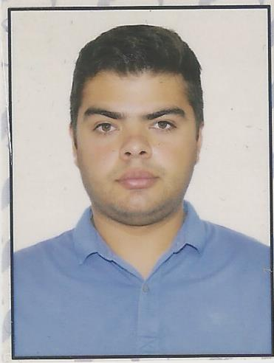

APPLICATIONFORM

PositionAppliedfor |  |  |  |  |  |  |  |  | DateAvailablefrom:
1.PersonalData
FamilyName:ABBASOV |  |  | FirstName:MAHAMMAD |  |  |  |  |  | MiddleName: +994504801441WHATAPP WHWHATSAPP
Dateof Birth:29.11.1992 |  |  | Place ofBirth(CityandCountry):  AZERBAIJAN. BAKU |  |  |  |  |  | Citizenship: AZERBAIJAN.
PermanentAddress  Baki seh Yasamal rayon Asad Ahamadov 28 |  |  |  |  |  |  |  |  | Phone (Home):  +994504801441
2.MaritimeEducation
Name ofschool |  | Country |  |  |  | Town | From |  |  | To |  | Typeofdegreeordiploma
Волга каспийский морскоий рыбопромышленный колледж |  | RUSIYA |  |  |  | ASTARXAN
3.ProfessionalTest
EnglishTestDate |  |  |  | Name ofTest |  |  |  |  |  |  | Score
Professional TestDate |  |  |  | Name ofTest |  |  |  |  |  |  | Score
Professional Interview Date. NO |  |  |  | Result.
4.FamilyDetails
CivilStatus(Single, Married,Separated, Divorced, Widowed) : SINGLE
NextofKin(thefirst emergency contact)NO |  |  |  |  |  |  |  |  |  |  | Relationship NO
AddressofResidence |  |  |  |  |  |  |  |  |  |  | Phone:
 | Daughter |  |  |  | Daughter |  |  |  |  |  | Daughter |  | Son
FamilyName
FirstName
DateofBirth
Cityofliving
PhoneNumbers

.IdentityDocuments
Document | Country | Number |  | PlaceofIssue |  |  |  | IssueDate | ExpiryDate
Seaman'sBook | AZERBAIJAN | DQK№026953 |  |  |  |  |  | 29.02.2024 | 28.02.2029
TravelPassport | AZERBAIJAN | C03747618 |  |  |  |  |  | 16.02.2022 | 15.02.2032
.CoursesAttendedandCertificatesObtained
Document |  |  | Number |  | Dates |  | Place
 |  |  |  |  | Issue | Expiry
INTERNATIONAL SAFETY MANAGEMENT |  |  | SP-1442-19 |  | 04.10.2019 | 04.10.2024 | AZERBAIJAN
MEDICAL STWC |  |  | SO-2435-19 |  | 10.10.2019 | 10.10.2024 | AZERBAIJAN
Training for seafarers with designated DUTIES |  |  | Sh-1307-19 |  | 08.10.2019 | 08.10.2024 | AZERBAIJAN
SHIP SECURITY RELATED Familliarization security |  |  | SI-2247-19 |  | 03.10.2017 | 03.10.2024 | AZERBAIJAN
PROFICIENCY IN SURVUVAL CRAFT AND BOATS OTHER TH |  |  | SP-1442-19 |  | 05.04.2019 | 05.04.2024 | AZERBAIJAN
MEDICAL FIRST AID |  |  |  |  | 28.02.2024 | 28.02.2026 | AZERBAIJAN
Tanker |  |  | SA-0656-22 |  | 02.09.2022 | 02.0.2027 | AZERBAIJAN

Page2 of 48.PhysicalData
Height | 173
Weight | 85
Colour of Hair | BALCK
Colour of Eyes | GREY
BoilersuitSize | L-XL
Shoes Size | 42
9.MedicalHistory |  | Yes | No
Haveyou ever signed off aship dueto medicalreasons? |  |  | NO
Didyouundergo anymedicaloperationinthepast? |  |  | NO
Haveyou consulted adoctor duringthelast 12 months for an illness/accident? |  |  | NO
Doyou have anyhealth or disabilityproblems now? |  |  | NO
If yes, pleasegivefulldetails:

 |  |  |  | Passed: |  | Valid till:
InternationalMedical Examination
Vaccination AgainstYellowFiver
Vaccination AgainstDiphtheria
10.References(pleasegivenameand addressof yourcurrentorpast employer) |  |  |  |  | Officeremarks
Nameof Company
Nameof person to contact
Address
Phone
Nameof Company
Nameof person to contact
Address
Phone
11.Bankaddressforallotments
Beneficiary
AccountNo.
Nameof Bank
BankAddress
12.Knowledgeandexperience |  |  |  |  | Yes |  | No
OCIMF vettingexperience:
ISGOT knowledge:
13.Iherebydeclarethattheabove,includingMedicalHistory,istrue
Place |  | Date |  |  | Signature
14.ForOfficeuseonly

SeagoingExperience

 | C. PREVIOUS SEA SERVICE
VESSEL |  | FLAG | TYPE / DWT | RANK | S/ON | S/OFF | OWNERS
M/V RIVER RAIN |  | PANAMA | GENERAL CARGO | SEAMAN | 06.08.2020 | 15.02.2021 | 7
M/V Volga-4009 |  | Cook island | GENRAL  CARGO | SEAMAN | 15.08.2021 | 13.01.2022 | 7
M/V BAKU-357 |  | AZERBAYCAN | TANKER | SEAMAN | 10.05.2022 | 13.01.2023 | 8

