Curriculum Vita
Personal information
Full Name:
KAZEM ROOHINA
Date of Birth :
21.09.1986
Nationality :
IRANIAN
Marital Status :
Married
Language:
Persian-English

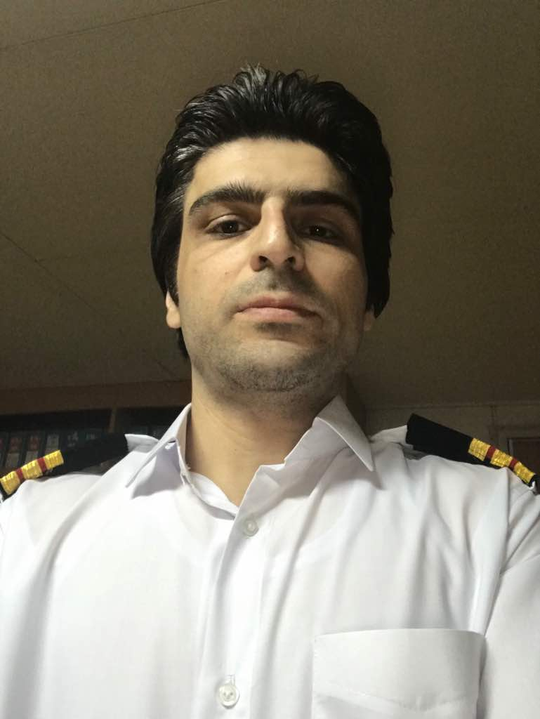

Education
Bachelor degree of marine engineer I.R.I.S.L MARITIME INSTITUTE

Publication , Studies & Professional Activity
Maintained machinery and controls and carried out repair functions on a variety of UMS and manned ECR ships with propulsion power up to 20000 Kw, aux. engines (up to 1.2MW), ship size up to 250m length also offshore psv dp2 vessels.
Proficient in cooling, circulating, supply, ballast and fuel systems, fuel handling, different types of pumps, turbo chargers, auxiliary and exhaust gas boilers, main air compressors, deck cranes (up to 30 tones) and their hydraulic systems, hatch cover hydraulic systems, mooring winches and windlasses, manual and control valves, air conditioning and refrigeration plants.
Utilized high level safety awareness, co-ordination, and critical management skills.
Planned and implemented maintenance programs.
Accomplished work under stress & adapting to a variety of work place situations and conditions.
Experience on psv dp2 vessel .

Performed trouble shooting and surveyed many kinds of machinery and equipment.
Dealt with port state controls and marine regulations.

Training
PLC, Hydraulic, control, pneumatic |  | IRISL Training Institute, Tehran 2014
Chief Engineer (Unlimited) course & Certificate of Competency endorsed by STCW2010. |  | IRISL Training Institute, Tehran  2018
Second Engineer (Unlimited) course & Certificate of Competency endorsed by STCW2010. |  | IRISL Training Institute, Tehran 2013_2014
Hydraulic and Electro-Hydraulic Courses. |  | IRISL training institute 2014
Third Engineer (Unlimited) course & Certificate |  | IRISL Training Institute  boushehr- 2007-2010
Trainee as a Cadet For Eight Months  Two ships : 1. m.v. nabovat 2.m.v. shariati |  | IRISL Company  2009
Basic safety, ISM, ISPS, Medical first aid, advance firefighting and survival craft at sea.
DP maintenance course |  | Win maritime institute Singapore 2022

Experiences
fifth engineer in IRISL company  - M.v.diyanat bulk carrier 8months | 2009-2010
Fourth engineer in IRISL company  - M.v. mulberry general cargo 4 months  - M.v. hootan bulk carrier 7 months  - M.v khorasan bulk carrier 7 months | 2010-2012
Third engineer in IRISL company  - M.v. perarin container 3 months  - M.v. naghme bulk carrier 3 months  - M.v. perarin container 5 months  - M.v. hamgam bulk carrier 10 months  - M.v behshad general cargo 2months | 2012-2016
Second engineer in IRISL company  - M.v. perarin container ship 5 months  - M.v. parshad bulk carrier 5 months  - M.v. kiazand bulk carrier 5 months  - M.v. jairan general cargo 5 months  - M.v. jairan general cargo 5 months | 2017-2020
Chief engineer in IRISL company
- M.v. behshad general cargo 4 months 2021
- C Apollo(bourbon liberty 108)PSV DP2 37 days 2022
- C Apollo(bourbon liberty 108)PSV DP2 100 DAYS 2022
- C Apollo(bourbon liberty 108)PSV DP2 50 DAYS 2022
2nd engineer in MSC (Mediterranean shipping company)
- MSC Corinna container ship 5 months 2023
- MSC Corinna. Container ship. 5 months. 2024

Contact Information
MOBILE: +989397621513
Tel: +981342141668
Email: kazemroohina@yahoo.com

