Vozbranyi Volodymyr – Chief Engineer
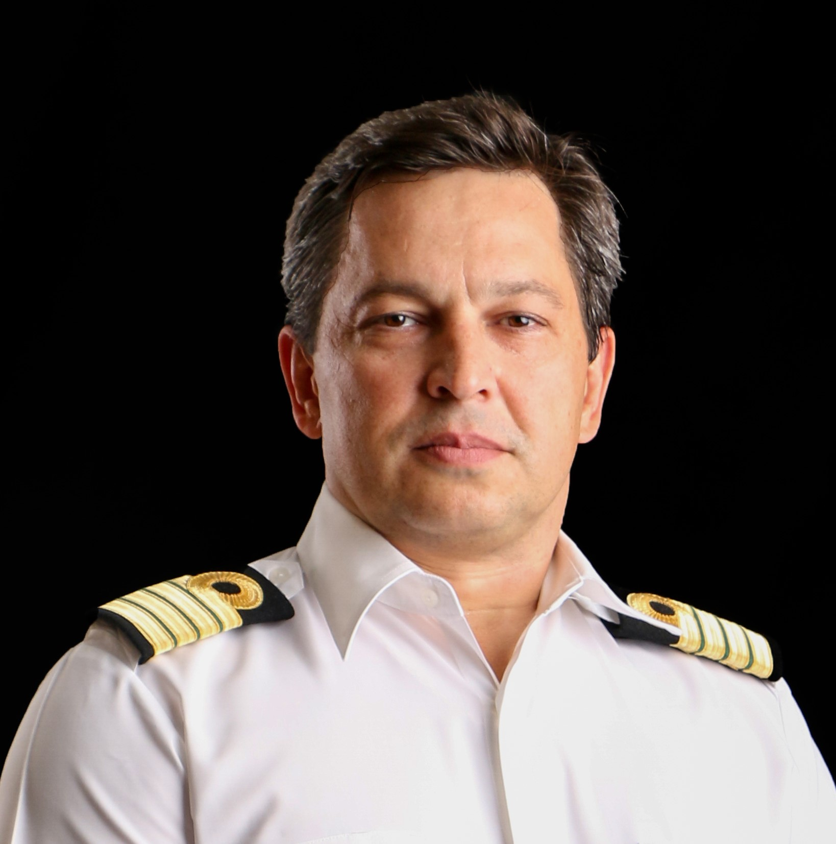

I am currently seeking new opportunities to move forward in the engineering field to sail as a
Chief Engineer
Marine Engineer who has worked in the Cruise industry for the last 20 years, have experience on
modern and older vessels, being involved in extensive refits. An effective manager and communicator
with both internal and external personnel, with an effective ability to utilize a team’s strengths and
knowledge to achieve efficient environment, whilst challenging and motivating each member
individually. The role also entailed a close working relationship with shoreside personnel,
superintendents, contractors.
EMPLOYMENT APPLICATION FORM
Rank: Chief Engineer/Staff Chief Eng. | Date Available for Joining: August 2025
 | Vessel: preferably – Passenger vessels

Personal details
Surname: Vozbranyi | First name: Volodymyr | E-mail : vvvseaman@gmail.com
Date of birth: 15.09.1976 | Place of birth: Kirovograd reg. Ukraine | Nationality: Ukraine
Home address: Odessa region, Ukraine.
Phones: +380963366489, WhatsApp,Viber,Telegram

Nearest airport: Chisinau, Moldova | Nearest international airport: Chisinau, Moldova

Documents

Travel Passport | FE660366 | Issued on: | 29.06.2016 | Expiry date: | 29.06.2026
Seaman”s Book | AB674068 | Issued on: | 06.01.2021 | Expiry date: | 06.01.2026
US visa C1/D | 01/D | Issued on: | 26.12.2019 | Expiry date: | 22.12.2029

LICENCE PARTICULARS
MOT | Grade | Cert No | Place of Issue | Date of Issue | Expiry date
Certificate of Competency | 1st class engineer | 18944/2022/08 | Port of Odessa | 28.10.2022
Endorsement |  | 18944/2022/08 | Port of Odessa | 28.10.2022 | 28.10.2027
Education | National University “Odessa Maritime Academy”,specialist’s diploma | C16 №095861 |  | 30.06.2016

CERTIFICATES | Cert No | Date of Issue | Expiry date
Proficiency In Survival Craft and rescue boats | 1510294 | 25.10.2022 | 25.10.2027
Basic Safety Training | 1510293 | 25.10.2022 | 25.10.2027
Advanced Fire Fighting | 1510295 | 25.10.2022 | 25.10.2027
Dangerous And Hazardous Substances
Training for personel serving on passenger ships | 1411669 | 04/11/2021 | 04/11/2026
Ship Security Officer | 1510485 | 25.10.2022 | 25.10.2027
Medical First Aid | 1510397 | 25.10.2022 | 25.10.2027
Medical Care
Engine Resourse Management | 1510296 | 25.10.2022 | 25.10.2027
Security-related training & instruction for all seafarers
Designated Security Duties | 1411668 | 05/11/2021 | 05/11/2026
High Voltage
Yellow fever |  | 21/11/2016
Medical examination |  | 23.12.2024 | 23.12.2026

Covid Vaccination | 2 + booster

SEA SERVICE
Name of Vessel | Year  Built | Flag | Type of Vessel  and Engine (Type) | DWT and HP | Rank | Period of Service |  | Name of Owners
Empress | 1990 | Bahamas | Passenger,Wartsila | 48563, 16200 kWt | Chief Engineer | 01.07.2024 | 05.10.2024 | Stella Seaways LTD
Empress | 1990 | Bahamas | Passenger,Wartsila | 48563, 16200 kWt | Chief Engineer | 27.12.2023 | 30.03.2024 | Stella Seaways LTD
Empress | 1990 | Bahamas | Passenger,Wartsila | 48563, 16200 kWt | Chief Engineer | 03.06.2023 | 25.09.2023 | Stella Seaways LTD
Empress | 1990 | Bahamas | Passenger,Wartsila | 48563, 16200 kWt | Chief Engineer | 16.01.2023 | 27.02.2023 | Stella Seaways LTD
Empress | 1990 | Bahamas | Passenger,Wartsila | 48563, 16200 kWt | Chief Engineer | 16.05.2022 | 08.10.2022 | Stella Seaways LTD
Empress | 1990 | Bahamas | Passenger,Wartsila | 48563, 16200 kWt | Staff Chief Eng | 19.02.2022 | 16.05.2022 | Stella Seaways LTD
Arethusa | 2007 | Malta | Passenger, Cummins | 1206, 1640 kWt | Chief Engineer | 01/08/2021 | 06/10/2021 | GCCL
SPIRIT OF DISCOVERY | 2019 | UK | Pass, MAN 9L32/44CR | 58250, 4x5400 kWt | Staff Chief Eng | 03/02/2021 | 13/04/2021 | Saga Cruises Ltd
SPIRIT OF DISCOVERY | 2019 | UK | Pass, MAN 9L32/44CR | 58250, 4x5400 kWt | Staff Chief Eng | 23/09/2020 | 15/12/2020 | Saga Cruises Ltd
SPIRIT OF DISCOVERY | 2019 | UK | Pass, MAN 9L32/44CR | 58250, 4x5400 kWt | Staff Chief Eng | 15/05/2020 | 01/08/2020 | Saga Cruises Ltd
SPIRIT OF DISCOVERY | 2019 | UK | Pass, MAN 9L32/44CR | 58250, 4x5400 kWt | Staff Chief Eng | 22/01/2020 | 15/03/2020 | Saga Cruises Ltd
SPIRIT OF DISCOVERY | 2019 | UK | Pass, MAN 9L32/44CR | 58250, 4x5400 kWt | Staff Chief Eng | 12/09/2019 | 18/11/2019 | Saga Cruises Ltd
Pearl II | 1981 | Malta | Pass, MAN 6L40/45 | 18628 4x 3300 kWt | Chief Engineer | 16/04/2019 | 04/05/2019 | Aqua Explore Holdings Limited
Saga Pearl II | 1981 | Malta | Pass, MAN 6L40/45 | 18628 4x 3300 kWt | Staff Chief Eng | 10/03/2019 | 15/04/2019 | Saga Cruises Ltd
Saga Pearl II | 1981 | Malta | Pass, MAN 6L40/45 | 18628 4x 3300 kWt | Staff Chief Eng | 13/11/2018 | 18/01/2019 | Saga Cruises Ltd

Experience with Multinational Crew: | yes
Nationalities: | English, Croatians,Bulgarians,Philippines,Indonesians,Romanians, Germans,Indians
Level of English | Fluent

Next of kin |  |  | Personal data:
Name/Relationship | Vozbrana Natalia- wife |  | Weight, kg: | 85 | Height, cm: | 173
Home address: | Ukraine, Odessa |  | Eyes: | brown | Hair: | black
Phones: | +380952012502 |  | Overall size: | 50 | Safety shoes: | 42

