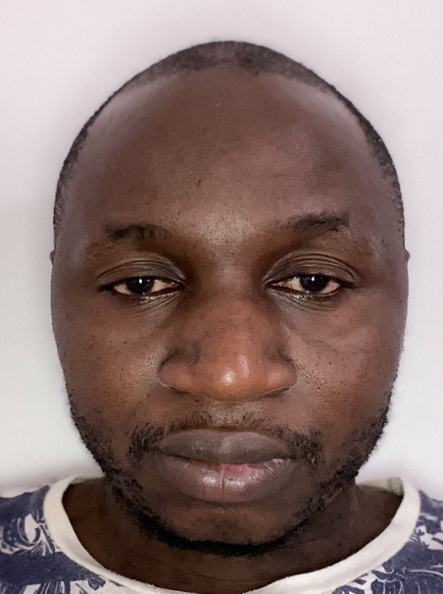Ousseynou bousso  dob :30/09/1985  LOCATION: RENNES  no TATOO, non-smoker  skills  Chief engineer , good experience in marine engineering, analyzes and diagnoses failures mainly mechanical, hydraulic and electrical, performs repairs according to the envisaged solutions.  Overall responsible for the technical systems of the ship.  ISM certification ,marine surveyor  Develops ,controls and executes plans for the maintenance of technical installations and equipment throughout the ship,  Maintains any planned maintenance system up to date and complete all relevant documentation.  Ensure optimum efficiency in the use of fuel, lubricating oil ,spare parts and stores.  Takes charge of an engine room watch if applicable.  Maintains and controls ISM/SMS,MARPOL,  MLC and others legislations to make sure the vessel is in compliance and ready for inspections at all times. | EXPERIENCES  - 2024: project manager of shipbuilding S/V ARTEMIS in PHU MY shipyard in VIETNAM (from May to nowadays)  - 2022 to 2024: Chief engineer on board of HSC GOLD EXPRESS in EXPRESS DES ILES company  - 2016 to 2022: Chief engineer on board of HSC ATLANTIC JET in VAL’FERRY COMPANY  - 2013 : Chief engineer on board of SURFER (crew boat) in BOURBON OFFSHORE SURF from June the 24,2013. To September the 17,2014.  - 2013 : Chief engineer on board of ROSE HERE (passenger vessel) in FINIST’MER COMPANY from April the 16, to June the 16,2013.  - 2012 : 2nd Engineer on board of Oil Tanker MT MAURITANKER in MEDTANKER MANAGEMENT SYSTEM from May the 22, to August the 22,2012.  - 2011 : Chief Engineer on board of Supply Vessel MV ARMORIC in OCEAN EXPRESS CONGO from February the 26, TO December the 3,2011.  - 2010 : 3rd Engineer on board of chemical Tanker MT TOUR POMEROL in V.SHIPS FRENCH from July the 2, To November the 6,2010.  - 2009: Chief Engineer on board of General Cargo MV DEBORAH 1 in TRIUMPH VENTURES LTD from October the 1,2009 to June the 30, 2010.  - 2009 : Training on board of fishing vessel MV KANBAL II in SOPERKA S.A from January the 16, to September the 30, 2009.  TRAINING and certificates  2012/2013: Certificate of chief engineer up to 8000 KW delivered by FRENCH maritime authority  August 2023: Training on high voltage in NSCC Nautical Institute  2024: MBA in Business Management
  chief engineer 8000KW

