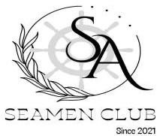
PERSONAL DETAILS
Position |  |  | SEAMAN (A/B & O/S) |  |  | 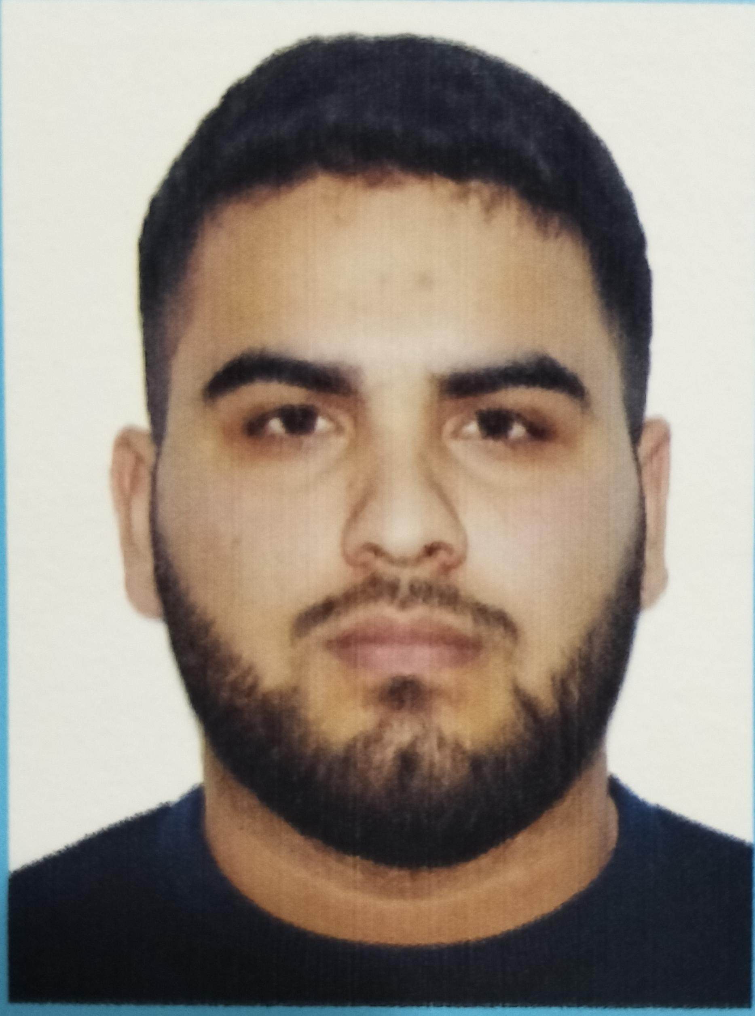
Family name |  |  | KAMRANOV
First name |  |  | BAHRUZ
Father’s name |  |  | SAFALAT
Date of birth |  |  | 20.04.2003
Marital status |  |  | SİNGLE
Permanent address |  |  | AZERBAIJAN, NEFTCHALA
Nearest airport |  |  | Heydar Aliyev International Airport  Baku, Azerbaijan
Height (cm) | Weight (kg) |  | Eyes color | Hair color | Size of safety shoes |  | Size of overalls
182 cm | 110 kg |  | BROWN | BLACK | 44 |  | 4XL
CONTACT DETAILS
Mobile |  |  |  | E-mail address
+994 99 714 46 47 |  |  |  | behruz.kamranov2003@gmail.com
NEXT OF KIN (FOR EMERGENCY)
Next of kin |  | Phone |  | Relationship |  | Address
KAMRANOV NURU |  | +994 10 214 46 47 |  | BROTHER |  | Azerbaijan
KNOWLEDGE OF LANGUAGE
Languages |  |  |  | Level
Azerbaijan |  |  |  | Advanced Level (C2)
Turkish |  |  |  | Advanced Level (C2)
English |  |  |  | Beginner Level (A2)
Russian |  |  |  | Beginner Level (A1)

TRAVEL PASSPORT DETAILS
Document | Place of Issue |  |  | Number |  | Issued | Valid
PASSPORT | Azerbaijan |  |  | C05582302 |  | 14.02.2025 | 13.02.2035
EDUCATION
Full name of School | Place of Issue |  |  | Grade/Class |  | From | To
“KAINAT MARITIME” LLC | Azerbaijan, Baku |  |  | Rating forming part of a navigational watch |  | 25.04.2024 | 21.01.2025
SEAMAN’S BOOK DETAILS
Document | Place of Issue |  |  | Number |  | Issued | Valid
SEAFARERS’ IDENTITY  DOCUMENT | Azerbaijan, Baku |  |  | AZE 035909 |  | 19.02.2025 | 19.02.2030
Seaman's Record  Book | Azerbaijan, Baku |  |  | DQK 031040 |  | 19.02.2025 | 19.02.2030
MEDICAL INFORMATION
Document |  | Place of issue |  |  |  | Date of issue | Date of expiry
Medical  Certificate |  | Azerbaijan, Baku |  |  |  | 10.05.2024 | 10.05.2026
COVID-19 Vaccination  Certificate |  | Azerbaijan, Baku |  |  |  | - | -
Vaccination Against  Yellow Fiver |  | - |  |  |  | - | -
CERTIFICATE OF COMPETENCY
Grade/Class | Issuing country |  | Certificate № |  | Date issued | Expires | Details of  Limitations/  STCW  Regulation
Rating forming part of a navigational watch | Azerbaijan  Marine  Administration |  | ID No:RP16568  No:0129/25 |  | 10.02.2025 | No Limit | A-II/4

STCW AND OTHER CERTIFICATES
Name of course/  Certificate |  | Institute |  |  | Place of issue |  | Certificate № |  |  | Date of issue |  | Date of expiry
International Safety  Management Code |  | Azerbaijan  Marine  Administration |  |  | Azerbaijan  Baku |  | SP-2975-24 |  |  | 03.09.2024 |  | 03.09.2029
Proficiency in survival craft and boats other than fast rescue boats |  | Azerbaijan  Marine  Administration |  |  | Azerbaijan  Baku |  | SL-2990-24 |  |  | 06.09.2024 |  | 06.09.2029
Basic safety training |  | Azerbaijan  Marine  Administration |  |  | Azerbaijan  Baku |  | SO-3300-24 |  |  | 30.08.2024 |  | 30.08.2029
Training for seafarers with designated security  duties |  | Azerbaijan  Marine  Administration |  |  | Azerbaijan  Baku |  | SH-2932-24 |  |  | 13.09.2024 |  | No Limit
Ship Security-related familiarization securityawareness training |  | Azerbaijan  Marine  Administration |  |  | Azerbaijan  Baku |  | SI-3686-24 |  |  | 18.09.2024 |  | No Limit
SEA EXPERIENCE (LAST 5 YEARS – MOST RECENT EXPERIENCE ON TP LINE)
Vessel | Company |  | Type of vessel | Flag |  | DWT |  | GRT | Rank |  | Sign on |  | Sign off
SVETLOMOR-2 | Caspian Shipping |  | Offshore  Tug/Supply Ship | Azerbaijan |  | 1000 |  | 1695 | CADET |  | 26.07.2024 |  | 25.10.2024
REFERENCES
Company Information
Name of Company: -
Name of person to contact: Phone: -

