POSITION:____4 Engineer __________SALARY :___2800________

Surname: Peresadin |  | Name: Nikita | Father's name: Sergeevich |  | ^{Gender (sex) :}  ^{Male / Female}
Date of birth 13.06.2003 |  | Place of birth: Russia, Elista | Nationality: Russian | Nearest airport:  Volgograd VOG, ESL, ASF, STW, KRR,  ROV, AAQ, AER, MRV, SIP, GDZ, VOZ,  LED, GOJ, MCX, SVO, DME, VKO, ZIA
Address (permanent)+Postal Index:  46, Apt.14, 4th Microrayon str., Elista, Rep.Kalmykia, Russia, 358011 |  |  | E-Mail: peresadin.nikita08@mail.ru  Skype: | 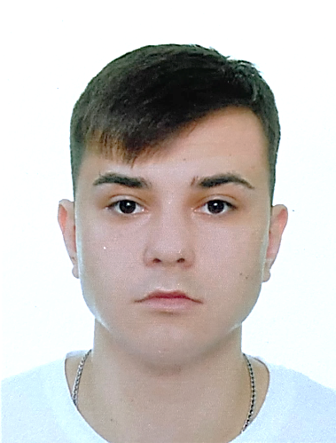  Mob: +79093956708  WApp, Telegram  Mob:
CES-Test (Competency Evaluation System): |  |  | Marlins test, %: | Visas:
Next of kin and relationship : Father Peresadin Sergey Nikolaevich  Mother Peresadina Nadezhla Ivanovna |  |  |  | Marital status: single yet
Next of kin’s address: 46, Apt.14, 4th Microrayon str., Elista, Rep.Kalmykia, Russia, 358011 |  |  |  | Next of kin’s phone: +79176848915f  +79613953208m
Travel Passport № 753625088 | Issued: 24.08.2016 |  | Valid: 24.08.2026 | Place of issue: Rostov-on-Don, Russia
Seaman's book № МК0350853 | Issued: 17.05.2021 |  | Valid: permanent | Place of issue: Rostov-on-Don, Russia
SID(RUS)/SSSRB(UKR)№ RUS 0525900 | Issued: 11.02.2021 |  | Valid: 10.02.2026 | Place of issue: Rostov-on-Don, Russia
Civil Passport № 8523613646 | Issued: 06.07.2023 |  | Place of issue: Rep. Kalmykia, RF | ID Code:080-001
Education (Town, Name, Date): Marine College Sedova Engineering Faculty graduated in 2022 with the Red Diploma
and entered Ushakov Water Transport Institute Engineering Faculty

*
CERTIFICATE OF COMPETENCY
Type of document | Grade | Number | Issued | Valid | Place of issue
Certificate of Competency | Officer in charge of an Engineering Watch III-1 | TAG208060257 | 02.02.2024 | 17.01.2029 | Taganrog HM
Certificate of Proficiency | Rating forming part of an Engineering Watch III-5 | TAG205438761 | 16.03.2022 | permanent | Taganrog HM
*

СERTIFICATES
Type of certificates | Number | Issued | Valid | Place of issue
Basic Safety Training (A-VI/1, Table A-VI/1-1,2,3,4) | 40754611 | 23.01.2024 | 23.01.2029 | Sedov water transport institute
Proficiency in survival Craft & rescue Boats (A-VI/2) | 40794166 | 19.01.2024 | 19.01.2029 | Sedov water transport institute
Advanced Fire Fighting (A-VI/3) | 40773774 | 26.01.2024 | 26.01.2029 | Sedov water transport institute
Medical First Aid/Medical Care Section A-VI/4,Table A-VI/4-1, A-VI/4-2 | 40824334 | 17.01.2024 | 17.01.2029 | Sedov water transport institute
Dangerous and Hazardous Cargoes (B-V/b ,B-V/c)
Ship Security Officer (VI/5)
GMDSS (+endorsement)
Radar observation and plotting (Radar & ARPA) (A-I/12, B-1/12)
Operational use of automatic radar plotting (ARPA) (A-I/12, B-I/12)
ECDIS (A-I/12, B-I/12)
Security related/awareness training for all seafarers (A-VI/6-1)
Designated security duties of shipboard personnel (A-VI/6-2) | 40557194 | 25.01.2024 | 25.01.2029 | Sedov water transport institute
Bridge/Engine Team and Resource Management (B-II/1, B-II/2)
Yellow Fever vaccination
COVID-19 vaccination / Vaccine name
Cyber Security Risks Management Certificate
*

PERSONAL PARTICULARS
Hair | Eyes | Blood Group/Rhesus | Height | Weight | Overall size | Shoes | Religion | Tattoo | Smoker
black | brown |  | 185 | 75 | 52 | 42 | christian | No | No
*

SEA GOING EXPERIENCE FOR THE LAST 5 YEARS
Name of vessel | IMO | Built | Owner Co./  Ship Manager | Flag | Type of vessel | DWT GRT | Main engine  Name / kW | Rank | From  dd, mm, yyyy | Till  dd, mm, yyyy | TTL  Month/Days
Caspian Stream | 9228332 | 2000 | SeverTransBunker | Russia | Oil taker | 7970/5137 | 2*8L20 Wartsila 2*1320 kW | Eng Cadet | 27.05.2021 | 06.08.2021 | 2m10d
Kpitan Marov | 7907221 | 1981 | LORP | Russia | Dry cargo | 3160/3505 | 6 ЧРН 36/45 1324 kW | Motorman | 30.04.2022 | 28.10.2022 | 5m29d
Ommax | 9481738 | 2010 | Blue wave shipping | Comoros | Dry cargo | 3662/3298 | 6NVDS48A-2U 1030kW | Motorman | 14.08.2023 | 16.12.2023 | 4m2d
Ommax | 9481738 | 2010 | Blue wave shipping | Comoros | Dry cargo | 3662/3298 | 6NVDS48A-2U 1030 kW | 3 Eng | 02.03.2024 | 18.07.2024 | 4m16d
*
REFERENCES
last Companies Names / Crewing Agency | Phone number | Contact person
LORP | +7 (411) 240-80-09 | Crewing Dpt
Blue Wave Shipping Co. | +7 (863) 322-33-70 | Crewing Dpt
*
I HEREBY CERTIFY that the information above is true and correct. Any misrepresentation or misinformation on my part shall be grounds for the
revocation of my application and if already employed, shall be ground for termination without any responsibility / liability on the part of
Company’s Crewing service
.
Seafarer | Date | 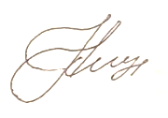  Signature
Peresadin Nikita Sergeevich | 20.09.2024

