Uniform TCC
Top Copy-Seafarer Pink Copy -Ship’s File  Green Copy-ITF London Yellow Copy -Company File | SEAFARER’SEMPLOYMENTCONTRACT
Date :09.01.2020 and agreed to be effective from 09.01.2020
This Employment Contract is entered into between the Seafarer and the Ship owner/the Employer on behalf of the Ship owner)
PACIFIC CREWING MANAGEMENT,INC
THESEAFARER
Surname:  TANDEL | Given Names:  HITESHKUMAR LALBHAI
Full home address:
33,MOHANPARKSOCIETY,DEVSAR,TA-GANDEVI,DI-NAVSARI,BILIMORA
Position:  ABLE SEAMAN | Medical certificate issued on:  23.12.2019
Estimated time of taking up position:  09.01.2020 | Port where position is taken up:  KOLKATA
Nationality:  INDIAN | Passport no:  L9603154
Date and place of birth:  07.05.1984 VAGHAI,DANG,GUJARAT | Seaman’s book no:  MUM-134184
THESHIPOWNER
Name:
AC HOLDINGSCORPORATION
Address:
ONE ARTILLERYCOURT,161ASHEDDONCOURT,GRANDCAYMANKY1-1001,CAYMANISLANDS
THEEMPLOYER
Name:
PACIFICCREWINGMANAGEMENT,INC
Address:
Calle43Este.Edif.ColoresdeBellavistaTektonBusinessPiso4.Cuidad de Panama. PANAMA.
THESHIP
Name:  PACIFICVENTURE |  | IMO No:  9743045
Flag:  CAYMANISLANDS | Port of registry:  GEORGETOWN
TERMSOFTHECONTRACT
Period of employment:  6 MONTHS+/-1month | Wages from and including:  09.01.2020 | Basic hours of work per week:  40HOURS
Basic monthly wage:  USD 850 | Monthly overtime (103hoursguaranteed)  103 HOURS | Overtime rate for hours worked in excess of 103hrs:  USD 6.13  Per hour
Leave :Number of days per month  7DAYS | Monthly leave pay:  USD 227 | Monthly subsistence allowance on leave:  USD 144
Monthly fixed overtime:  USD 631 | Company bonus:  USD0.00 | Total wages:  USD 1852
1.The applicable ITF CBA shall be considered to be incorporated into and to form part of the contract
2.The Ship’s Articles shall be deemed for all purposes to include the terms of this Contract (including the applicable ITF CBA) and it shall be the duty of the Company
To ensure that the Ship’s Articles reflect these terms.These terms shall take precedence over all other terms.
3.The ITF may vary the terms and conditions of the applicable ITFCBA from time to time. Terms and conditions as so varied shall form part of this Contract with effect from the date of the Variation in place of the Terms and Conditions current immediately preceding the Variation.
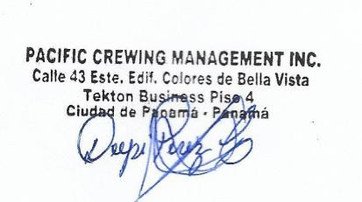
CONFIRMATIONOFTHECONTRACT

Signature of Ship owner / Employer on behalf of the Ship owner: | Signature of Seafarer:  Place: Date: 09.01.2020

