Application Form
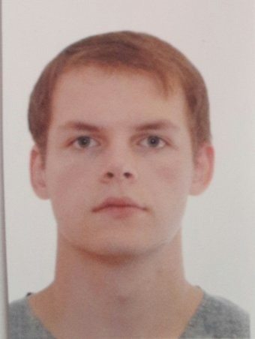
Position | Motorman/oiler
Alternative position
Expected salary | 2000 USD/month
Availability date | 04.04.2024

Personal Details

Last Name | Stankevichs | First Name | Viktors
Date of Birth | 07.01.1998 | Place of Birth | Riga
Nationality | Latvia | Citizenship | Latvia
Sex | Male | Marital Status | Single
Shoe size | 44 | Weight | 80 kg
Height | 180 cm | Overall size | L
Hair color | Brown | Eyes color | Green
Address | Lapla Iela 7/15 | Country | Latvia
Airport | RIX (Riga International Airport) | City | Riga
Home phone |  | Mobile phone | +37127180153
Phone number 2 |  | Skype | Stankevi4Viktor
E-mail | vitja_stankevi4@inbox.lv | Availability date | 20.03.2024
Relatives

Contact name | Relationship | Date of Birth
Viktors | Father | 01.01.1970
Next of Kin

Name | Relationship | Address | Phone number
Viktors Stankevis | Father | Lacplesa Iela 7/15 | +37129545034
National Documents
Novikontas maritime college
Maritime Training Institute

 | Number | Issue date | Expiry date | Place of issue
Passport | LV5857044 | 06.03.2018 | 05.03.2028 | PMLP RIGAS 2 NODALA
Seaman's Book | 0275474 | 28.01.2021 | 28.01.2032 | LATVIJAS JURNIEKU REGISTRS RIGA
Seafarer Identity Card
Certificates

 | Grade | Number | Issue date | Expiry date | Place of issue
COC | Motorman | 6041/21 | 17.12.2021 | 15.02.2026 | Latvijas jurnieku registrs
Endorsement

 | Number | Issue date | Expiry date | Place of issue
Basic Safety Training (VI/1) | 14-136 | 11.12.2020 | 11.12.2025 | Novikontas maritime college
Yellow Fever Vaccination |  | 09.08.2022 |  | Latvian center of infectology
Designated Security Duties | 74-105/20 | 28.12.2020 |  | Novikontas maritime college
Personal Skills

 | A: | B: | C: | D: | E: | Remarks
 | Upper | Intermed. / | Lower | Elementary / | Beginner /
 | Intermed. / | Upper | Intermed. / | Lower | Elementary
 | Advanced | Intermed. | Intermed. | Intermed.
Command of English language |  | x
Computer literacy
Previous Sea Services

Name of Vessel | Vessel type | Year built | Flag | GT | Engine type | KW | Engine model | Rank | Manager / Crew Agent | From | To
STI PIMLICO (IMO: 9686871) | Chemical/Oil tanker | 2014 | Marshall Islands | 24162 | B&W | 8502 | 6S50ME | Motorman Grade 2/wiper | Astor Shipmanagem. Ltd | 11.06.2023 | 17.12.2023
GNV AZZURRA (IMO: 7826790) | RO-RO | 1981 | Italy | 30316 | B&W | 5367 |  | Motorman Grade 2/wiper | MSC Crewing Services (Ukraine) | 21.09.2022 | 25.03.2023
WHITE MARLIN (IMO: 9670224) | Heavy lift vessel | 2015 | Malta | 51065 | Wartsila | 24040 | 8L38 | Motorman Grade 2/wiper | BOSKALIS OFFSHORE MARINE SERVICES - PAPENDRECHT, NETHERLANDS | 14.02.2022 | 21.06.2022
POLAR PIONEER (IMO: 8010324) | Passenger vessel | 1982 | Cyprus | 1753 | Rus Diesel | 2294 | Kaweda disel | Engine Cadet | Gota crewing | 30.04.2021 | 03.09.2021

Nationalities worked with | Ukraine, Russian Federation
Reason of leaving the previous company
References (contacts)
Ability to work in | War zones: No Pirate zones: No
In accordance GDPR (Regulation (EU) 2016/679) herewith I confirm my compliance with automatic processing of my personal data given in this application form, including transfer of my personal data and documents to the third parties and storage of this data and documents for employment purposes, I confirm that my personal data and documents inserted into this application are considered to be public information.

Above information is to the best of my knowledge correct. (To be signed by the person who completed the form)

Availability date | 04.04.2024 | Name in print | Viktors Stankevichs

