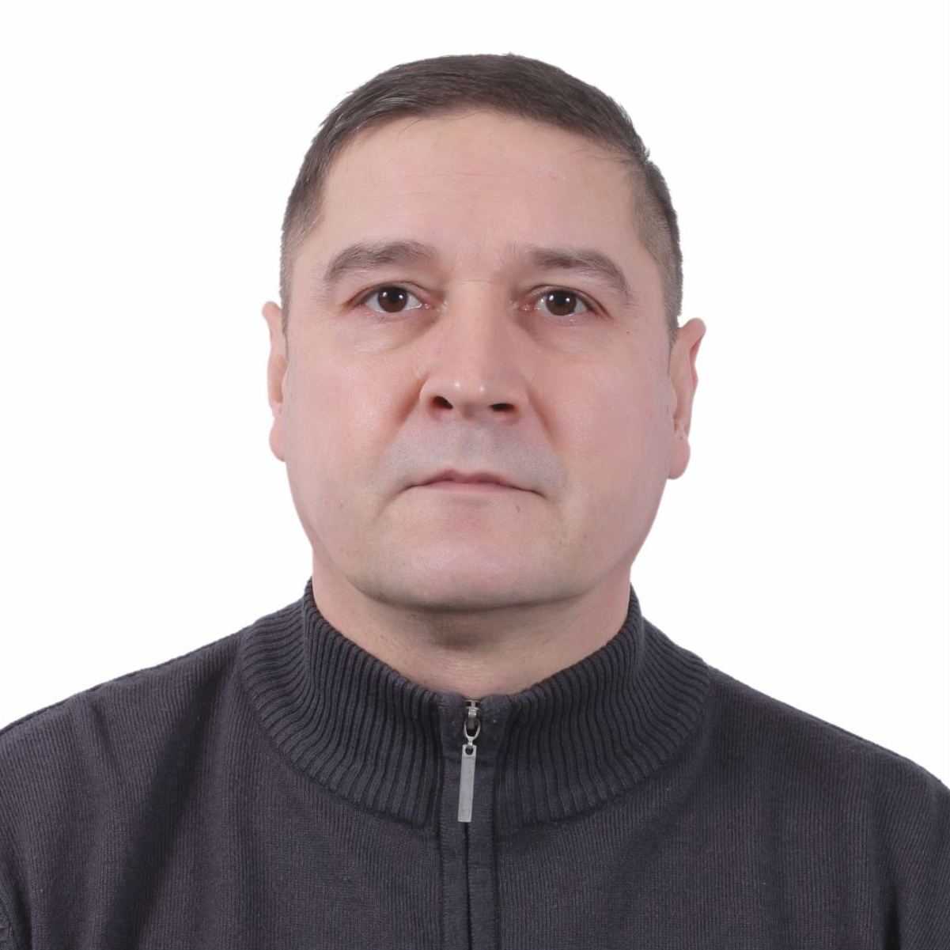

APPLICATION FORM

Position Applied
C/E

Personal Data
Last Name | Middle Name | First Name | Date and Place of Birth
Pavlychev | Valentinovich | Sergey | 07.01.1966 / USSR
Permanent Address | Leningradskaya obl., 6, v. Novosel'e apt.58
Telephone Numbers | Home: | Mobile: +7 962 6985901 | Additional Phone:
Nationality | Russian | Email :serg-pavlychev@yandex.ru
Nearest Airport | Saint-Petersburg |  | Marital status :married

Other Data
Sex | Weight (kg) | Height (cm) | Hair Colour | Eyes Colour
m | 90 | 176 | Dark | Brown

Clothing Sizes
Safety Shoes | Trousers | Shirts | Boiler Suit
43 |  |  | 52

Next of Kin
Relationship | Name | Telephone | Observations

Documents
DOCUMENT TYPE | Document Number | Date of Issue | Date of Expiry | Issue Place
Passport | 770763682 | 08.07.2023 | 08.07.2033 | SPB
Seaman’s Book | 0078666 | 24.04.2011 |  | SPB
American Visa | NA
Schengen Visa | NA
Seaman ID | 0492597 | 18.01.2021 | 18.01.2026 | SPB
SRC

Certificates

Course/Certificate: | Document Number | Date of Issue | Date of Expiry
General:
Basic Safety Training | MTC 1008150 | 01.12.2020 | 01.12.2025
PSCRB
Security certificate | MTC 1008154 | 11.12.2020 | 01.12.2025
First aid | MTC 1008153 | 09.12.2020 | 01.12.2025
Advanced FF | MTC 1008151 | 03.12.2020 | 01.12.2025
GOC
Rescue boat | MTC 1008152 | 02.12.2020 | 01.12.2025
ARPA
GMDSS
HAZ
SSO
SO
PADAMS
SH
BTM
ECDIS
ENGINE ROOM SIMULATOR W/ ERM
SDSD
CONSOLIDATED MARPOL
DECK WATCHKEEPING
ANTI-PIRACY
PDOS
SSO
SSBT
Catering:
Cook Qualification
Tanker:
TF
Vaccinations:
Yellow Fever | Dutch | 2023 | No limited

Certificate of Competency (COC) & Endorsement
Grade | Document Number | Date of Issue | Date of Expiry
Chief engineer | LED204679460 | 09.02.2021 | 01.12.2025
Dutch Endorsement | 20110798 | 29.08.2023
Portugal Endorsement | 0029916101 | 25.05.2021 | 01.12.2025

Languages Spoken
 | Speak |  |  | Write |  |  | Read
 | Excellent | Well | Fair | Excellent | Well | Fair | Excellent | Well | Fair
English |  | х |  |  | х |  |  | х
Italian
Other

Sea Experience

Name of Vessel  Year Build | Rank | From |  |  | To |  |  | No. of Mos. On Board | Reason for Leaving | DWT | Engine / HP | Type of Vessel | Name of Principal | Name of Crew Manager
Name of Vessel  Year Build | Rank | Day | Mo. | Yr. | Day | Mo. | Yr. |  |  |  |  |  |  |  | Name of Local Manning Agent
Rotterdam Traider (ex Sheppers Co) | C/E | 13 | 03 | 24 | 30 | 07 | 24 | 4/20 | EOC | 9755 | MAK8M43 7200 kW 4 str | Conteiner | Sheppers Sheefahrt | Marlow
Trito Navigator | C/E | 18 | 06 | 23 | 30 | 09 | 23 | 3/12 | EOC | 8137 | MAK  6M32C  2995  4 str | General Cargo | Forest Wave Navigation BV | Danica ua
FWN Splendide | C/E | 03 | 01 | 23 | 21 | 04 | 23 | 3/18 | EOC | 10585 | MAK  9M32C  4320  4 str | General Cargo | Forest Wave Navigation BV | Danica ua
WEC De Hoogh | C/E | 14 | 12 | 21 | 30 | 06 | 22 | 6/16 | EOC | 13716 | MAK  9M43  8400  4 str | Container | MSC | MSC ua
Wec Corneille | C/E | 12 | 03 | 21 | 01 | 08 | 21 | 4/20 | EOC | 11416 | MAK  9M43  8399  4 str | Container | MSC | MSC ua
Wec Corneille | C/E | 04 | 07 | 20 | 14 | 11 | 20 | 4/10 | EOC | 11416 | MAK  9M43  8399  4 str | Container | MSC | MSC ua
Johanna C | C/E | 09 | 05 | 19 | 12 | 09 | 19 | 4/3 | EOC | 12947 | MAK  6M43C  5400  4 str | Container | Carisbrooke | Naval ru
Maike D | C/E | 18 | 06 | 18 | 30 | 10 | 18 | 4/12 | EOC | 7944 | MAK  6M43C  6600  4 str | Container | Drevin Bereederungs | Peter Dohle
Maike D | C/E | 18 | 10 | 17 | 20 | 02 | 18 | 4/2 | EOC | 7944 | MAK  6M43C  6600  4 str | Container | Drevin Bereederungs | Peter Dohle
A2B Energy | C/E | 07 | 03 | 17 | 09 | 05 | 17 | 2/2 | EOC | 5356 | MWM  TBD645L9  3825  4 str | Container | KAAS Crew Services | Halverson Nl
Max Producer | C/E | 01 | 09 | 16 | 31 | 12 | 16 | 4 | EOC | 8124 | MAK  8M43C 7200  4 str | Container | OSM, Norway | OSM Hamburg

Date: 25.02.2025
Name: Sergey Pavlychev
Applicant Signature:

