SEAFARER’S APPLICATION FORM |  |  |  | 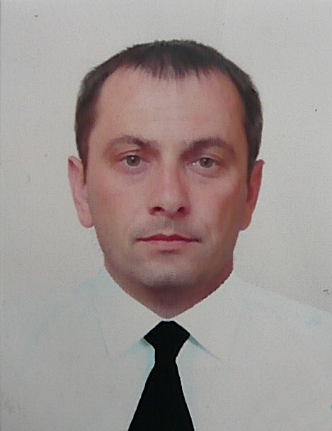
Main information
Position: | Chief Officer | Date of birth: | 26.10.1976
Certified for | Deep sea navigator | Place of birth: | Ukraine
Desired salary: | 6000 $ | Country of residence: | Ukraine
Full Name: | Anatolii Bulava | City: | Mariupol
Citizenship: | Ukraine | Address:
Phones: | +380982393201 | USA visa valid up:
E-mail address: | Bulava2109@ukr.net | Schengen visa valid up: | Biometric passport
Skype: | Anatolii Bulava | English level: | Good
Graduated from | Kherson State Maritime Academy

Passports / Smbk |  | # | Date of issue | Place of issue | Date of expire
International passport |  | FH 790193 | 07.09.2017 | Ukraine | 07.09.2027
Seaman's book |  | AC 011265 | 19.10.2023 | Ukraine | 19.10.2028
National passport |  | НК 135170 | 10.09.1996 | Ukraine
Diploma | Reg. | # | Date of issue | Place of issue | Valid up
Rank : Deep sea navigator
Professional license | II/2 | 00352/2020/06 | 09.12.2020 | Ukraine | 03.12.2025
Endorsement |  | 00352/2020/06 | 09.12.2020 | Ukraine | 03.12.2025
Certificates | Reg. | # | Date of issue | Place of issue | Valid up
GMDSS Operator | IV/2 | 10267/2016/06 | 25.03.2016 | Ukraine | 03.12.2025
GMDSS Endorsement |  | 10267/2016/06 | 10.12.2020 | Ukraine | 03.12.2025
Medical Care on board Ship | A-VI/4 | 214448 | 30.10.2020 | Ukraine | 30.10.2025
Medical First aid on board Ship | A-VI/4-1 | 214447 | 30.10.2020 | Ukraine | 30.10.2025
Advanced Fire Fighting | A-VI/3 | 214446 | 30.10.2020 | Ukraine | 30.10.2025
Proficiency in Survival craft and rescue boats (other thenfast rescue boats) | A-VI/2 | 214445 | 30.10.2020 | Ukraine | 30.10.2025
Bridge team /resource management | A-I/12,  A-II/1,2,  B-VIII/2 | 218033 | 06.11.2020 | Ukraine | 06.11.2025
Radar navigation (ARPA) | A-I/12 | 223423 | 13.11.2020 | Ukraine | 13.11.2025
Dangerous cargo | B-V/b,c | 256686 | 28.12.2020 | Ukraine | No limit
Ship security officer | A-VI/5 | 256702 | 04.02.2021 | Ukraine | 27.11.2025
Electronic chart display and information systems (ECDIS) | A-II/1, 2,3,12  B-I/12 | 223424 | 13.11.2020 | Ukraine | 13.11.2025
Safety familiarization, basic training and instruction for all seafarers | A-VI/1 | 214444 | 30.10.2020 | Ukraine | 30.10.2025
Security-related training and instruction for all seafarers | A-VI/6 | 214443 | 30.10.2020 | Ukraine | 30.10.2025
Designated security duties of seafarers | A-VI/6  A-VI/6-2 | 001076 | 21.02.2020 | Ukraine | No limit
FURUNO ECDIS |  | 9063055036AB | 26.10.2023
Ship Safety Officer | 3.13 | 32334224/07/0221/024 | 13.05.2024 | Ukraine | 13.05.2029

Medicine | # | Date of issue | Place of issue | Valid up
Medical fitness certificate: | 2025/0114 | 09.02.2025 | Ukraine | 09.02.2026
Alco-drug certificate: |  | 09.02.2025 | Ukraine | 09.02.2026
Yellow fever: |  | 10.03.2015 | Ukraine. Mariupol | No limit
COVID-19 Vaccination | Comirnaty / 3 doses | 16.01.2023

Flag Documents and Other Countries Seaman's Books
Country | № | Document type (Endorsement ) | Date of issue | Date of expire
PANAMA | PA0057107 | Chief Mate II/2 | 01.03.2021 | 03.12.2025
PANAMA | PA0057108 | GMDSS general operator IV/2 | 01.03.2021 | 03.12.2025
MARCHALL ISLANDS | M0807889 | Chief Mate II/2 | 21.06.2021 | 20.06.2026
MALTA | 2144518-R | Chief Mate II/2,  GMDSS general operator IV/2 | 14.03.2024 | 03.12.2025
LIBERIA | 1930328 | Chief Mate II/2 | 05.07.2024 | 05.07.2029
LIBERIA ENDORSEMENT | 1397561 | Chief Mate II/2  GMDSS general operator IV/2 | 05.07.2024 | 03.12.2025

Sea experience (reverse order)
Position | Name | Type / Flag | DWT/GTN | ME Type/  kW | From | Till | OWNERS
2nd  Officer | ALEXIA I | General Cargo / Panama | 10887/6945 | PIELSTICK/  2868 | 05.01.2021 | 20.04.2021 | Alexia Navigation LTD
Chief  Officer | ALEXIA I | General Cargo / Marshall Islands | 10887/6945 | PIELSTICK/  2868 | 25.05.2021 | 04.02.2022 | Alexia Navigation LTD
Chief  Officer | ATLANTA | General Cargo / Malta | 12223/7988 | YANMAR  8N330/  3310 | 02.05.2022 | 24.11.2022 | Atlanta Navigation LTD
Chief  Officer | AIKATERINI K | General Cargo / Panama | 8100/5599 | MAN B&W/2800 | 05.02.2023 | 07.09.2023 | Nearchos Shipmanagement CO
Chief  Officer | OCEAN DESTINY | Bulk Carrier /  Liberia | 55848/31540 | WARTSILA/  6RT-FLEX50/  8890 | 30.10.2023 | 24.12.2023 | Trustone Shipping Company LTD
Chief  Officer | AKOMENA | General Cargo / Malta | 10813/7450 | MAK/2970 | 30.12.2023 | 26.04.2024 | Bemaris Marine CO LTD
Chief  Officer | ANNAMARIA | General Cargo / Liberia | 8090/6569 | YANMAR  6N330EN/  2574 | 26.06.2024 | 01.02.2025 | Annamaria Shipping LTD

Next of Kin
Next of kin: Daughter |  | Phone: +38(098) 290 18 17
Name, Surname: Elizabeth Bulava |  | Address: 35 Tsubylko str, apt 5.,Mariupol, Ukraine
Biometricaldata
Hair color: brown | Height: 176 |  | Overall size: 50
Eyes color: brown | Weight: 85 |  | Shoe size: 42

