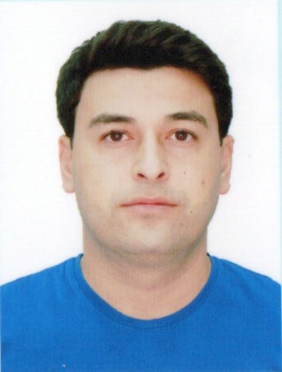
APPLICATION FORM

Position Applied for Ratting Forming Part of Engine-Room Watch | Date Available from: anytime

1. Personal Data
Surname: IBADOV | First Name: ABDULKHEYIR
Date of Birth: 24.03.1994 | Place of Birth: (City and  Country):  NEFTCHALA  AZERBAIJAN | Citizenship:AZERBAIJAN
Permanent Address :AZERBAIJAN, Baku,SURAKHANI |  | Phone (Home):  Phone (Business/ Mobile) :+99455 943 05 75 E-mail:  abdulibad2303@gmail.com

2. Maritime Education
Name of school | Town | Country | From | To | Type of degree or diploma
“KAİNAT TADRİS MARKAZİ” LLC  (State Maritime Administration) | BAKU | AZERBAIJAN | 11.12.2017 | 29.07.2018 | Training course  Ratting Forming Part of Engine-Room Watch

3. Language Speaking |  |  | Reading | Writing
 | ENGLISH | Good | Good | Good
 | TURKISH | Excelent | Excelent | Excelent
 | AZERBAIJANI | Excelent | Excelent | Excelent

4. Physical Data
Height | 175
Weight | 78
Colour of Hair | BLACK
Colour of Eyes | BROWN
Boilersuit Size | 40-42
Shoes Size | 42
WWW.A Z-MARINER.AZ Page 1 of 3

5. Identity Documents
Document | Country | Number | Place of Issue | Issue Date | Expiry Date
Seaman's Book | Azerbaijan |  | State of maritime administration
Travel Passport | Azerbaijan |  | Ministry of internal affairs
Civil Passport | Azerbaijan | 5UNZ75F | ASAN 2 | 26.03.2019 | 12.05.2029
Medical  Ceritificarte | Azerbaijan | E/W | Uniklinika Medical Center | 26.09.2024 | 26.09.2026

6. Courses Attended and Certificates Obtained
Document | Number | Da | tes | Place
Document | Number | Issue | Expiry | Place

Certificate of Competency | RP16471 0012/25 | 08.01.2025 |  | AZERBAIJAN
Maltese Endorsement of COC
Oil Tanker Endorsement
Chemical Tanker Endorsement
Gas Tanker Endorsement
Oil Tanker Familiarization Training
Chemical Tanker Familiarization Training
Gas Tanker Familiarization Training
Oil Tankers Specialized Training
Chemical Tanker Specialized Training
Gas Tanker Specialized Training
Basic Trainings
Proficiency in Survival Craft and Rescue Boats | SL-4035-24 | 28.11.2024 | 27.11.2029 | AZERBAIJAN
Advanced Fire Fighting | S0-4495-24 | 29.11.2024 | 22.11.2029 | AZERBAIJAN
Medical First Aid Training | S0-4495-24 | 29.11.2024 | 22.11.2029 | AZERBAIJAN
Medical First Aid Training and Medical Care
GMDSS
GMDSS Endorsement
Automatic Radar Plotting Aids Simulator (ARPA)
Bridge Team Management
Shiphandling & Maneuvering
Ship Security related familiarization securityawareness training | SI-4558-24 | 06.12.2024 |  | AZERBAIJAN
Maltese Endorsement of SSO
ISM Code | SP-3968-24 | 05.12.2024 | 05.12.2029 | AZERBAIJAN
Safety Officer
ECDISTraining Course
Risk Assessment Course
C.O.W./ I.G.S
Fire Practice on Tankers
Vapour Recovery System
Unmanned Machinery Space
FRAMO Familiarization Course
Cargo Ballast Operations on Oil/Chemical Tankers
Hazardous Materials
Welder
Turner
Risk Management And Incident Investigation
Training of seafarers with designated security duties in compliance with ISPS Code | SH-3738-24 | 06.12.2024 |  | AZERBAIJAN

7. Seagoing Experience

Name of vessel | Flag | Vessel’s Type | DWT | Eng Type | HP | Manager or Owner | Rank | From d/m/y | To d/m/y | Total m/d
ARAZ- 357 | Azerbaijan | Fishing Vessel | 1873 |  |  | Azerbaijan Caspain Shipping | Fishing | 29.12.24 | 28.01.25 | 1 Month
 |  |  |  |  | .

WWW.AZ-MARINER.AZ Page 3 of 3

