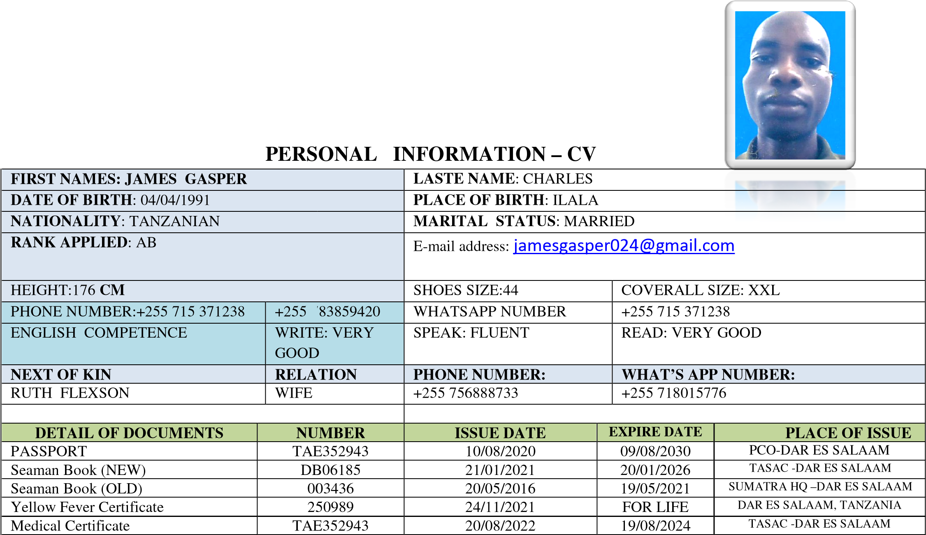


CERTIFICATE OF PROFFICIENCY (COP)
NAME OF CERTIFICATE |  | CERT.NO | ISSUE DATE | EXPIRE DATE | PLACE OF ISSUE
1. | PERSONAL SURVIVAL TECHNIQUES(PST) | 07864 | 22/01/2022 | 21/01/2027 | TASAC –DAR ES SALAAM
2. | ELEMENTARY FIRST AID | 03452 | 21/12/2021 | 20/12/2026 | TASAC –DAR ES SALAAM
3. | PERSONAL SAFETY AND SOCIAL  RESPONSIBILITIES(PSSR) | 03465 | 21/12/2021 | 20/12/2026 | TASAC –DAR ES SALAAM
4. | FIRE PREVENTION AND FIRE FIGHTING | 07014 | 21/12/2021 | 20/12/2026 | TASAC –DAR ES SALAAM
5. | SECURITY AWARENESS TRAINING | 08345 | 21/12/2021 | NIL | TASAC –DAR ES SALAAM
6. | PROFICIENCY IN SURVIVAL CRAFT & RESCUE  BOATS | 03072 | 21/12/2021 | 20/12/2026 | TASAC –DAR ES SALAAM
7. | ABLE SEAFERER DECK | 03461 | 21/12/2021 | NIL | TASAC-DAR ES SALAAM
8. | RATING FORMING PART OF A NAVIGATIONAL WATCH | 02621 | 21/12/2021 | NIL | TASAC-DAR ES SALAAM
9. | SEAFARER DESIGNATED SECURITY DUTIES | 03377 | 21/12/2021 | NIL | TASAC, DAR ES SALAAM
10. | HYDROGEN SULPHIDE SAFETY (H2S) | 00418 | 27/12/2021 | 26/12/2026 | DMI,DAR ES SALAAM
11. | BASIC SAFETY TRAINING (BST) | 00187 | 27/12/2021 | 26/12/2026 | DMI,DAR ES SALAAM

SEA SERVICES AS RECORDED IN SEAMAN BOOK
Vessel Name | FLAG | Rank | Type | GRT/N RT | Sign on – Sign off |  |  | Company
 |  |  |  |  | From | To
F.B SEAGULL | ZANZIBAR | OILER | TANKER | 576 | 03/06/2016 | 15/12/2016 | F.B SEAGULL
MT MOHAMMAD | ZANZIBAR | OILER | TANKER | 7904231 | 18/02/2017 | 22/12/2017 | MT. MOHAMMAD
CHATU | TANZANIA | OILER | TANKER | 717 | 10/02/2018 | 22/11/2018 | CHATU
LIEMBA | ZANZIBAR | OILER | TANKER | 832 | 12/12/2018 | 22/11/2019 | LIEMBA
SIMBA | TANZANIA | OILER | TANKER | 1750 | 18/03/2020 | 19/09/2021 | SIMBA

