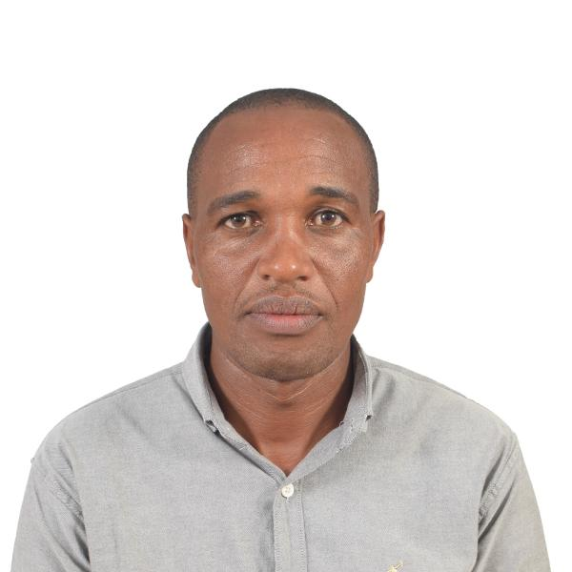
CURRICULUM VITAE

PERSONAL INFORMATION.
Name Hezekiah MuriuKaranja
Nationality Kenyan
Date of birth. 26th July1981
Marital status Married.
Residence Nairobi,Kenya
Email. hezelm@yahoo.com
Dates Available as soon as possible
Telephone +254 704 104678
Alternative +254 723 021020
OBJECTIVE.
Seek a fulfilling position in a professionally managed organization
Which will allow me to contribute and impart my knowledge and
Acquired skills through my solid work experience for the success of
company.
EDUCATION BACKGROUND.
Kenya primary education 1989____1997
Kenya secondary education. 1998____2001

PROFFESSION
1. Mechanical Engineering-Nairobi Technical Training Institute - 2003
2. Mechanical Engineering -Kabete Technical Training Institute 2004 -2006
3. Driver-Class BCE-Suitabilty test for drivers by gorverment of Kenya.

CERTIFICATION BY KENYA MARITIME AUTHORITY
CERTIFICATE OF PROFICIENCY
1. Standard of training Certification and Watch Keeping(STCW) and Ancillary Maritime Basic Safety Training for Seafares.
2.Elementary First Aid-(STCW Reg VI/1-3)
3.Personal Survival Techniques(STCW Reg VI/1-1)
4.Fire Prevention and Fire Fighting(STCW Reg VI/1-2)
5.Personal Safety and Social Responsibility(STCW VI/1-4)
6. Security Awareness(STCW VI/1

TRAINED ON
-HSE on confined space and permit
-H2S AandSO2 training program

WORK EXPERIENCE.
2007- 2011- Gulf piping company
Abudhabi,UAE.
Designation.Mechanical technician/Fabricator
Responsibilties.
-Carrying the maintenance of equipments
-Ensuring all equipments are operating in good order
-Keeping maintenance records for equipments.
-Pumps installation and alignment in the rigs.
-Maintain the equipments in clean and safe condition.
-Ensure compliances with GPC permit to work safe
-Reporting operational disturbances to the supervisor and
taking action when directed to do so.
-Greasing and changing the worn out parts for the equipments.
-Routine Maintenance of diesel engines.
-Parcipating in safety rig drills

2012- January 2014– Belgravia Services ltd
Lusaka,Zambia.

Position :Mechanical Technician.
Principal Accountabilities.
-Receive instruction and obtains specified materials,spare parts and tools.
-Underguidance of senior mechanical technician inspects,maintain,repair
and overhauls avariety of heavy plant equipments in accordance with
companystandards,codes and practices.
-Dismantles,repair or replaces various types of equipments and reassembles
either on site or in the workshop and carries out appropriated final tests.
-Carries out vibration survey for predictive maintenance.
-Ensure all maintenance activities are conducted within company standing
instruction and procedures and good oil industry's practice.
-Submits a technical report on each item of equipment repaired for
maintenance history record.
-Ensures good housekeeping on the job site and maintain all tools and
equipments in good order.
-carrying out the mechanical fabrication of materials when required to do so
-Perform other similar or related duties as required.

February 2014 –May 2015 Ray Energy International
Sultanate of Oman
Responsibilities
-Monitoring the performance of engines in the engine room.
-Report any faulty of an equipment to chief engineer.
-Daily check up of oil levels in engines
-Preparing daily report of plant equipments
-Ensuring that routine maintenance and fault rectification of engines
and other equipments in the station is carried out.
-Working closely with chief engineer through review system to agree on
development plans including training of new workers joining the plant.
-Reporting any abnormality of equipment to the area manager.
-Keeping fuel inventory records
-Testing fuel before off loading
-Implimentation of procedures and company policies are maintained.

2015 May -2015 October:marriot drilling group.
Employer:Royal oilfield services ltd.
Designation:Assistant rig mechanic.
Responsibilities
-Repairs and maintain mechanical equipments conform the preventive
maintenance program as directed by a superior mechanic.
-Carry out tasks in a maintenance as directed by chief mechanic.
-Liaise closely with superior mechanic regarding the planning for repair and
Ofequipments regarding the rules to follow as well as the operational
requirement dictated.
-Report to the chief mechanic any lack in stock of mechanical parts,tools
and consumables on board.
-Responsible for rig service.
-Participate during rig down and rig up.
-Participate in stop card writing and drills.
-Ensuring the engine room is neatly kept clean and all equipments are
Properly running.

2016 to Date-self employee
Duties and responsibilities{Driver}
1.Offering logistic services.
2.Keeping the log records of the vehicle’s performance.
3.Keeping inventory record of service parts.
4.Maintaining time management during goods delivery.
5.Making sure clients goods are handled in safety manner.
6.Inspection of goods before loading.
7.Ensuring the routine service of the vehicle is done on time.
8.Maintain discipline while driving and observe highway code.
9.Performing routine check up of the vehicle.
10.Maintaining vehicle cleaness.

INTERESTS
-Travelling
-socializing

REFEREES
1.LorenzKersting 3.Muhammud Shoaib
Maintenance Manager Field Manager
Gulf Piping Company Ltd, Ray Energy international
Abu dhabi. Sultanate of oman.
Contact .+971508115425 Contact.+968 1112766
Email.lkersting@imcc.ae

2. Human resources manager 4.Human resources office
Belgravia services Ltd, Royal oilfield services ltd
Lusaka Zambia Nairobi,Kenya.
Phone:+260 977 425321 Cell phone:+254 726 478475

5.Director Six square ltd.
Kenya.
Ajey Zain
Cell phone: +254794316166

