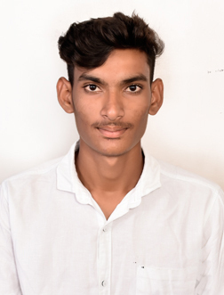
RESUME
Name : Nithishkumar
Date of birth : 16/07/2002
Gender : Male
Nationality : Indian
Religion : Hindu
LanguageKnown : English, Tamil.
Emailid : nithishnithish748@gmail.com
Contac no : 9344855722, 9500356187

DOCUMENTS COURSE

DOCUMENT | NUMBER | PLACE OF ISSUE | DATE OF ISSUE | DATE OF EXPIRY
PASSPORT | V0580110 | CHENNAI | 05/04/2021 | 04/04/2031
SEAMAN BOOK | CHN109788 | CHENNAI | 18/08/2022 | 17/08/2032
INDOS | 21NM0733 | CHENNAI | 13/06/2021 | UNLIMITED
YELLOW FEVER | 4672 | CHENNAI | 16/08/2022 | UNLIMITED
CERTIFICATES

COURSE | NUMBER | PLACE OF ISSUE | DATE OF IUUSE | DATE OF EXPIRY
PERSONAL SURVIVAL TECHNIQUES | 4060286101210088 | CHENNAI | 15/09/2022 | UNLIMITED
STSDSD | 4060286621210098 | CHENNAI | 08/12/2021 | UNLIMITED
FIRE PREVENTION AND FIRE FIGHTING | 4060286101210088 | CHENNAI | 15/09/2022 | UNLIMITED
ELEMENTARY FIRST AID | 4060286101210088 | CHENNAI | 15/09/2022 | UNLIMITED
PERSONAL SAFETY AND SOCIAL RESPONSIBILITY | 4060286101210088 | CHENNAI | 15/09/2022 | UNLIMITED

EXPERIENCES
NAME OF SHIP | COMPANY | RANK | PERIOD | TYPE | GRT | FLAG
RAPTOR | MANASSA 2M SHIPPING | DECK CADET | 08/11/2022  TO  11/10/2023 | GENERAL CARGO | 4294 | COMOROS
BLUE SHARK | SEABOOT SHIP MANAGEMENT PRIVATE LIMITED | DECK  CADET | 04/07/2024  TO  13/12/2024 | BULK CARIER | 16270 | BELIZE
DECLARATION

I hereby declare that the above information is true to the best of my knowledge and belief Regards:

DATE: (Candidate’s Name)
PLACE: NITHISHKUMAR

