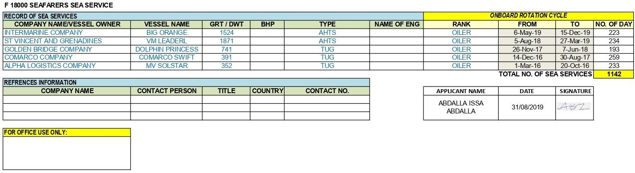


SEAMAN EMPLOYMENT APPLICATION FORM

PERSONAL DETAIL:
First Name | ABDALLA |  | Nationality | KENYA
Middle Name | ISSA |  | Date of Birth | 20/11/1979
Surname | ABDALLA |  | Place of Birth | MOMBASA
Application for position | OILER |  | Religion | MUSLIM
Marital Status | MARRIED |  | Height, Weight | 5.4FT 72KG
Home Address | MOMBASA |  | Relative Name
Home Tel No. |  |  | Relative Tel No.
Mobile No. | +254110026991 |  | Shoe Size | 8
Email Address | issaabdallah99@yayoo.com |  | Nearest Airport | MOI INTERNATIONAL AIRPORT
Blood Group | A+ |  | Availability Date | ANY TIME

TRAVELLING DOCUMENTS:
DOC. TYPE | DOC. NO. |  | ISSUE | EXPIRY | PLACE
Passport | AK0401031 |  | 14/06/2019 | 14/06/2029 | MOMBASA
Seaman Book | 00973 |  | 26/02/2016 | 25/02/2021 | MOMBASA
Seaman Book | 0007451 |  | 06/03/2023 | 05/03/2028 | MOMBASA
Yellow Fever
Marine Medical
USA VISA (If Applicable)
STCW 95/2010 COURSES:
COURSE No. |  | CERTIFICATE NO. | ISSUE | EXPIRY | INSTITUTE
Personal Survival Techniques (PST) |  | 06831 | 26/03/2019 | 27/06/2024 | TASAC, TANZANIA
Elementary First Aid (EFA)
Fire Prevention & Fire Fighting (FPFF) |  | 06793 | 26/06/2019 | 27/06/2024 | TASAC, TANZANIA
Personal Safety & Social Responsibility |  | 05172 | 26/06/2019 | 27/06/2024 | TASAC, TANZANIA
Proficiency Survival Craft & Rescue Boats |  | 06950 | 28/06/2019 | 27/06/2024 | TASAC, TANZANIA
Medical Fitness
Medical First Aid (MFA)
Advance Fire Fighting |  | 00654 | 26/08/2019 | 27/06/2024 | TASAC, TANZANIA
GMDSS GOC
Radar Observe / Radar Simulator
A.R.P.A.
Ship Security Officer (S.S.O)
Security awareness training |  | 0013539 | 06/03/2023 | 05/03/2028 | KMA, KENYA
Medical Care Certificate
Fast Rescue Certificates
Crane Operator Certificate
Basic Training
Rating Watch keeping Certificate
Rating Forming Part of An Engineering  Watch |  | 06675 | 26/06/2019 | N/A | TASAC, TANZANIA
Designated Security Duties
Able seafarer deck
V4 VHF & VTS

VOC5060 Operator course
Radar navigation operational level
Dynamic Positioning basic (induction) Course
Electronic Navigational Aids (Operational)
Hydrogen Sulphide Safety (H2S) | DMI/H2S/019/76/091 | 15/06/2019 | 14/06/2022 | DMI, TANZANIA
Helicopter Underwater Escape Technique
Basic training for oil and chemical tanker
cargo operations
Electronic chart display and information
system
Bridge resource management
BOSIET
Leadership and teamwork skills (Operational level)
General Operators Certificate
Bridge Team Management Course
Automatic identification system
*Please add columns for additional Certs*
CERTIFICATE OF COMPETENCY:
GRADE | CERTIFICATE NO. | ISSUE | EXPIRY | AUTHORITY

I hereby, the below signed applicant, confirm and acknowledge the validity of the above listed information:

APPLICANT NAME | DATE
ABDALLA ISSA ABDALLA | 31/08/2019

APPLICANT SIGNATURE | APPLICANT PHOTO
 | 

