Part A
Note: To be completed by Candidate

Personal Data
Position applied for | COOK |  |  | 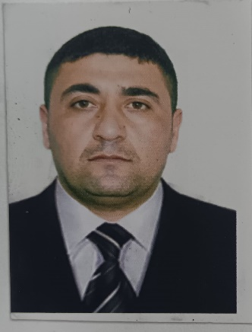
Full name | SHUKUROV ORXAN MƏRDAN
Date of birth | 16.12.1985 | Place of birth | AZERBAIJAN ASTARA REGİON PENSAR VİLLAGE
Nationality | AZERBAIJAN | Marital status | MARRİED
Phone | +994508508761 | Email | Shukurovorxan1985@gmail.com
Home address | AZERBAIJAN ASTARA REGİON PENSAR VİLLAGE
English level | Poor Average Good Excelent N/A

Next of Kin

Full Name | SHUKUROV REVAN | Phone Number | +994515965616
Home address | AZERBAIJAN ASTARA REGİON PENSAR VİLLAGE

Documents

Type of document | Country | № | Date of issue | Expire date
Seaman's book | AZERBAIJAN | DQK 019227 | 27.01.2022 | 27.01.2027
International passport | AZERBAIJAN | C01308706 | 13.11.2017 | 12.11.2027
Identity card (if applicable) | AZERBAIJAN | AZE 024144
COC endorsement (if applicable) | AZERBAIJAN | 2198/23 | 04.10.2023
ATOT endorsement (if applicable)
GMDSS endorsement (if applicable)

Health Information

 | Certificate Number (If available) | Issue Date | Expiry Date
Medical Examination |  | 29.05.2024 | 29.05.2026
Drug and Alcohol test
Yellow Fever
COVID 19 vaccination | B22360041A/B24440057A | 05.10.2021 | 02.11.2021

Education

Name of university/ College/ Course | IST SERVİCES
Specialty
Academic degree
Start date | 03.04.2023 | End date | 03.08.2023

Vessel Type Experience

Vessel Name | IMO  number | Vessel Type | Rank | Flag | DWT | Engine | Company | Sign ON Date | Sign OFF Date | Months on board
M/V RAVEN | 9165059 | MULTİSERVICE SHIPPING | COOK | VANUATU | 3404 | 6870 | GENERAL CARGO | 07.11.2023 | 29.01.2024 | 3 MONTHS
DOA STORY | 9014949/370579000 | SAMBURCO DENIZCILIK | COOK | PANAMA | 4188 | 1690 | GENERAL CARGO | 30.05,2024 | 03.04.2025 | ONE YEAR
Name of Last Company for take reference:
Address:
Telephone/E-mail:
Name of person to contact:

 | In rank | 0-6 month | 6-12 month | 1-3 year | 3 + year
Total Experience

 | 0-6 month | 6-12 month | 1-3 year | 3 + year
Total experience on Tanker

Training Information
Certificate | Issue Authority | Issue Place | Serial Number | Issue Date | Expiry Date
BASİC TRAİNİNG AND QUALİFİCATİONS ON OİL AND CHEMİCAL TANKER CARGO OPERATUONS | AZERBAIJAN MARİNE ADMİNSTRATİON | AZERBAIJAN | SA-0060-25 | 11.02.2025
PROFİCİENCY İN SURVİVAL CRAFT AND BOATS OTHER THAN FAST RESCUE BOATS | AZERBAIJAN MARİNE ADMİNSTRATİON | AZERBAIJAN | SL-0381-23 | 06..02.2023 | 06.02.2028
TRAİNİNG FOR SEAFARERS WITH DESIGNATED SECURITY DUTIES | AZERBAIJAN MARİNE ADMİNSTRATİON | AZERBAIJAN | SH-0207-23 | 01.02.2023 | 01.02.2028
SHİP SECURİTY-RELATED FAMİLİARİZATİON SECURİTY-AWARENESS TRAINIG | AZERBAIJAN MARİNE ADMİNSTRATİON | AZERBAIJAN | SI-1558-21 | 10.12.2021 | 10.12.2026
INTERNATİONAL SAFETY MANAGEMENT | AZERBAIJAN MARİNE ADMİNSTRATİON | AZERBAIJAN | SP-0371-23 | 07.02.2023 | 07.02.2028
BASİC SAFETY TRAİNİG ELEMANTARY FİRST AİD,PERSONAL SURVİVAL TECHİNQUES | AZERBAIJAN MARİNE ADMİNSTRATİON | AZERBAIJAN | SO-3528-21 | 25.12.2021 | 15.12.2026

