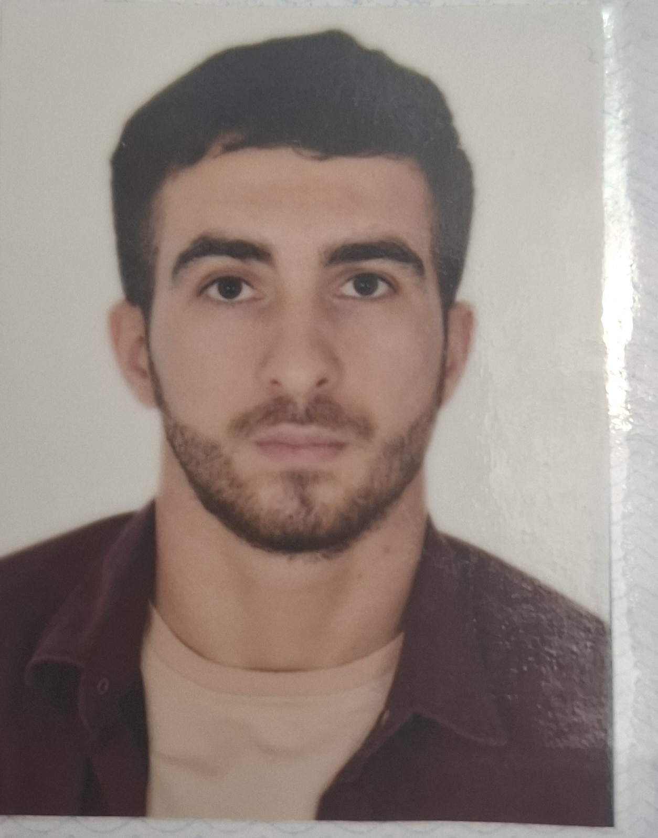

7 | 0 | V | D | T | 3 | G
Personal ID Number

Position Applied For: Cook | Date Available from: Any Time

1. Personal Data
Family Name: HUSEYNZADE | First Name: Madat | Middle Name: Bakhtiyar
Date of Birth: 02.03.2000 | Place of Birth : Azerbaıjan Baku | Citizenship: Azerbaıjan
Permanent Address: Azerbaıjan , Baku |  | Phone Mobil : Az (+994) 55 758 11 61 WP  E-mail : medeth559@gmail.com

2. Maritime Education
Name of school | Town | Country | From | To | Type of degree or diploma
Caspian Marine Education | Baku | Azerbaıjan | 15.09.2023 | 15.12.2023 | Professional

3. Language | Speak | Reading | Write
Azerbaijani | Native | Native | Native
Turkısh | Good | Good | Good
Russian | Little | Good | Good
English | Fair | Fair | Fair

4. Family Details
Civil Status(Single, Married, Separated, Divorced, Widowed) : Single
Next of Kin (the first emergency contact) Huseymov Bakhtiyar |  |  |  |  |  | Relationship: Father
Address of Residence : Azerbaıjan , Baku |  |  |  |  |  | Phone : (+994) 51 942 26 46
5. Identity Documents

Document | Country | Number |  | Place of Issue |  |  |  | Issue Date |  | Expiry Date
Seaman's Book | Azerbaıjan | DQK 026938 |  | Azerbaijan |  |  |  | 28.02.2024 |  | 28.02.2029
Travel Passport | Azerbaıjan | C03623445 |  | Azerbaijan |  |  |  | 15.12.2023 |  | 14.12.2033
Civil Passport | Azerbaıjan | AA3722376 |  | Azerbaijan |  |  |  | ------------- |  | 13.03.2032
6. I hereby declare that the above, including Medical History, is true
Place: |  |  | Date |  |  | Signature:
7. Courses Attended and Certificates Obtained

Document |  |  | Number |  | Dates |  |  |  | Place
 |  |  |  |  | Issue |  | Expiry
Certificate of Competency |  |  |  |  |  |  |  |  | Azerbaıjan
Training for seafarers with designated security duties |  |  | SH-3057-23 |  | 27.11.2023 |  | 24.11.2028 |  | Azerbaıjan
Proficiency in Survival Craft and Rescue Boats Other Than Fast Rescue Boats |  |  | SL-4171-23 |  | 30.11.2023 |  | 30.11.2028 |  | Azerbaıjan
Ship Security-related familiarization security – awareness |  |  | SI-3511-23 |  | 07.11.2023 |  | 04.11.2028 |  | Azerbaıjan
International Safety Management Code |  |  | SP-3722-23 |  | 27.11.2023 |  | 22.11.2028 |  | Azerbaıjan
-personal survival techniques –fire prevention avdfire fighting –elementary first aid –personal safety and social responsibilities |  |  | SO-5296-23 |  | 17.11.2023 |  | 17.11.2028 |  | Azerbaıjan
Basic training and qualifications on oil and cemical tanker cargo operations (STCW Code A-V/1-1 Pa.1) |  |  | SA-1008-23 |  | 06.12.2023 |  | 06.12.2023 |  | Azerbaıjan

8. Physical Data

Height | 175 sm
Weight | 78
Colour of Hair | Black
Colour of Eyes | Brown
Boilersuit Size | M
Shoes Size | 41

9. References ( please give name and address of your current or past employer )
Name of Company 1
Name of person to contact
Address
Phone
Name of Company 2
Name of person to contact
Address
Phone
10. Bank address for allotments
Beneficiary
Account No.
Name of Bank
Bank Address

11. Seagoing Experience
Name of vessel | Flag | Vessel’s Type | DWT | Manager or Owner | Rank | From d/m/y | To  d/m/y | Total  m/d
A plus 1 | Vanuatu | General Cargo | 4742 | YRB SHIPPING | Chief Cook | 11.06.2024 | 22.10.2024
ALENA | Panama | General CARGO | 4949 | NHR SHIPPING | Chief Cook | 01.01.2025 | 26.06.2025

