SEAFARER APPLİCATİON FORM

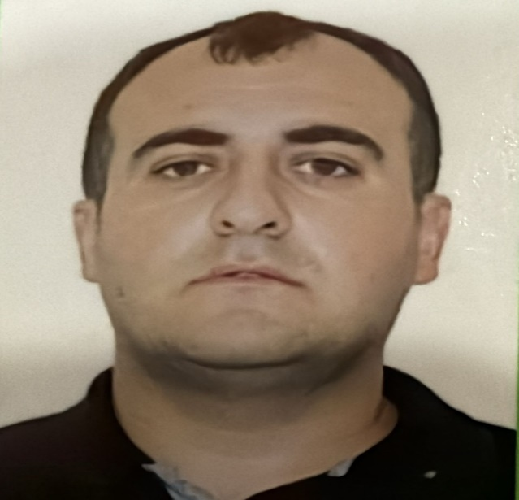
Position applied for: Able Seaman

1.Surname : Abdullayev
2. Name : Ramil
3. Given Name : Ramiz
4. Place of brith : Azerbaycan Nefchala
5. Citizenship : Azerbaijan
6. Adress : AZERBAIJAN, NEFCHALA BANKE QESEBESİ A. GOZELOV EV40
7. Phone No. (home) : Nİl
8. Phone No.(contract) : +994707339393
9. Seaman’s İD No. : AZE033552
10. Place of issue : Azerbaijan/ Baku
11. Date of issue : 26/06/2024
12. Date of expiry : 26/06/ 2029

13. İnterPassport No. : CO2574235
14. Place of issue : Azerbaijan/Baku
15. Date of issue : 09/07/2019
16. Date of expiry : 08/07/2029
17. Martial status : (celibatarian- married – discovered – widowed)
18. Weight/ Height : 90/172
19. Mother’s name : ABDULLAYEVA DURDANE
20.. Approved Education: _Huger Education

CERTIFICATES
SERTIFICATE NAME | Place of issue | ISSUE ON | VALID UNTILL
Basic training and qualifications on oil and chemical tanker cargo operations | ASMA | 07 /10 /22 | 20/ 09/ 27
International Safety Management Code | ASMA | 07/10/22 | 23 /09 /27
Ship Security -related familiarization security- awareness training | ASMA | 07 /10 /22 | 29 /09 /27
Training for seafarers with designated security duties | ASMA | 07 /10 /22 | 30 /09/ 27
safety familiarization training  personal survival techniques  fire prevention and fire fighting  elementary first oil  Personal safety and social responsibilities | ASMA | 28 /06 /24 | 28 /06 /29
Proficiency in survival craft and boats other than fast rescue boats | ASMA | 28 /06 /2024 | 20 /06 /29

SEAMAN’S IDENTIFICATION AND RECORD BOOK. REPUBLIC OF LIBRIA | BOOK 1677018  FIN1289127 | 24/03/22 | 24/03/2027
MERCHANT MARINE OF PANAMA | HA0027538  500528899 | 03 /03/21 | 26 /02/ 2026
Medical | UNIKLINIK | 24 /07 /2024  24 /07 /2026

POFESSIONAL EXPERINCES 15 YEARS (in backwards order)
RANK | MISSION STARTED | MISSION COMPLETED | SHIPOWNER/Nationality Tel/Fax/e-mail | VESSEL Name & Type | DWT | ME Type/BHP
ABLE SEAMAN | 09/12/ 2009 | 19/06/2010 | PALMALI SHIPPING TEL.+902123500900 FAX.+902123500909 EMAIL.Palmali@palmali.com | PALMALI DISCOVERY general cargo | 6933 | VOLVO PENTA 2240KWT
ABLE SEAMAN | 08/09/ 2010 | 9/03/2011 | PALMALI SHIPPING TEL.+902123500900 FAX.+902123500909 EMAIL.Palmali@palmali.com | PALMALI DISCOVERY general cargo | 6933 | VOLVO PENTA 2240KWT
ABLE SEAMAN | 14/09/ 2011 | 09/03/ 2012 | PALMALI SHIPPING TEL.+902123500900 FAX.+902123500909 EMAIL.Palmali@palmali.com | PALMALI DISCOVERY general cargo | 6933 | VOLVO PENTA 2240KWT
ABLE SEAMAN | 18/05/ 2012 | 28/10/ 2012 | PALMALI SHIPPING TEL.+902123500900 FAX.+902123500909 EMAIL.Palmali@palmali.com | PALMALI CONFIDIENCE general cargo | 6933 | VOLVO PENTA 2240KWT
ABLE SEAMAN | 25/01/ 2013 | 20/06/ 2013 | PALMALI SHIPPING TEL.+902123500900 FAX.+902123500909 EMAIL.Palmali@palmali.com | MIRZAGA KHALILOV General cargo | 6354 | ME(6R32LN) Wartsila 1x2460 kwt.
ABLE SEAMAN | 02/09/ 2013 | 14/03/2014 | PALMALI SHIPPING TEL.+902123500900 FAX.+902123500909 EMAIL.Palmali@palmali.com | “Ismayil Shikhly” General Cargo | 6354 | ME(6R32LN) Wartsila 1x2460 kwt.
ABLE SEAMAN | 18/05/ 2014 | 28/10/2014 | PALMALI SHIPPING TEL.+902123500900 FAX.+902123500909 EMAIL.Palmali@palmali.com | “Nakhchivan Dry Cargo” | 6933 | Volvo Penta 2240 kwt
ABLE SEAMAN | 06/12/ 2014 | 15/06/ 2015 | PALMALI SHIPPING TEL.+902123500900 FAX.+902123500909 EMAIL.Palmali@palmali.com | PALMALI CONFIDENCE General cargo | 6933 | Volvo Penta 2240 kwt
ABLE SEAMAN | 12/12/ 2015 | 19/06/ 2016 | Palmali Shipping TEL:+902123500900 / FAX:+902123500909 Email:palmali@palmali.com | “Ismayil Shikhly” General Cargo | 6354 | ME(6R32LN) Wartsila 1x2460 kwt.
BOSMAN | 02/11/ 2016 | 16/06/ 2017 | Palmali Shipping TEL:+902123500900 / FAX:+902123500909 Email:palmali@palmali.com | AKHMED MAHMUDOV. general cargo | 6354 | ME(6R32LN) Wartsila 1x2460 kwt.
BOSMAN | 03/11/ 2017 | 21/05/ 2018 | Palmali Shipping TEL:+902123500900 / FAX:+902123500909 Email:palmali@palmali.co | “ Mirzaga Khalilov” General Cargo | 6354 | ME(6R32LN) Wartsila 1x2460 kwt.
BOSMAN | 03/09/ 2018 | 12/03/2019 | Palmali Shipping TEL:+902123500900 / FAX:+902123500909 Email:palmali@palmali.com | “Mirzaga Khalilov” General Cargo | 6354 | ME(6R32LN) Wartsila 1x2460 kwt.
BOSMAN | 25/09/ 2019 | 20/07/ 2020 | Palmali Shipping TEL:+902123500900 / FAX:+902123500909 Email:palmali@palmali.com | Mirzaga Khalilov” General Cargo | 6354 | ME(6R32LN) Wartsila 1x2460 kwt.
BOSMAN | 01/03/2020 | 1/07/ 2021 | Statu Shipping.com TEL:+902165312300 Email:info@statushipping.c om | BONITA | 5558.09 | 1960kvt volvo
ABLE SEAMAN | 31/01/2022 | 28/08/2022 | PALMALI SHIPPING | IMAN BAHRAM MAMMADZADEH chimical tanker | 7109DWT | WARTSILA 2460 kwt
ABLE  SEAMAN | 06/11/2022 | 25/06/2023 | CASPIAN MARINE SERVICE | GÜLÜSTAN PASENGER | 1500 DWT | VOLVA 900KWT
ABLE  SEAMAN | 24/08/2023 | 05/03/ 2024 | PALMALI SHIPPING | IMAN BAHRAM MAMMADZADE H chimical tanker | 7139 | 2460kwt
ABLE SEAMAN | 04 /09 /2024 | 26 /12/ 2024 | PALMALI SHIPPING | NATIG ALIYEV | 19800  DWT | 7500kwt
ABLE SEAMAN | 03 /05 /2025 | 21/ 08/2025 | PALMALI SHIPPING | KARABAGH HEROES | 7110 DWT | 2460 KWT  WARTSILA

I, undersigned, confirm all above information to be true and correct to my best knowledge: Signature of the Applicant ____________________
CREW MANAGER REMARKS | 1 | 2 | 3 | 4 | 5
English: |  |  | X
Russian: |  |  |  |  | X
Azerbaijani: |  |  |  |  | X
Turkish: |  |  |  |  | X

