APPLICATION FORM
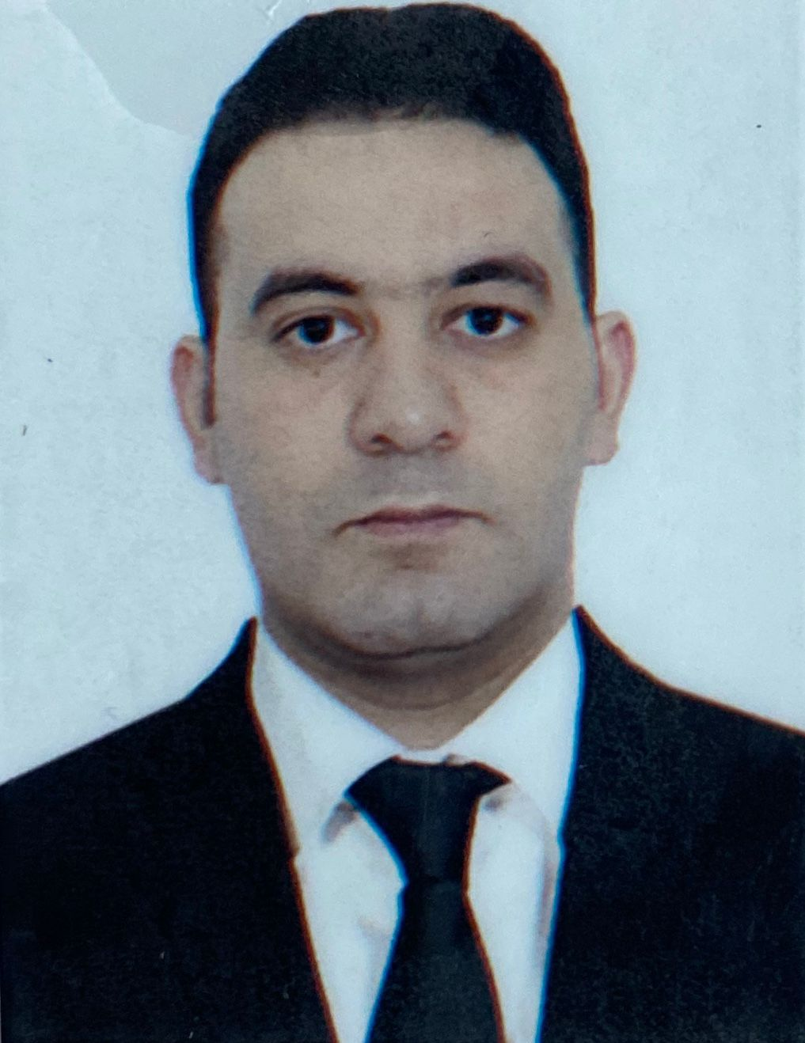

 |  |  |  |  | 5 | U | J | 3 | Y | Q | Y
Personal ID Number

Position Applied for:Watch Engineer Officer | Date Available from: ANY TIME

1. PersonalData
Family Name: İbrahimov | First Name: İbrahim | Middle Name: Eynulla
Date of Birth: 19.06.1995 | Place of Birth:Azerbaijan/UJAR | Citizenship: Azerbaijani
Permanent Address: Azerbaijan/Baku  ABSERON RAYONU,XIRDALAN SEHERI,QALUBIYYE KUCESIEV 75- MENZIL 37 |  | Phone (Home): 0515630126  WhatsApp +994708210126  E-mail: ibrahimovi641@gmail.com

2. MaritimeEducation
Nameofschool | Town | Country | From | To | Type of degree or diploma
Azerbaijan State Marine Academy | Baku | Azerbaijan | 2012 | 2016 | Bachelor

3. ProfessionalTest
EnglishTest Date | Nameof Test | Score
Professional TestDate | Nameof Test | Score
Professional Interview Date | Result

4. FamilyDetails
Civil Status (Single, Married, Separated, Divorced, Widowed) : Married

Next of Kin (the first emergency contact) : | Relationship /FATHER
Address of Residence:  Azerbaijan/Baku | +994 50 480-71-89  +7 961-340-56-16

5. IdentityDocuments
Document | Country | Number | PlaceofIssue | IssueDate | ExpiryDate
Seaman'sBook | Azerbaijan | DQK 015776 | State Maritime Adminstration | 04.02.2025 | 04.02.2030
TravelPassport | Azerbaijan | C03106676 | Ministry of Internal Affairs | 11.12.2019 | 10.12.2029

6. ValidVisa
CountryorUnion | Type | ValidUntil

7. Courses Attended and Certificates Obtained
Document | Number | Dates |  | Place
Document | Number | Issue | Expiry | Place

Certificate of Competency | No000545/23 | 23.05.2023 | 25.05.2028 | State Maritime Administration
Advanced training for oil tanker cargo operations | SB-0107-20 | 21.08.2020 | 24.07.2025 | State Maritime Adminstraction
BasicTrainings | SO-0284-25 | 14.02.2025 | 14.02.2030 | State Maritime Administration
Proficiency in Survival Craft and Rescue Boats | SL-0159-25 | 03.02.2025 | 03.02.2030 | State Maritime Administration
Training in advanced fire-fighting | SJ-0024-21 | 02.02.2021 | 02.02.2026 | State Martimate Adminstraction
Leadership and Teamwork | DL-0172-20 | 15.10.2025 | 15.10.2030 | State Martimate Adminstracti.
Ship Security-related familiarization security-awareness training | Sİ-0144-25 | 07.02.2025 | ~~~~~~~ | State Maritime Administration
Training for seafarers with designated security duties | SH-0144-25 | 07.02.2025 | ~~~~~~~ | State Maritime Administration
Dangerous hazardous and harmfull cargoes | SK-1353-25 | 15.10.2025 | 15.10.2030 | State Martimate Administration
BasicTraining and qualifications on oil and chemical tanker cargo operations | SA-0203-21 | 02.07.2021 | 02.07.2026 | State Martimate Adminstractio
Crowd management training | SC-0147-21 | 16.07.2021 | 16.07.2026 | State Martimate Adminstraction
Passenger safety,cargo safety and hull integrity | SF-0023-22 | 19.04.2022 | 17.02.2027 | State Martimate Adminstractio
Engine resource management | ER-0194-25 | 11.07.2025 | 11.07.2030 | State Martimate Adminstractio
İnternational Safety Management Code | SP-0239-25 | 21.02.2025 | 21.02.2030 | State Martimate Adminstractio
Crisis management and human behaviour training | SE-0037-25 | 19.02.2025 | ~~~~~~~ | State Martimate Adminstractio
```Safe operation and maintenance of high voltage systems 1000 volts or more`` | DM-0106-25 | 25.02.2025 | 25.02.2030 | State Martimate Adminstractio
Medical First Aid | SN-0036-21 | 08.10.2025 | ~~~~~~~ | State Martimate Adminstractio
State Martimate Adminstractio

8. PhysicalData
Height | 169sm
Weight | 76
ColourofHair | Black
ColourofEyes | Brown
BoilersuitSize | M
ShoesSize | 41

9. MedicalHistory | Yes | No
Have you ever signed off a ship due to medical reasons? | Yes
Did you undergo any medical operation in the past? |  | No
Have you consulted a doctor during the last 12 months for an illness/accident? |  | No
Do you have any health or disability problems now? |  | No

If yes, please give full details:

 | Passed: | Validtill:
International Medical Examination | 25.06.2024 | 25.06.2026
Vaccination Against YellowFiver
Vaccination Against Diphtheria

10. References (please give name and address of your current or past employer) | Officeremarks

NameofCompany
Name of person to contact
Address
Phone

NameofCompany
Name of person to contact
Address
Phone

11. Bank address forallotments
Beneficiary
AccountNo.
NameofBank
BankAddress

12. Knowledgeandexperience | Yes | No
OCIMF vetting experience:
ISGOT knowledge:

13. I hereby declare that the above, including Medical History, is true
Place

14. ForOfficeuseonly

15.
Nameofvessel | Flag | Vessel’sType | DWT | EngType | HP | Manageror Owner | Rank | From d/m/y | Tod/m/y | Total  m/d
Hasan Aliyev | Azerbaijan | Cargo ship | 3950 | Man6DKRN45/90D |  | Azerbaijan Caspian Shipping Closed Joint-Stock Company | Motorman | 02.03.2020 | 09.06.2020 | 3 m,6 d
Ordubag | Azerbaijan | Passenger  ship | 3950 | MAN6 DKRN45/90 |  | Azerbaijan Caspian Shipping Closed Joint Company | Motorman | 01.11.2020 | 13.01.2021 | 2m,13d
AGDAM | Azerbaijan | Passenger ship | 5398 | Man 5S26MC98 |  | Azerbaijan Caspian Shipping Closed Joint Company | Motorman | 09.03.2021 | 09.06.2021 | 3m.
SHAHDAG | Azerbaijan | Passenger ship | 5398 | Man5S26MC98 |  | Azerbaijan Caspian Shipping Closed Joint Company | Watch Enginer Officer | 22.08.2021 | 13.10.2021 | 1m,23d
BARDA | Azerbaijan | Ro-ro ship | 5600 | Man5S26MC98 |  | Azerbaijan Caspian Shipping Closed Joint Company | Warch Enginer Officer | 15.10.2021 | 07.01.2022 | 2m23d
BARDA | AZERBAIJAN | RO-RO SHIP | 5600 | Man5S26MC98 |  | Azerbaijan Caspian Shipping Closed Joint Company | Warch Enginer Officer | 02.04.2022 | 02.08.2022 | 4 M
ERKUL S | PANAMA | CARGO VESSEL | 13000 | MAN 5S26MC |  | GANT DENIZCILIK | Warch Enginer Officer | 29.08.2022 | 29.12.2022 | 4 M
NAXCIVAN | AZERBAIJAN | RO-RO SHIP | 5600 | MAN 5S26MC |  | Azerbaijan Caspian Shipping Closed Joint Company | Warch Enginer Officer | 02.02.2023 | 03.05.2023 | 3M 3d
ZERIFE ALIYEVA | AZERBAIJAN | RO-RO PAX | 8523 | 8L26 WARTSİLA |  | Azerbaijan Caspian Shipping Closed Joint Company | SECOND  ENGINER | 12.06.2023 | 17.09.2023 | 3 M 5d
LADY MERAL | PANAMA | CARGO VESSEL | 32000 | MITSUBUSHI 6UEC52LA |  | GN GROUP | SECOND  ENGINER | 24.09..2023 | 31.01.2024 | 4 M,7 d
Husey Cavid | AZERBAIJAN | CARGO VESSEL | 5000 | 6L20 |  | Azerbaijan Caspian Shipping Closed Joint Company | SECOND  Enginer | 18.03.2024 | 20.06.2024 | 3m
Medkon Sinop | Panama | Cargo | 10000 | mak |  | Medkon Lines | SECOND  Enginer | 30.06.2024 | 30.10.2024 | 4m
Qəhraman xəlilbəyli | Azərbaycan | Tanker |  | 6L20 wartsila |  | Azerbaijan Caspian Shipping Closed Joint Company | SECOND  EnginerSECOND  Enginer | 02.04.2025 | 07.07.2025 | 3m.5d
PREZDENT HEYDƏR ƏLİYEV | Azərbaycan | Tanker |  | 6l20 |  | Azerbaijan Caspian Shipping Closed Joint Company | SECOND  Enginer | 21.07.2025 | 29.09.2025

Total rank sea service: Total type of vessel sea service:
Rank | Years |  | Typeofvessel | Years
Able seaman |  |  | OIL TANKER
 |  |  | LPG0
 |  |  | DRY CARGO
 |  |  | TANKER ICE
 |  |  | OIL /CHEMICAL TANKER
 |  |  | FERRY
Total |  |  | Total:

