CURRICULUM VITAE
PERSONAL DETAILS
Family name |  | JAVADOV |  |  | 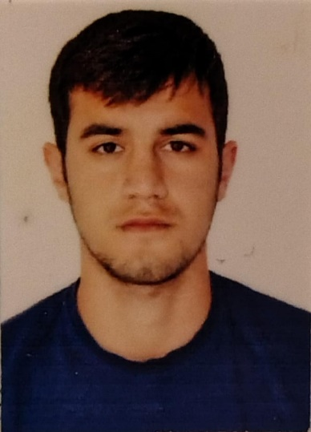
First name |  | MAIS
Father’s name |  | FAIQ
Date and place of birth |  | 16.11.2002 Azerbaijan
Nationality |  | Azerbaijani
Marital status |  | No
Permanent address |  | Azerbaijan, BAKU
Nearest airport |  | Heydar Aliyev International Airport Baku, Azerbaijan
Height (cm) | Weight (kg) | Eyes color | Hair color | Size of safety shoes | Size of coveralls
185 cm | 85 kg | BROWN | BLACK | 42 | 52
CONTACT DETAILS
Mobile | E-mail address
+994773426798 | cavadovmais37@gmail.com
NEXT OF KIN (FOR EMERGENCY)
Next of kin | Javadov Faiq | Relationship | Father
Date of birth | 16.07.1970 | Address | Baku,Azerbaijan
Phone | +994513378766 | Mobile phone | +994555965168
TRAVEL PASSPORT DETAILS
Document | Number | Place of Issue | Issued | Valid
PASSPORT | C04008199 | Azerbaijan | 13.12.2023 | 12.12.2033
SEAMAN’S BOOK DETAILS
Document | Number | Place of Issue | Issued | Valid
Seaman book | DQK017650 | Azerbaijan ,Baku | 02.06.2021 | 02.06.2026
SEAARERS IDENTITY | AZE022574 | Azerbaijan ,Baku | 02.06.2021 | 02.06.2026
EDUCATION
Full name of School | Place of Issue | Grade/Class | From | To
Azerbaijan State Marine Academy | Azerbaijan , Baku | NAVIGATION | 2020 | 2024
KNOWLEDGE OF LANGUAGES
Languages | Speaking | Reading | Writing
Azerbaijan | Excellent | Excellent | Excellent
Russian | Excellent | Excellent | Excellent
Turkish | Excellent | Excellent | Excellent
English | Good | Good | Good
COMPUTER SKILLS
Windows | Microsoft Office | Internet
Excellent | Excellent | Excellent
MEDICAL INFORMATION
Document | Grade | Place of issue | Date of issue | Date of expiry
Med.Sertificate | OOW | Azerbaijan | 12.08.2025 | 11.08.2027
CERTIFICATE OF COMPETENCY
Class/Grade | Issuing country | Certificate No. | Date issued | Expires | Details of Limitations
Rating forming part of a navigational watch | Azerbaijan | 2742/23 | 21.12.2024 | - | None
STCW AND OTHER CERTIFICATES
Name of course/Certificate | Institute | Place | Date of issue | Cert.No | Date of expiry
International Safety Management | State Maritime and Port Agency | Azerbaijan Baku | 30.07.2021 | SP-1227-21 | 16.06.2026
IMO Model Courses 1.13, 1.19, 1.20, 1.21 | State Maritime and Port Agency | Azerbaijan Baku | 22.07.2021 | SO-1650-21 | 14.06.2026
Ship Security-related familization security-awareness training | State Maritime and Port Agency | Azerbaijan Baku | 17.07.2021 | SI-0765-21 | 18.06.2026
Training for seafarers with designated security duties | State Maritime and Port Agency | Azerbaijan Baku | 05.09.2025 | SH-1337-25 | Unlimited
Proficiency in survival craft and boats other than fast rescue boats | State Maritime and Port Agency | Azerbaijan Baku | 08.10.2025 | SL-1516-25 | 01.10.2030
Operational Use of Electronic Chart Display and Information Systems (ECDIS) | State Maritime and Port Agency | Azerbaijan Baku | 15.04.2024 | SZ-0243-24 | 05.01.2029
Radar navigation,radar plotting and use of ARPA (Operational Level) | State Maritime and Port Agency | Azerbaijan Baku | 16.04.2024 | SR-0106-24 | 09.01.2029
GMDSS General Operator | State Maritime and Port Agency | Azerbaijan Baku | 15.04.2024 | DQ-0262-24 | 14.06.2028

SEA EXPERIENCE (LAST 5 YEARS)
Vessel | Company | Type of vessel | Flag | DWT | GRT | Rank | Sign on | Sign off
SABIT ORUCOV | “Azerbaijan Caspian Shipping” CJSC | PASSANGER | AZERBAIJAN | 549 | 2621 | CADET | 29.06.2021 | 14.09.2021
MIKAYIL  MUSHFIG | “Azerbaijan Caspian Shipping” CJSC | GENERAL CARGO | AZERBAIJAN | 4150 | 3182 | CADET | 20.06.2022 | 07.09.2022
GENERAL ALIAGA SHIKHLINSKY | “Azerbaijan Caspian Shipping” CJSC | CRANE VESSEL | AZERBAIJAN | 3343 | 19813 | CADET | 16.06.2023 | 07.09.2023
BESTEKAR FIKRET EMIROV | “Azerbaijan Caspian Shipping” CJSC | RO-RO/PASSANGER | AZERBAIJAN | 6894 | 4673 | CADET | 02.02.2024 | 24.05.2024

