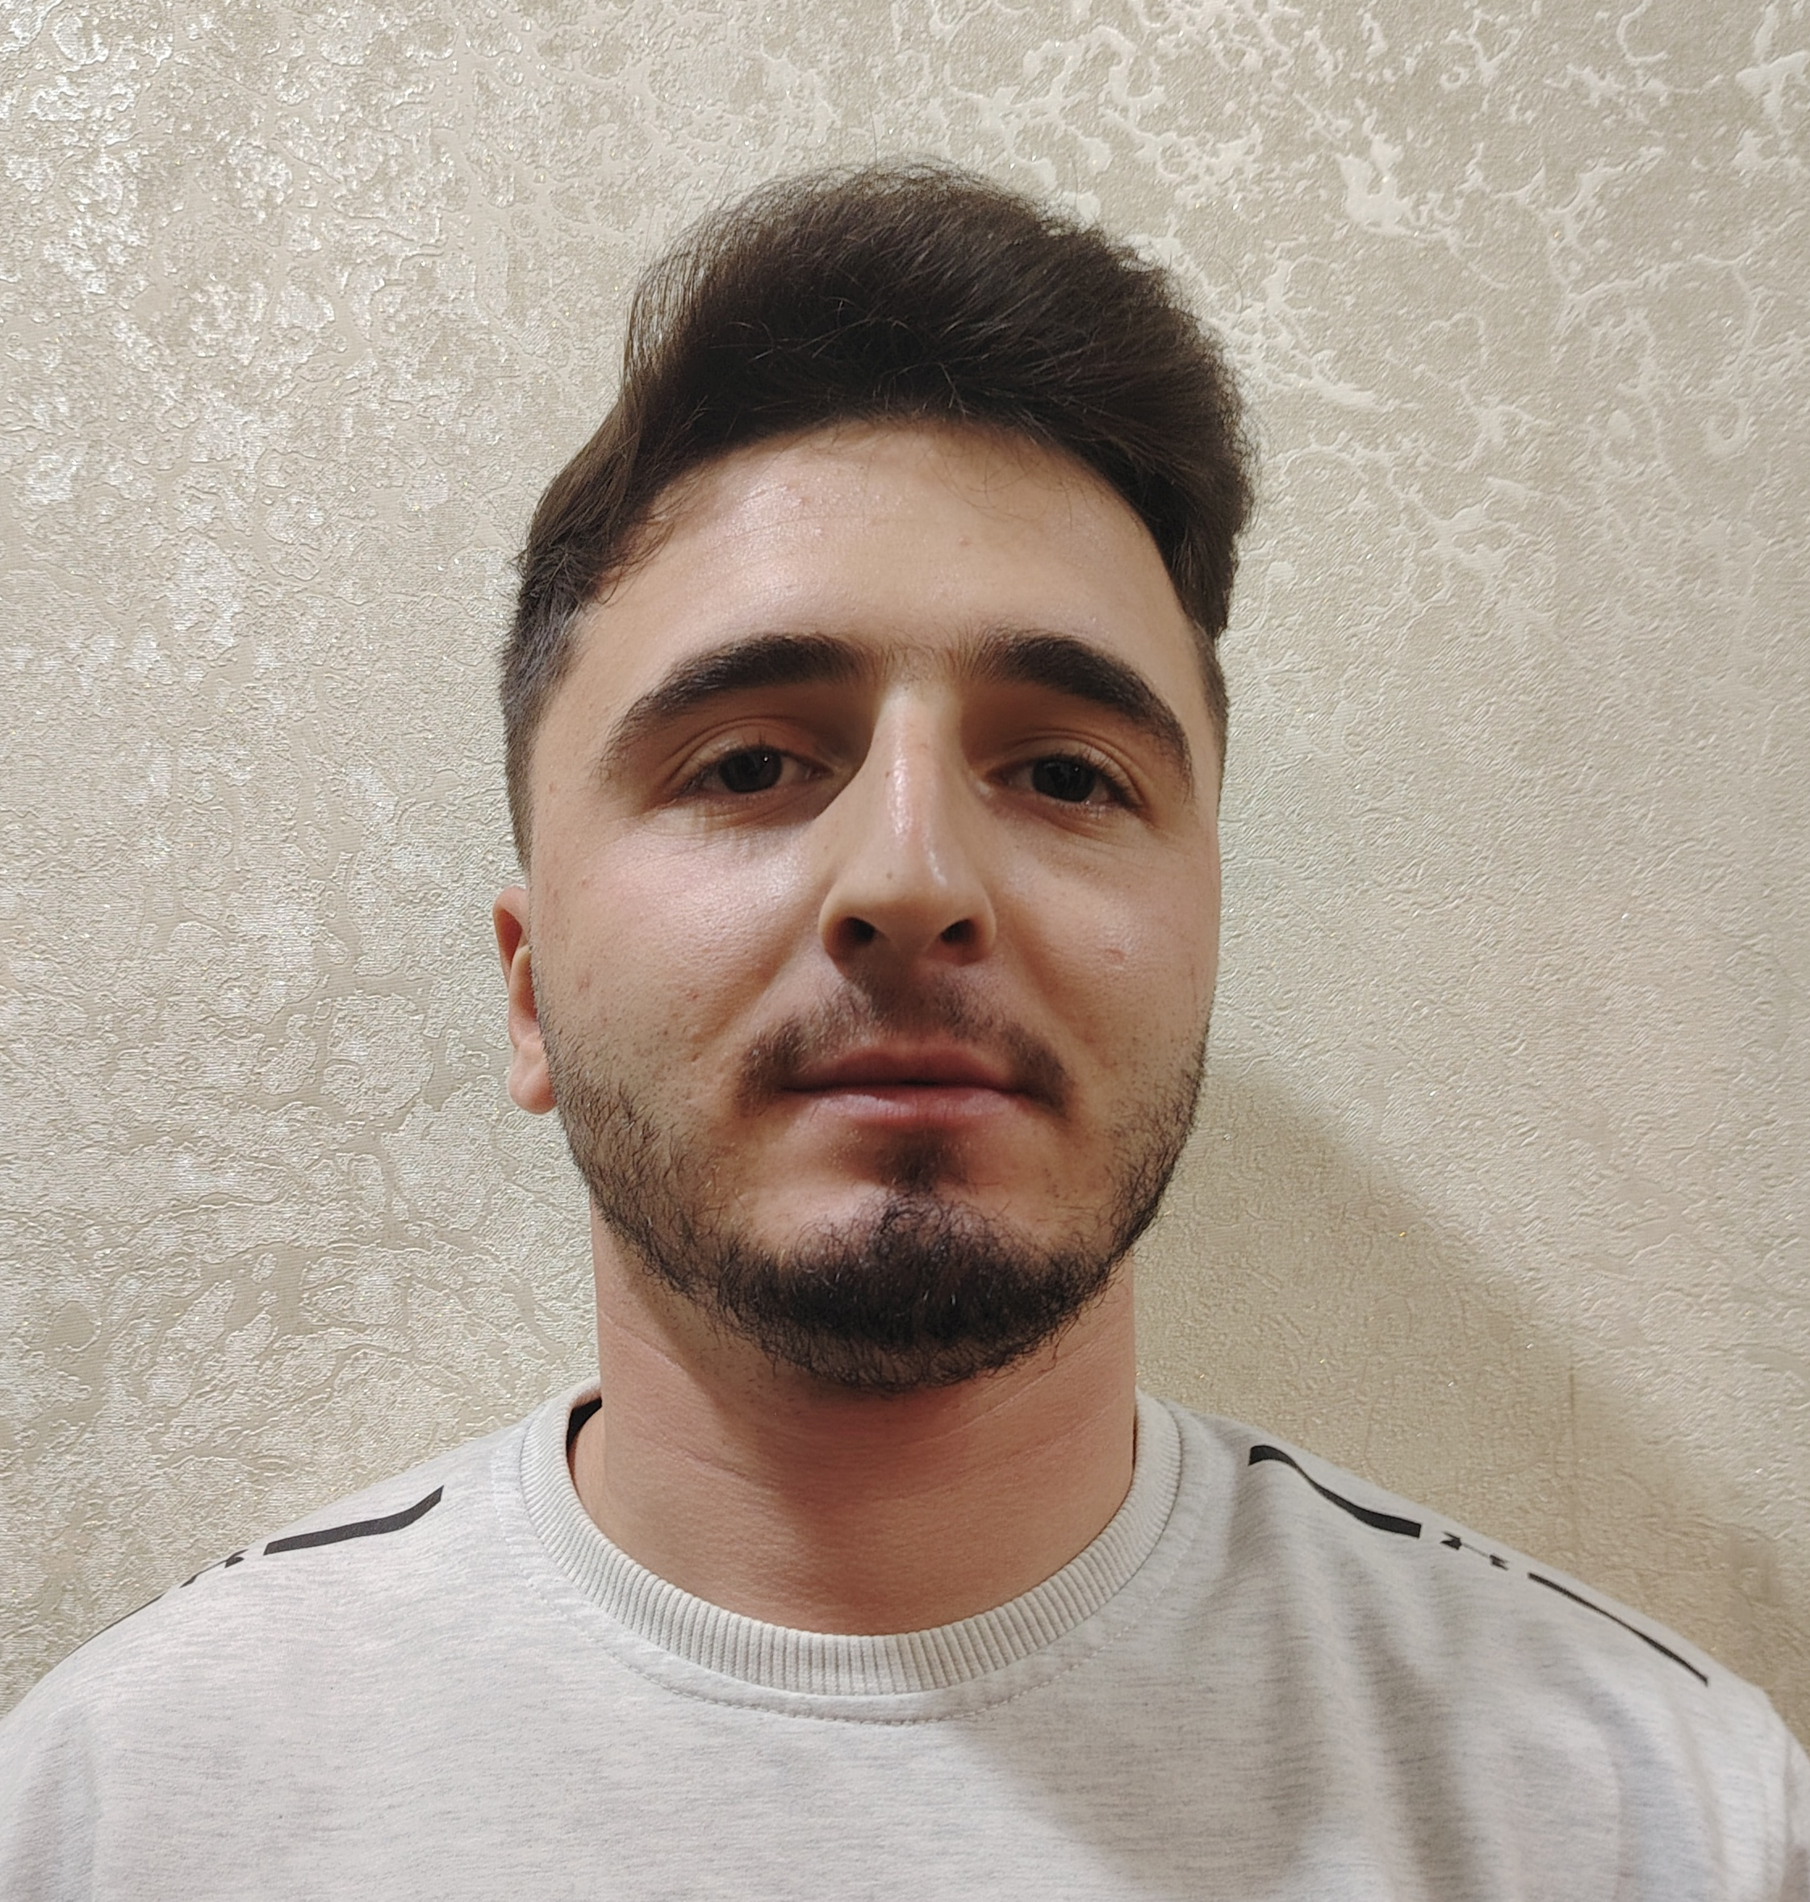

APPLICATION FORM

1 |  | Position identity card PIN Number : 7M9K8C6
 |  | Position Applied for: | Seafarer Deck
 |  | Date Available from: | -

2 |  | Personal Information Gender: Male
 |  | First Name:AKSHİN | Last Name:NASİBLİ
 |  | Date of Birth:01.01.2004 | Place of Birth (City and Country): Azerbaijan, GAKH district
 |  | Email: aksinnesibli@gmail.com | Mobile Number: (+994) 775341225
 |  | Permanent Address: Zayam village Gakh district, Azerbaijan | Expected Salary Per Month:
 |  | Nationality: Azerbaijan | Alternative rank applying for: -
 |  | Person to call in emergency: (+994) 70 537 88 89 (Father)

3 |  | Family Details: (If Unmarried kindly give details of Father / Mother)
 |  | First Name | Last Name | Gender | Relation | Contact
 |  | Firuz | Nasibov | Male | Father | +994705378889
 |  | Khanim | Nasibova | Famale | Mother | +994709680895

4 |  | Maritime Education
 |  | Name of school | Country | From | To | Type of degree or diploma
 |  | Azerbaijan State Marine Academy | Azerbaijan | 2020 | 2024 | Bachelor

5 |  | Physical Data
 |  | Height | 181
 |  | Weight | 85
 |  | Boilersuit Size | 2XL
 |  | Shoes Size | 44
 |  | Blood group | O(I)RH+
 |  | Additional Physical Information:{You can write any other information you want to add about your physique in this field.}

6 |  | Seaman`s Book&Identify Docs
 |  | DOCUMENT | COUNTRY |  | NUMBER |  |  | DATE OF ISSUE |  | PLACE OF ISSUE |  |  | DATE OF EXPIRY
 |  | Seaman Book | Azerbaijan |  | DQK 017825 |  |  | 24. 06.2021 |  | Azerbaijan |  |  | 24.06.2026
 |  | Certificate of Competency | Azerbaijan |  | RP17297 |  |  | 18.08.2025 |  | Azerbaijan |  |  | -
 |  | Republic of Azerbaijan | Azerbaijan |  | AA1663551 |  |  | 11.01.2020 |  | Azerbaijan |  |  | 11.01.2030
 |  | Do you hold a US Visa ‘C1/D’? |  |  | YES/NO | NO |  | Issue Date: |  | - |  | Expiry Date: -
 |  | Do you hold a US Visa ‘B1/B2’? |  |  | YES/NO | NO |  | Issue Date: |  | - |  | Expiry Date:-
 |  | Have you been rejected for any visa applied for? |  |  |  |  |  | YES/NO |  | NO
 |  | If YES, please state the country and reasons |  |  |  |  |  | -
7 |  | STCW Certificates&Trainings
 |  | Courses |  | Issued Country |  |  | Certificate No. |  | Training Center |  | Date Issued |  |  | Date Of Expiry
 |  | PERSONAL SURVIVAL TECHNICS |  | Azerbaijan |  |  | SO-1714-21 |  | SMPA |  | 23.07.2021 |  |  | 14.06.2026
 |  | FIRE PREVENTION&FIRE FIGHTING |  | Azerbaijan |  |  | SO-1714-21 |  | SMPA |  | 23.07.2021 |  |  | 14.06.2026
 |  | ELEMENTARY FIRST AID |  | Azerbaijan |  |  | SO-1714-21 |  | SMPA |  | 23.07.2021 |  |  | 14.06.2026
 |  | PERSONAL SAFETY&SOCIAL RESPONSIBILITY |  | Azerbaijan |  |  | SO-1714-21 |  | SMPA |  | 23.07.2021 |  |  | 14.06.2026
 |  | SAFETY FAMILIARIZATION TRAINING |  | Azerbaijan |  |  | SO-1714-21 |  | SMPA |  | 23.07.2021 |  |  | 14.06.2026
 |  | International Safety Management |  | Azerbaijan |  |  | SP-1290-21 |  | SMPA |  | 30.07.2021 |  |  | 16.06.2026
 |  | Proficiency in Survival Craft&Rescue Boats |  | Azerbaijan |  |  | SL-1665-25 |  | SMPA |  | 22.10.2025 |  |  | 22.10.2030
 |  | Security Awareness Training For All Seafarers |  | Azerbaijan |  |  | SI-0828-21 |  | SMPA |  | 17.07.2021 |  |  | 18.06.2026
 |  | Security Training For Seafarers With Designated Security Duties |  | Azerbaijan |  |  | SH-1335-25 |  | SMPA |  | 05.09.2025 |  |  | Unlimited
 |  | Global Maritime Distress and Safety System general operator |  | Azerbaijan |  |  | DQ-0292-24 |  | SMPA |  | 15.04.2024 |  |  | 14.06.2028
 |  | Radar, ARPA, bridge teamwork and search and rescue |  | Azerbaijan |  |  | SR-0114-24 |  | SMPA |  | 16.04.2024 |  |  | 12.01.2029
 |  | Operational Use of Electronic Chart Display and Information Systems (ECDIS) |  | Azerbaijan |  |  | SZ-0087-24 |  | SMPA |  | 16.12.2024 |  |  | 09.01.2029

8  9 |  | Seagoing Experience
 |  | (Please give a full record starting with the last vessel on which you served)

COMPANY | Name of vessel | Flag | Vessel’s Type | DWT | Eng Type | GRT | TEU | Rank | From m/d/y | To  m/d/y | Total  m/d | REASONS FOR S/OFF
ASCO | 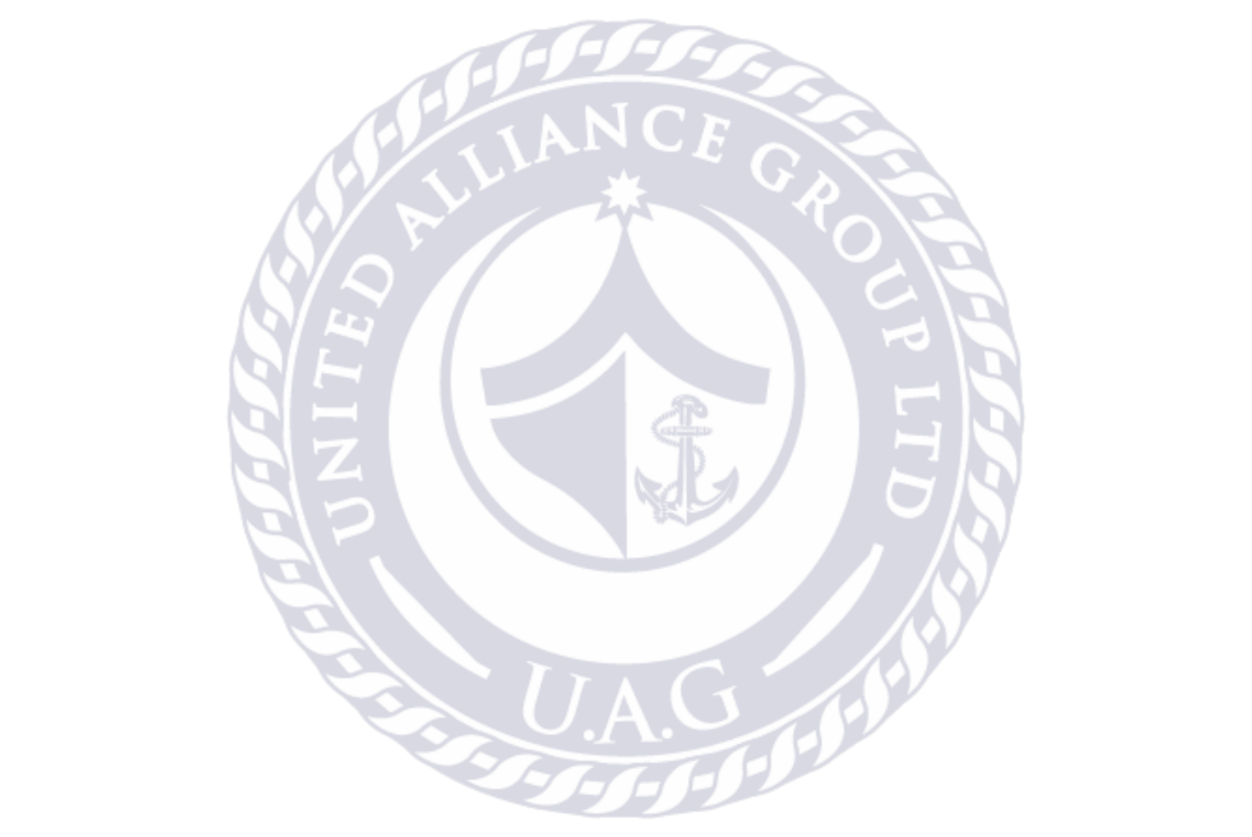  M/V SABİT ORUJOV | Azerbaijan | Passanger  Vessel | 549 | Wartsila | 2621 | - | Probationer | 30.06.2021 | 13.09.2021 | 1 month  24 days | End of Contract
ASCO | M/V VAGİF JAFAROV | Azerbaijan | Crane Vessel | 1326 | Sulzer-Yugoturbina | 2791 | - | Probationer | 16.06.2022 | 07.09.2022 | 2 month  22 days | End of Contract
ASCO | M/V ALİ MUSTAFAYEV | Azerbaijan | Oil products  Tanker | 4056 | 6CRN 36/45 | 4510 | - | Probationer | 16.06.2023 | 07.09.2023 | 2 month  22 days | End of Contract
ASCO | M/V Mikayil  Mushfiq | Azerbaijan | Dry  Cargo Vessel | 4150 | 8DR 30/50 | 6181 | - | Probationer | 02.02.2024 | 25.05.2024 | 3 month  22 days | End of Contract

9 |  | Other Experience
Russian Language : Average Azerbaijan,Turkish Language : Perfect
English Language: Average

10 |  | Insurance ,Health Related Documentation
 |  | Medical Certificate (Fit for Duty) | YES/NO | YES
 |  | Vaccination
 |  | Yellow Fever | YES/NO | NO
 |  | COVID-19 | YES/NO | YES

11 |  | Medical history
 |  | Have you ever signed off a ship due to medical reasons? | YES/NO | NO
 |  | Have you undergone any operation in the past? | YES/NO | NO
 |  | Have you consulted a doctor during the last 12 months for an illness/accident? | YES/NO | NO
 |  | Do you have any health or disability problems now? | YES/NO | NO
 |  | Do you take any medications regularly? | YES/NO | NO

12 |  | General
 |  | Have you ever been the subject of a court of enquiry or involved in a maritime accident? | YES/NO | NO
 |  | Have you ever had a professional license suspended or revoked? | YES/NO | NO

NASİBLİ AKSHİN FİRUZ |  | Date: | 07.11.2025
Signature

