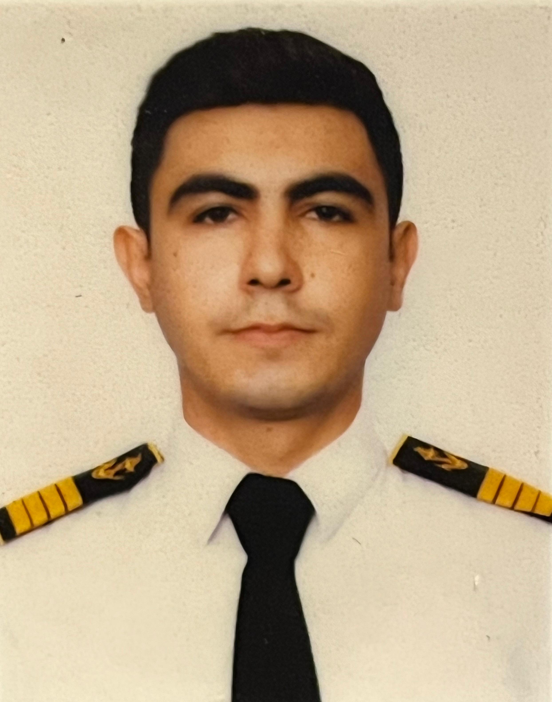

PHOTO

APPLICATION FORM

1 |  | Position identity card PIN Number : 7M9K8C6
 |  | Position Applied for: | Able Seafarer Deck
 |  | Date Available from: | -

2 |  | Personal Information Gender: Male
 |  | First Name: SAMIR | Last Name: XUDAVERDIYEV
 |  | Date of Birth: 31.03.2002 | Place of Birth (City and Country): Azerbaijan, SIAZAN district
 |  | Email: samirxuda06@gmail.com | Mobile Number: (+994) 706531525
 |  | Permanent Address: M.A.Sabir No56 Siazan district, Azerbaijan | Expected Salary Per Month:
 |  | Nationality: Azerbaijan | Alternative rank applying for: -
 |  | Person to call in emergency: (+994) 55 215 37 34 (Father)

3 |  | Family Details: (If Unmarried kindly give details of Father / Mother)
 |  | First Name | Last Name | Gender | Relation | Contact
 |  | Sabir | Xudaverdiyev | Male | Father | +994552153734

4 |  | Maritime Education
 |  | Name of school | Country | From | To | Type of degree or diploma
 |  | Azerbaijan State Marine Academy | Azerbaijan | 2019 | 2023 | Bachelor

5 |  | Physical Data
 |  | Height | 167
 |  | Weight | 67
 |  | Boilersuit Size | M
 |  | Shoes Size | 41
 |  | Blood group | A(III)RH+
 |  | Additional Physical Information:{You can write any other information you want to add about your physique in this field.}

6 |  | Seaman`s Book & Identify Docs
 |  | DOCUMENT | COUNTRY |  | NUMBER |  |  | DATE OF ISSUE |  | PLACE OF ISSUE |  |  | DATE OF EXPIRY
 |  | Seaman Book | Azerbaijan |  | DQK 017582 |  |  | 21.05.2021 |  | Azerbaijan |  |  | 21.05.2026
 |  | Certificate of Competency | Azerbaijan |  | RP12316 |  |  | 25.01.2023 |  | Azerbaijan |  |  | -
 |  | Republic of Azerbaijan | Azerbaijan |  | AA0430054 |  |  | 17.01.2019 |  | Azerbaijan |  |  | 16.01.2029
 |  | Do you hold a US Visa ‘C1/D’? |  |  | YES/NO | NO |  | Issue Date: |  | - |  | Expiry Date: -
 |  | Do you hold a US Visa ‘B1/B2’? |  |  | YES/NO | NO |  | Issue Date: |  | - |  | Expiry Date:-
 |  | Have you been rejected for any visa applied for? |  |  |  |  |  | YES/NO |  | NO
 |  | If YES, please state the country and reasons |  |  |  |  |  | -
7 |  | STCW Certificates & Trainings
 |  | Courses |  | Issued Country |  |  | Certificate No. |  | Training Center |  | Date Issued |  |  | Date Of Expiry
 |  | PERSONAL SURVIVAL TECHNICS |  | Azerbaijan |  |  | SO-1200-21 |  | SMPA |  | 17.06.2021 |  |  | 31.05.2026
 |  | FIRE PREVENTION & FIRE FIGHTING |  | Azerbaijan |  |  | SO-1200-21 |  | SMPA |  | 17.06.2021 |  |  | 31.05.2026
 |  | ELEMENTARY FIRST AID |  | Azerbaijan |  |  | SO-1200-21 |  | SMPA |  | 17.06.2021 |  |  | 31.05.2026
 |  | PERSONAL SAFETY & SOCIAL RESPONSIBILITY |  | Azerbaijan |  |  | SO-1200-21 |  | SMPA |  | 17.06.2021 |  |  | 31.05.2026
 |  | SAFETY FAMILIARIZATION TRAINING |  | Azerbaijan |  |  | SO-1200-21 |  | SMPA |  | 17.06.2021 |  |  | 31.05.2026
 |  | International Safety Management |  | Azerbaijan |  |  | SP-0868-21 |  | SMPA |  | 25.06.2021 |  |  | 02.06.2026
 |  | Proficiency in Survival Craft & Rescue Boats |  | Azerbaijan |  |  | SL-2635-24 |  | SMPA |  | 12.08.2024 |  |  | 12.08.2029
 |  | Security Awareness Training For All Seafarers |  | Azerbaijan |  |  | SI-0487-21 |  | SMPA |  | 18.06.2021 |  |  | 04.06.2026
 |  | Security Training For Seafarers With Designated Security Duties |  | Azerbaijan |  |  | SH-1351-25 |  | SMPA |  | 05.09.2025 |  |  | Unlimited
 |  | Global Maritime Distress and Safety System general operator |  | Azerbaijan |  |  | DQ-0054-23 |  | SMPA |  | 31.01.2023 |  |  | 14.06.2027
 |  | Radar, ARPA, bridge teamwork and search and rescue |  | Azerbaijan |  |  | SR-0091-23 |  | SMPA |  | 17.02.2023 |  |  | 19.01.2028
 |  | Operational Use of Electronic Chart Display and Information Systems (ECDIS) |  | Azerbaijan |  |  | SZ-0173-23 |  | SMPA |  | 01.03.2023 |  |  | 12.01.2028

8  9 |  | Seagoing Experience
 |  | (Please give a full record starting with the last vessel on which you served)

COMPANY | Name of vessel | Flag | Vessel’s Type | DWT | Eng Type | GRT | TEU | Rank | From m/d/y | To  m/d/y | Total  m/d | REASONS FOR S/OFF
ASCO | 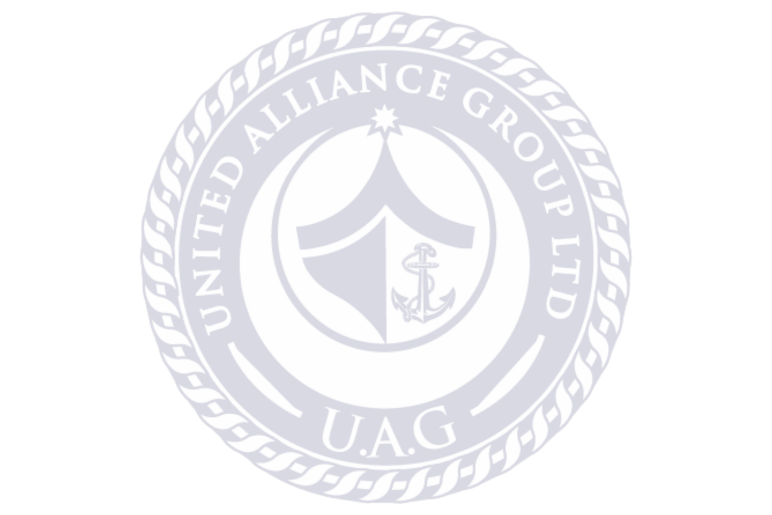  M/V GENERAL ALIAGHA SHIXLINSKI | Azerbaijan | Crane Vessel | 3343 | Wartsila | 19813 | - | Probationer | 01.08.2021 | 15.09.2021 | 1 month | End of Contract
ASCO | M/V SABIT ORUCOV | Azerbaijan | Passenger Vessel | 549 | Wartsila | 2126 | - | Probationer | 29.06.2021 | 30.07.2021 | 1 month | End of Contract
ASCO | M/V SHIRVAN-3 | Azerbaijan | Crane Vessel | 1326 | Sulzer-Yugoturbina | 2971 | - | Probationer | 15.06.2022 | 07.09.2022 | 3 months | End of Contract
ASCO | M/V SHAHDAG | Azerbaijan | Ferry Vessel | 5991 | Wartsila | 8786 | - | Probationer | 02.02.2023 | 25.05.2023 | 3 months | End of Contract

9 |  | Other Experience
Russian Language : Average Azerbaijan,Turkish Language : Perfect
English Language: Good

10 |  | Insurance ,Health Related Documentation
 |  | Medical Certificate (Fit for Duty) | YES/NO | YES
 |  | Vaccination
 |  | Yellow Fever | YES/NO | NO
 |  | COVID-19 | YES/NO | YES

11 |  | Medical history
 |  | Have you ever signed off a ship due to medical reasons? | YES/NO | NO
 |  | Have you undergone any operation in the past? | YES/NO | NO
 |  | Have you consulted a doctor during the last 12 months for an illness/accident? | YES/NO | NO
 |  | Do you have any health or disability problems now? | YES/NO | NO
 |  | Do you take any medications regularly? | YES/NO | NO

12 |  | General
 |  | Have you ever been the subject of a court of enquiry or involved in a maritime accident? | YES/NO | NO
 |  | Have you ever had a professional license suspended or revoked? | YES/NO | NO

Date:
Signature

