 | SECOND OFFICER |  | 30.10.2023 | 
Position: | SECOND OFFICER | Readiness: | 30.10.2023
Position: | SECOND OFFICER | Citizenship: | Ukraine
Last name: | Tkachenko | Marital status | Married
First name: | Oleksandr | Children: | 1
Middle name: | Olegovich | Nationality: | Ukrainian
Birth date: | 30.03.1980 | Birth place: | Ukraine
Home address: | Ukraine, Odessa 47  Bocharova Str.,fl.37  NOW MY LOCATION IN  MINSK | Phone mobile: | +375292859770  Skype : +380632224505
Home address: |  | WhatsApp | +375292859770
Home address: |  | Email: | seanavigator5307@gmail.  com
English level: | Good

Salary | Minimum: 3300 | Expected: 3500 | Last: 3521 | $/month

Education
Educational institution | Speciality | Faculty | Place | Number | From | Till
Odessa Maritime College of Technical Fleet of  ONMA | Navigator | Navigation | Odessa/UKR | 17927/2016/07 | 01.09.2004 | 25.05.2008

Passports, Licenses & Certificates
Title | Class | Number | Place of issue | Issued | Valid
 |  | Passports & Visas
Civil passport |  | EA181545 | Odessa, UKR | 18.11.1996 | permanent
Seaman's book |  | AC011373 | Odessa, UKR | 24.10.2023 | 24.10.2028
Travel passport |  | FJ267644 | Odessa, UKR | 17.10.2017 | 17.10.2027
USA Visa C1/D |  | N6690345 | Kyiv, UKR | 28.09.2018 | 26.09.2028
 |  | Diplomas & Endorsements
Diploma |  | 17927/2016/07 | Odessa, UKR | 09.12.2016 | permanent
Diploma Endorsement |  | 17927/2016/07 | Odessa, UKR | 05.11.2021 | 26.10.2026
GMDSS General Operator  Certificate |  | 01035/2017/07 | Odessa, UKR | 16.11.2017 | permanent
GMDSS General Operator Certificate Endorsement |  | 01035/2017/07 | Odessa, UKR | 05.11.2021 | 08.10.2026
 |  | Certificates & Licenses
Operational Use of Electronic Chart Display and Information System(ECDIS) |  | 147531 | Odessa, UKR | 29.05.2020 | 29.05.2025
Designated Security Duties for Shipboard Personnel |  | 147037 | Odessa, UKR | 28.05.2020 | 28.05.2025
Advanced Fire Fighting |  | 32334224/04/1114/021 | Odessa, UKR | 06.09.2021 | 06.09.2026
Radar Operational (ARPA+RADAR) |  | 32334224/26/1111/021 | Odessa, UKR | 06.09.2021 | 06.09.2026
Basic Safety Training |  | 32334224/01/115/021 | Odessa, UKR | 06.09.2021 | 06.09.2026
Dangerous and Hazardous Substances |  | 32334224/11/1111/021 | Odessa, UKR | 06.09.2021 | 06.09.2026
Medical First Aid |  | 32334224/05/1113/021 | Odessa, UKR | 06.09.2021 | 06.09.2026
Proficiency in Survival Craft and RB |  | 32334224/02/1116/021 | Odessa, UKR | 06.09.2021 | 06.09.2026
Leadership & Teamwork |  | 2/IS/0005/0/21 | Odessa, UKR | 06.09.2021 | 06.09.2026
TRANSAS NAVI-SAILOR 4000 ECDIS |  | 2015-UA-OMTC-NS40-  0184 | Odessa, UKR | 01.12.2015 | permanent
FURUNO ECDIS model FMD – 3100/3200/3300 |  | FEC2014-001 | Odessa, UKR | 04.04.2018 | permanent
 |  | Medical Certificates
Yellow Fever |  |  | Odessa, UKR | 08.11.2018 | Permanent
COVID I9 |  | 4 pcs | Odessa, UKR | 31.10.2021 | 24.07.2024
MEDICAL EXAMINATION |  |  | Odessa, UKR | 26.10.2023 | 26.10.2024

 | Vessel’s  Name  ECDIS | Flag | Type | Engine | Rank | From | Shipowner
 | Vessel’s  Name  ECDIS | Year | DWT | HP | Rank | Till | Crew Agency
1 | Royal  Forward  ECDIS FURUNO  ECDIS model  FMD -  3300 | Singap  ore | Bulk  Carrier  DWT 88200 | MAN  B&W  12240 | Second Officer | 05.11.2022  23.08.2023 | STAFF MARITIME  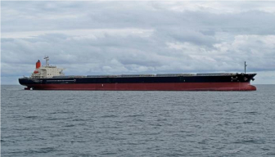  OWNER: ROYAL FORWARDLTD BRITISH LINE GROUP
2 | Ever  Alliance  ECDIS FURUNO  ECDIS model  FMD -  3300 | Panam  a 2011 | Bulk  Carrier  57991 DWT | MAN  B&W  9480 | Second Officer | 13.03.2022  18.09.2022 | Renewal Shipping S. A  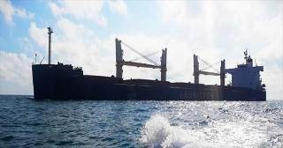  ALLIANCE STEAMSHIP
3 | White  Pearl  ECDIS FURUNO  ECDIS model  FMD -  3200 | BHS | General  Cargo  (SELF-  DISCH  ARGE) | MAN-  B&W | Second Officer | 14.11.2018  05.03.2020 | SMT Shipmanagement  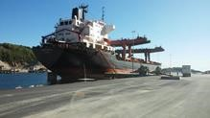
3 | White  Pearl  ECDIS FURUNO  ECDIS model  FMD -  3200 | 1985 | 39273 | 11200 | Second Officer | 05.03.2019

Sea-going experience
4 | White  Pearl  ECDIS FURUNO  ECDIS model  FMD -  3200 | BHS | General  Cargo  (SELFDISCH  ARGE) | MAN-  B&W | Second Officer | 05.04.2018 | SMT Shipmanagement  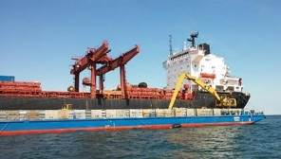
4 | White  Pearl  ECDIS FURUNO  ECDIS model  FMD -  3200 | 1985 | 39273 | 11200 | Second Officer | 06.08.2018
5 | Sider  Atlantic  TRANSAS  NAVI-  SAILOR  4000  ECDIS | MLT | Bulk Carrier | B&W | Second Officer | 23.02.2017 | ITALTEH S.R.L  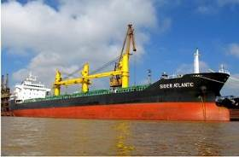
5 | Sider  Atlantic  TRANSAS  NAVI-  SAILOR  4000  ECDIS | 2011 | 24252 | 5180 | Second Officer | 07.07.2017
6 | MAX  Venture  TRANSAS  NAVI-  SAILOR  4000  ECDIS | MLT | Containe r Ship | MAN-  B&W | Second Officer | 10.04.2016 | OSM  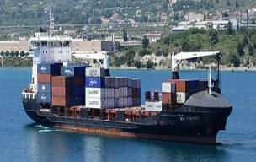
6 | MAX  Venture  TRANSAS  NAVI-  SAILOR  4000  ECDIS | 2008 | 12244 | 12712 | Second Officer | 14.10.2016 | OSM Crew Management
7 | MAX  Winner | LBR | Containe r Ship | B&W | Second Officer | 09.12.2015 | OSM

 | TRANSAS  NAVI-  SAILOR  4000  ECDIS |  |  |  |  |  | 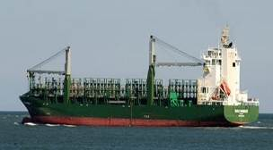
 | TRANSAS  NAVI-  SAILOR  4000  ECDIS | 2008 | 17350 | 17190 |  | 18.04.2016 | OSM Crew Management Ltd
8 | Sider  Atlantic  TRANSAS  NAVI-  SAILOR  4000  ECDIS | MLT | Bulk Carrier | B&W | Second Officer | 11.08.2014 | ITALTEH S.R.L  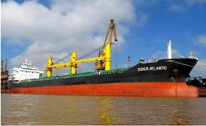
8 | Sider  Atlantic  TRANSAS  NAVI-  SAILOR  4000  ECDIS | 2011 | 24252 | 5180 | Second Officer | 16.12.2014
9 | Divina  TRANSAS  NAVI-  SAILOR  4000  ECDIS | BMU | MultiPurpose  Vessel | MAN-  B&W | Second Officer | 17.07.2013 | ISTOS MARITIME - ATHENS, GREECE  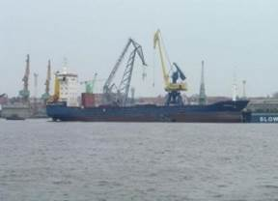
9 | Divina  TRANSAS  NAVI-  SAILOR  4000  ECDIS | 1995 | 5909 | 6650 | Second Officer | 27.02.2014

Height (cm) | Weight (kg) | Shoes | Clothes | Hair color | Eye color
185 | 99 | 45 | XXL | brown | green
Additional information

General Physical State
Good day,
Dear Employer.
My name is Oleksandr Tkachenko.
Please consider my CV for the position of 2nd Officer.
I have been carrying out the duties of Navigation and GMDSS officer for the last 14 years. Have worked with ECDIS Transas Navi-
Sailor 4000, and Furuno FMD 3300.
Position - 2nd Officer/Biometric passport/USA visa C1/D.COVID 19
Experience on such vessel as General Cargo (self-unloading, offshore NON DP), Bulk Carrier, Multi-Purpose. Knowledge English – Good. Available – ASAP.
Duration: 6(+/-1).
I am reliable, serious, loyal and responsible candidate with good ability to learn fast.
If you don’t have an open position which corresponds my qualification, please add my CV to your database of candidates to consider my candidature in the future.
Thank you very much for your time and interest to my CV.
I DO NOT CONSIDER VACANCIES FOR CONTAINERS, ONLY FOR BULK CARRIERS AND DRY CARGO.

Best Regards,
Oleksandr Tkachenko
Mob/WhatsApp +375292859770

@ Email: seanavigator5307@gmail.com

